**BAGPACKERS AND LOGISTIC SERVICES**

**A PROJECT REPORT**

**SUBMITTED AS A JTH COMPONENT FOR MCA**

**By**

**MANSI LOHIYA 19MCA0154**

**BHARGAV MEHTA 19MCA0034 (TEAM MEMBER)**

**ANINDA KANJILAL 19MCA0124 (TEAM MEMBER)**

**UNDER THE GUIDANCE OF**

**PROF. EPHZIBAH E.P**



**SCHOOL OF INFORMATION TECHNOLOGY & ENGINEERING**

 **JUNE, 2020**

1. **SIGN-IN & SIGN-UP FORM:**

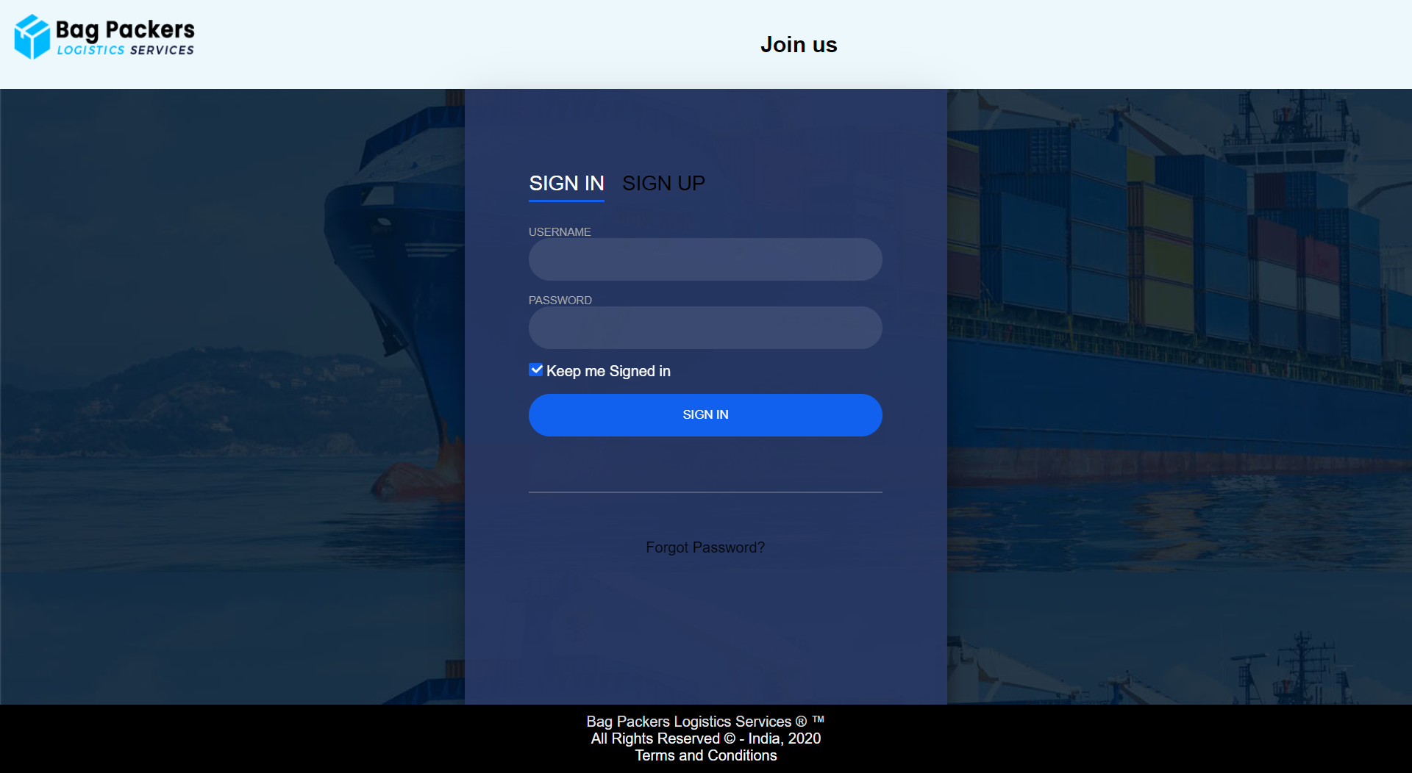

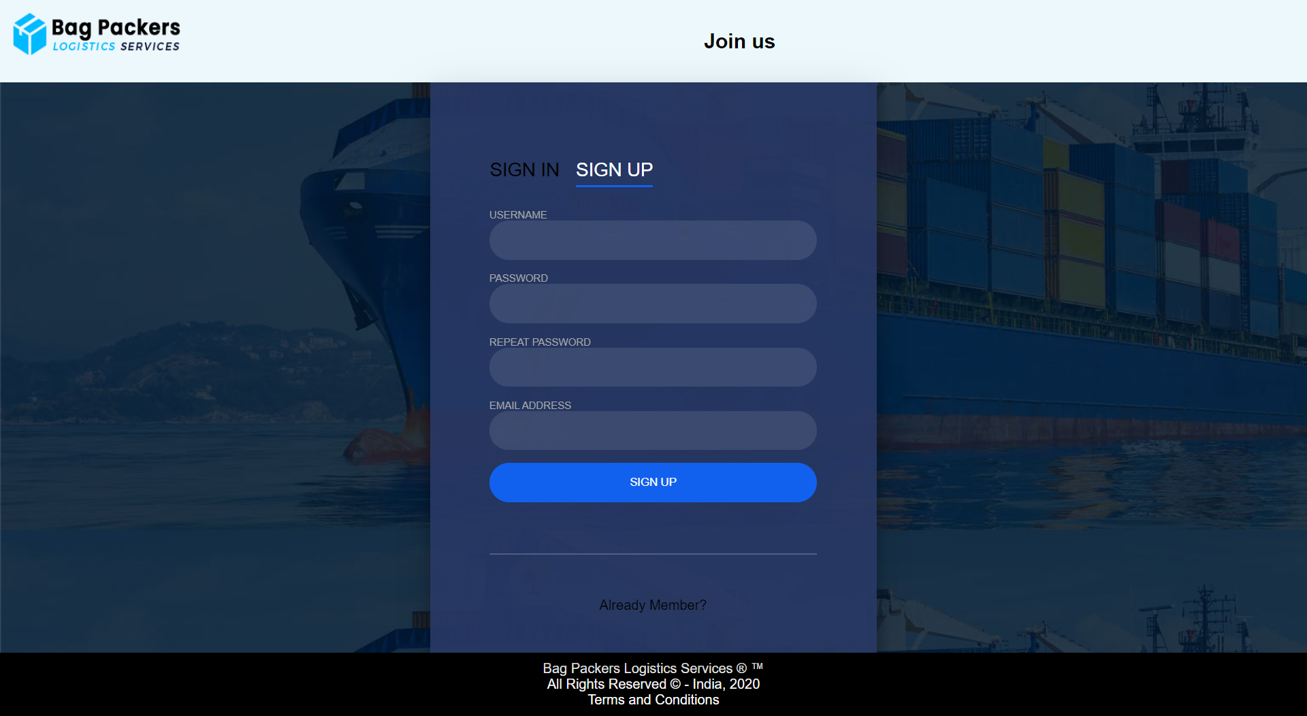

**// HTML CODE**

<html>

<head>

<meta name="viewport" content="width=device-width, initial-scale=1">

<link rel="stylesheet" type="text/css" href="login.css">

</head>

<!--header part-->

<body background="bg-box-2.jpg">

<div style="background-color:#edf8fc;padding:15px;">

<img src="navy-darkblue_dark.png" width="200" height="50" align="left"/>

<div style="text-align:center">

<h2><center>Join us</center></h2>

</div></div>

<!--signin form-->

<div class="login-wrap">

<div class="login-html">

<input id="tab-1" type="radio" name="tab" class="sign-in" checked><label for="tab-1" class="tab">Sign In</label>

<input id="tab-2" type="radio" name="tab" class="sign-up"><label for="tab-2" class="tab">Sign Up</label>

<div class="login-form">

<form action="profile.html">

<div class="sign-in-htm">

<div class="group">

<label for="user" class="label">Username</label>

<input id="user" type="text" class="input" required>

</div>

<div class="group">

<label for="pass" class="label">Password</label>

<input id="pass" type="password" class="input" data-type="password" required>

</div>

<div class="group">

<input id="check" type="checkbox" class="check" checked>

<label for="check"><span class="icon"></span> Keep me Signed in</label>

</div>

<div class="group">

<a href="profile.html"><input type="submit" class="button" value="Sign In"></a>

</div>

<div class="hr"></div>

<div class="foot-lnk">

<a href="#forgot">Forgot Password?</a>

</div>

</div>

</form>

<!--signup form-->

<form action="">

<div class="sign-up-htm">

<div class="group">

<label for="user" class="label">Username</label>

<input id="user" type="text" class="input" required>

</div>

<div class="group">

<label for="pass" class="label">Password</label>

<input id="pass" type="password" class="input" data-type="password" required>

</div>

<div class="group">

<label for="pass" class="label">Repeat Password</label>

<input id="pass" type="password" class="input" data-type="password" >

</div>

<div class="group">

<label for="pass" class="label">Email Address</label>

<input type="email" class="input" required>

</div>

<div class="group">

<a href="profile.html"><input type="submit" class="button" value="Sign Up"></a>

</div>

<div class="hr"></div>

<div class="foot-lnk">

<label for="tab-1">Already Member?</a>

</div>

</div>

</form>

</div>

</div>

</div>

<!--footer part-->

<footer>

Bag Packers Logistics Services &reg; &trade; <br>All Rights Reserved &copy; - India, 2020<br>

<a href="faq.html">Terms and Conditions</a>

</footer>

</body>

</html>

**// CSS CODE**

body{

margin: 0;

font-family: Arial, Helvetica, sans-serif;

}

.navbar {

overflow: hidden;

background-color: #edf8fc;

}

.navbar a {

float: left;

font-size: 16px;

color: black;

text-align: center;

padding: 14px;

text-decoration: none;

}

.dropdown {

float: left;

overflow: hidden;

}

.dropdown .dropbtn {

font-size: 16px;

border: 0;

outline: none;

color: black;

padding: 14px;

background-color: inherit;

font-family: inherit;

margin: 0;

}

.navbar a:hover, .dropdown:hover .dropbtn {

background-color: #ddd;

}

.dropdown-content {

display: none;

position: absolute;

background-color: white;

min-width: 160px;

box-shadow: 0px 8px 16px 0px rgba(0,0,0,0.2);

z-index: 1;

}

.dropdown-content a {

float: none;

color: black;

padding: 12px 16px;

text-decoration: none;

display: block;

text-align: left;

}

.dropdown-content a:hover {

background-color: #ddd;

}

.dropdown:hover .dropdown-content {

display: block;

}

*,:after,:before{box-sizing:border-box}

.clearfix:after,.clearfix:before{content:'';display:table}

.clearfix:after{clear:both;display:block}

a{color:inherit;text-decoration:none}

.login-wrap{

width:100%;

margin:auto;

max-width:525px;

min-height:670px;

position:relative;

box-shadow:0 12px 15px 0 rgba(0,0,0,.24),0 17px 50px 0 rgba(0,0,0,.19);

}

.login-html{

width:100%;

height:100%;

position:absolute;

padding:90px 70px 50px 70px;

background:rgba(40,57,101,.9);

}

.login-html .sign-in-htm,

.login-html .sign-up-htm{

top:0;

left:0;

right:0;

bottom:0;

position:absolute;

transform:rotateY(180deg);

backface-visibility:hidden;

transition:all .4s linear;

}

.login-html .sign-in,

.login-html .sign-up,

.login-form .group .check{

display:none;

}

.login-html .tab,

.login-form .group .label,

.login-form .group .button{

text-transform:uppercase;

}

.login-html .tab{

font-size:22px;

margin-right:15px;

padding-bottom:5px;

margin:0 15px 10px 0;

display:inline-block;

border-bottom:2px solid transparent;

}

.login-html .sign-in:checked + .tab,

.login-html .sign-up:checked + .tab{

color:#fff;

border-color:#1161ee;

}

.login-form{

min-height:345px;

position:relative;

perspective:1000px;

transform-style:preserve-3d;

}

.login-form .group{

margin-bottom:15px;

}

.login-form .group .label,

.login-form .group .input,

.login-form .group .button{

width:100%;

color:#fff;

display:block;

}

.login-form .group .input,

.login-form .group .button{

border:none;

padding:15px 20px;

border-radius:25px;

background:rgba(255,255,255,.1);

}

.login-form .group input[data-type="password"]{

text-security:circle;

-webkit-text-security:circle;

}

.login-form .group .label{

color:#aaa;

font-size:12px;

}

.login-form .group .button{

background:#1161ee;

}

.login-form .group label .icon{

width:15px;

height:15px;

border-radius:2px;

position:relative;

display:inline-block;

background:rgba(255,255,255,.1);

}

.login-form .group label .icon:before,

.login-form .group label .icon:after{

content:'';

width:10px;

height:2px;

background:#fff;

position:absolute;

transition:all .2s ease-in-out 0s;

}

.login-form .group label .icon:before{

left:3px;

width:5px;

bottom:6px;

transform:scale(0) rotate(0);

}

.login-form .group label .icon:after{

top:6px;

right:0;

transform:scale(0) rotate(0);

}

.login-form .group .check:checked + label{

color:#fff;

}

.login-form .group .check:checked + label .icon{

background:#1161ee;

}

.login-form .group .check:checked + label .icon:before{

transform:scale(1) rotate(45deg);

}

.login-form .group .check:checked + label .icon:after{

transform:scale(1) rotate(-45deg);

}

.login-html .sign-in:checked + .tab + .sign-up + .tab + .login-form .sign-in-htm{

transform:rotate(0);

}

.login-html .sign-up:checked + .tab + .login-form .sign-up-htm{

transform:rotate(0);

}

.hr{

height:2px;

margin:60px 0 50px 0;

background:rgba(255,255,255,.2);

}

.foot-lnk{

text-align:center;

}

footer{

background-color:black;

padding:10px;

color:white;

text-align:center;

}

1. **PROFILE FORM:**

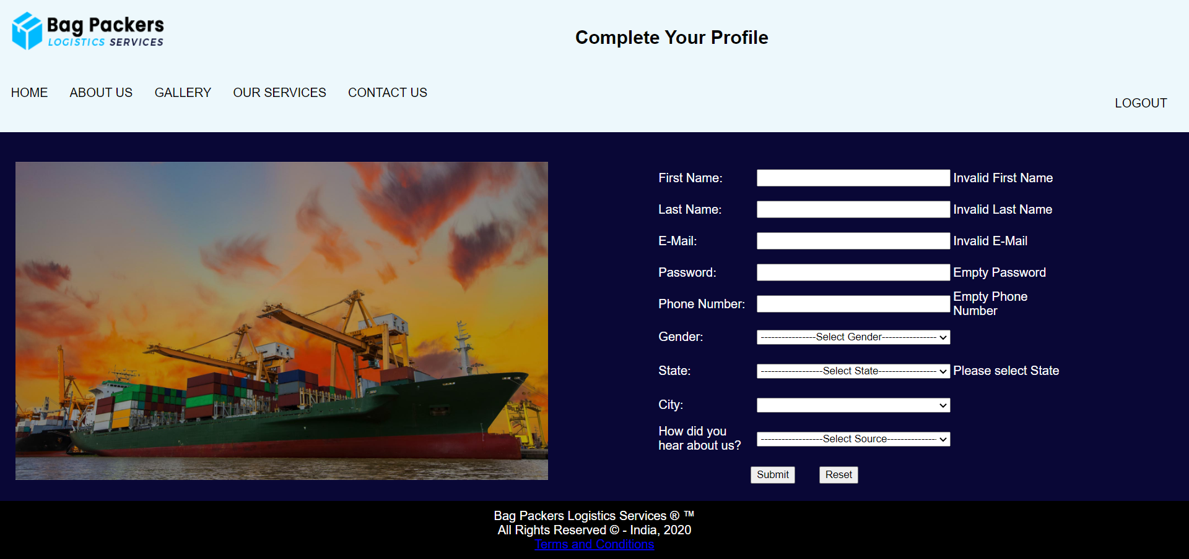

**// HTML CODE**

<!DOCTYPE html>

<html>

<head>

<meta charset="utf-8">

<link rel="stylesheet" type="text/css" href="profile.css">

<script src="profile.js"></script>

</head>

<!--header part-->

<body>

<div style="background-color:#edf8fc;padding:15px;">

<img src="navy-darkblue_dark.png" width="200" height="50" align="left"/>

<div style="text-align:center">

<h2><center>Complete Your Profile</center></h2>

</div></div>

<div class="navbar">

<a href="profile.html">HOME</a>

<a href="profile.html">ABOUT US</a>

<a href="profile.html">GALLERY</a>

<div class="dropdown">

<button class="dropbtn">OUR SERVICES

<i class="fa fa-caret-down"></i>

</button>

<div class="dropdown-content">

<a href="profile.html">SERVICES</a>

<a href="profile.html">PRICE QUOTE</a>

<a href="profile.html">TESTIMONIAL</a>

</div>

</div>

<a href="profile.html">CONTACT US</a>

<div class="dropdown" style="float:right">

<button class="dropbtn">

<a href="firstpage.html">LOGOUT</a></button>

</div>

</div>

<div class="container">

<br>

<div style="float:left; width:46%">

<img src="slide3-2.jpg" height="100%" width="100%">

</div>

<table width="528" border="0" align="center">

<tbody>

<tr>

<td width="167" height="39" >First Name:</td>

<td width="146"><input type="text" name="textfield" id="firstname" onBlur=""></td>

<td width="201"><span id="error_fname"></span></td>

</tr>

<tr>

<td width="167" height="39">Last Name:</td>

<td width="146" ><input type="text" name="textfield2" id="lastname"></td>

<td width="201"><span id="error_lname"></span></td>

</tr>

<tr>

<td height="39"> E-Mail:</td>

<td><input type="text" name="textfield3" id="email"></td>

<td width="201"><span id="error_mail"></span></td>

</tr>

<tr>

<td height="39">Password:</td>

<td><input type="password" name="password" id="password"></td>

<td width="201"><span id="error_pass"></span></td>

</tr>

<tr>

<td height="39">Phone Number:</td>

<td><input type="text" name="textfield4" id="phonenumber" maxlength="10"></td>

<td width="201"><span id="error_phone"></span></td>

</tr>

<tr>

<td height="42">Gender:</td>

<td><select id="gender" style="width:100%">

<option>----------------Select Gender----------------</option>

<option>Male</option>

<option>Female</option>

<option>Other</option>

</select></td>

<td width="201"><span id="error_gender"></span></td>

</tr>

<tr>

<td height="42">State:</td>

<td><select style="width:100%" onchange="print_city('state', this.selectedIndex);" id="sts" name ="stt" class="form-control"></select>

</td>

<td width="201"><span id="error_state"></span></td>

</tr>

<tr>

<td height="42">City:</td>

<td><select style="width:100%" onchange="print_state('city', this.selctedIndex);"id="state" name="state" class="form-control">

</select></td>

<td width="201"><span id="error_city"></span></td>

</tr>

<tr>

<td height="42">How did you hear about us?</td>

<td><select style="width:100%" id="select" name="select2">

<option>------------------Select Source------------------</option>

<option>Internet Search</option>

<option>Recommendation</option>

<option>Advertisement</option>

<option >Newspapers and Magazines</option>

</select></td>

</tr>

<tr>

<td height="10"></td>

<td></td>

</tr>

<tr>

<td colspan="2">

<div align="center">

<input type="submit" name="submit" id="submit" value="Submit" onClick="validateProfile()">

&nbsp;&nbsp;&nbsp;&nbsp;&nbsp;

<input type="reset" name="reset" id="reset" value="Reset" onclick="window.location.href = 'profile.html'">

</div>

</td>

<td></td>

</tr>

</tbody>

<script language="javascript">print_state("sts");</script>

</table>

</div>

<footer>

Bag Packers Logistics Services &reg; &trade; <br>All Rights Reserved &copy; - India, 2020<br>

<a href="faq.html">Terms and Conditions</a>

</footer>

</body>

<script>

function isEmpty(str){

str = str.trim()

if(str==undefined || str=="" || str.length==0)

return true;

else

return false;

}

function isNumber(str){

var pattern = new RegExp("^[0-9]+$")

return pattern.test(str);

}

function validateProfile() {

var fname = document.getElementById('firstname');

var lname = document.getElementById('lastname');

var mail = document.getElementById('email');

var pass = document.getElementById('password');

var phone = document.getElementById('phonenumber');

/*Regex Code*/

var filter_name = /^[a-zA-Z]+$/;

var filter_mail = /^(([^<>()[\]\\.,;:\s@\"]+(\.[^<>()[\]\\.,;:\s@\"]+)*)|(\".+\"))@((\[[0-9]{1,3}\.[0-9]{1,3}\.[0-9]{1,3}\.[0-9]{1,3}\])|(([a-zA-Z\-0-9]+\.)+[a-zA-Z]{2,}))$/;

var filter_zipcode = /^[0-9]{6}$/;

/*Conditions*/

if (filter_name.test(fname.value)) {

document.getElementById('error_fname').innerHTML = '';

} else {

document.getElementById('error_fname').innerHTML = '<span>Invalid First Name</span>';

}

if (filter_name.test(lname.value)) {

document.getElementById('error_lname').innerHTML = '';

} else {

document.getElementById('error_lname').innerHTML = '<span>Invalid Last Name</span>';

}

if (filter_mail.test(mail.value)) {

document.getElementById('error_mail').innerHTML = '';

} else {

document.getElementById('error_mail').innerHTML = '<span>Invalid E-Mail</span>';

}

if (!isEmpty(pass.value)) {

document.getElementById('error_pass').innerHTML = '';

if(pass.value.length>=6){

document.getElementById('error_pass').innerHTML = '';

}

else{

document.getElementById('error_pass').innerHTML = '<span>Should contain minimum 6 chars</span>';

}

} else {

document.getElementById('error_pass').innerHTML = '<span>Empty Password</span>';

}

if (!isEmpty(phone.value)) {

document.getElementById('error_phone').innerHTML = '';

if((isNumber(phone.value)) && (phone.value.length==10)){

document.getElementById('error_phone').innerHTML = '';

}

else{

document.getElementById('error_phone').innerHTML = '<span>Invalid 10-digit Mobile Number</span>';

}

} else {

document.getElementById('error_phone').innerHTML = '<span>Empty Phone Number</span>';

}

if (sts.selectedIndex == 0) {

document.getElementById('error_state').innerHTML = '<span>Please select State</span>';

return false;

} else {

document.getElementById('error_state').innerHTML = '';

}

if (state.selectedIndex == 0) {

document.getElementById('error_city').innerHTML = '<span>Please select City</span>';

return false;

} else {

document.getElementById('error_city').innerHTML = '';

}

if(validateProfile){

alert('Profile Completion is Successfull');

window.location.href = 'home2.html';

}

}

</script>

</html>

**// CSS CODE**

body{

margin: 0;

font-family: Arial, Helvetica, sans-serif;

}

.navbar {

overflow: hidden;

background-color: #edf8fc;

}

.navbar a {

float: left;

font-size: 16px;

color: black;

text-align: center;

padding: 14px;

text-decoration: none;

}

.dropdown {

float: left;

overflow: hidden;

}

.dropdown .dropbtn {

font-size: 16px;

border: 0;

outline: none;

color: black;

padding: 14px;

background-color: inherit;

font-family: inherit;

margin: 0;

}

.navbar a:hover, .dropdown:hover .dropbtn {

background-color: #ddd;

}

.dropdown-content {

display: none;

position: absolute;

background-color: white;

min-width: 160px;

box-shadow: 0px 8px 16px 0px rgba(0,0,0,0.2);

z-index: 1;

}

.dropdown-content a {

float: none;

color: black;

padding: 12px 16px;

text-decoration: none;

display: block;

text-align: left; }

.dropdown-content a:hover {

background-color: #ddd;

}

.dropdown:hover .dropdown-content {

display: block;

}

*,:after,:before{box-sizing:border-box}

.clearfix:after,.clearfix:before{content:'';display:table}

.clearfix:after{clear:both;display:block }

.login-wrap{

width:100%;

margin:auto;

max-width:525px;

min-height:670px;

position:relative;

box-shadow:0 12px 15px 0 rgba(0,0,0,.24),0 17px 50px 0 rgba(0,0,0,.19);

}

.login-html{

width:100%;

height:100%;

position:absolute;

padding:90px 70px 50px 70px;

background:rgba(40,57,101,.9);

}

.login-html .sign-in-htm,

.login-html .sign-up-htm{

top:0;

left:0;

right:0;

bottom:0;

position:absolute;

transform:rotateY(180deg);

backface-visibility:hidden;

transition:all .4s linear;

}

.login-html .sign-in,

.login-html .sign-up,

.login-form .group .check{

display:none;

}

.login-html .tab,

.login-form .group .label,

.login-form .group .button{

text-transform:uppercase;

}

.login-html .tab{

font-size:22px;

margin-right:15px;

padding-bottom:5px;

margin:0 15px 10px 0;

display:inline-block;

border-bottom:2px solid transparent;

}

.login-html .sign-in:checked + .tab,

.login-html .sign-up:checked + .tab{

color:#fff;

border-color:#1161ee;

}

.login-form{

min-height:345px;

position:relative;

perspective:1000px;

transform-style:preserve-3d;

}

.login-form .group{

margin-bottom:15px;

}

.login-form .group .label,

.login-form .group .input,

.login-form .group .button{

width:100%;

color:#fff;

display:block;

}

.login-form .group .input,

.login-form .group .button{

border:none;

padding:15px 20px;

border-radius:25px;

background:rgba(255,255,255,.1);

}

.login-form .group input[data-type="password"]{

text-security:circle;

-webkit-text-security:circle;

}

.login-form .group .label{

color:#aaa;

font-size:12px;

}

.login-form .group .button{

background:#1161ee;

}

.login-form .group label .icon{

width:15px;

height:15px;

border-radius:2px;

position:relative;

display:inline-block;

background:rgba(255,255,255,.1);

}

.login-form .group label .icon:before,

.login-form .group label .icon:after{

content:'';

width:10px;

height:2px;

background:#fff;

position:absolute;

transition:all .2s ease-in-out 0s;

}

.login-form .group label .icon:before{

left:3px;

width:5px;

bottom:6px;

transform:scale(0) rotate(0);

}

.login-form .group label .icon:after{

top:6px;

right:0;

transform:scale(0) rotate(0);

}

.login-form .group .check:checked + label{

color:#fff;

}

.login-form .group .check:checked + label .icon{

background:#1161ee;

}

.login-form .group .check:checked + label .icon:before{

transform:scale(1) rotate(45deg);

}

.login-form .group .check:checked + label .icon:after{

transform:scale(1) rotate(-45deg);

}

.login-html .sign-in:checked + .tab + .sign-up + .tab + .login-form .sign-in-htm{

transform:rotate(0);

}

.login-html .sign-up:checked + .tab + .login-form .sign-up-htm{

transform:rotate(0);

}

.hr{

height:2px;

margin:60px 0 50px 0;

background:rgba(255,255,255,.2);

}

.foot-lnk{

text-align:center;

}

footer{

background-color:black;

padding:10px;

color:white;

text-align:center;

}

input[type=text]

{

width:250px;

}

input[type=password]

{

width:250px;

}

footer{

background-color:black;

padding:10px;

color:white;

text-align:center;

}

span

{

color: white;

}

* {

box-sizing: border-box;

}

.container {

border-radius: 0;

background-color: #090736;

color:white;

padding: 20px;

}

.column-33 {

float: left;

width: 33.33333%;

height: 45%;

padding: 20px;

}

**// JAVASCRIPT CODE**

var state_arr = new Array("Andaman & Nicobar", "Andhra Pradesh", "Arunachal Pradesh", "Assam", "Bihar", "Chandigarh", "Chhattisgarh", "Dadra & Nagar Haveli", "Daman & Diu", "Delhi", "Goa", "Gujarat", "Haryana", "Himachal Pradesh", "Jammu & Kashmir", "Jharkhand", "Karnataka", "Kerala", "Lakshadweep", "Madhya Pradesh", "Maharashtra", "Manipur", "Meghalaya", "Mizoram", "Nagaland", "Orissa", "Pondicherry", "Punjab", "Rajasthan", "Sikkim", "Tamil Nadu", "Tripura", "Uttar Pradesh", "Uttaranchal", "West Bengal");

var s_a = new Array();

s_a[0]="";

s_a[1]=" Alipur | Andaman Island | Anderson Island | Arainj-Laka-Punga | Austinabad | Bamboo Flat | Barren Island | Beadonabad | Betapur | Bindraban | Bonington | Brookesabad | Cadell Point | Calicut | Chetamale | Cinque Islands | Defence Island | Digilpur | Dolyganj | Flat Island | Geinyale | Great Coco Island | Haddo | Havelock Island | Henry Lawrence Island | Herbertabad | Hobdaypur | Ilichar | Ingoie | Inteview Island | Jangli Ghat | Jhon Lawrence Island | Karen | Kartara | KYD Islannd | Landfall Island | Little Andmand | Little Coco Island | Long Island | Maimyo | Malappuram | Manglutan | Manpur | Mitha Khari | Neill Island | Nicobar Island | North Brother Island | North Passage Island | North Sentinel Island | Nothen Reef Island | Outram Island | Pahlagaon | Palalankwe | Passage Island | Phaiapong | Phoenix Island | Port Blair | Preparis Island | Protheroepur | Rangachang | Rongat | Rutland Island | Sabari | Saddle Peak | Shadipur | Smith Island | Sound Island | South Sentinel Island | Spike Island | Tarmugli Island | Taylerabad | Titaije | Toibalawe | Tusonabad | West Island | Wimberleyganj | Yadita";

s_a[2]=" Achampet | Adilabad | Adoni | Alampur | Allagadda | Alur | Amalapuram | Amangallu | Anakapalle | Anantapur | Andole | Araku | Armoor | Asifabad | Aswaraopet | Atmakur | B. Kothakota | Badvel | Banaganapalle | Bandar | Bangarupalem | Banswada | Bapatla | Bellampalli | Bhadrachalam | Bhainsa | Bheemunipatnam | Bhimadole | Bhimavaram | Bhongir | Bhooragamphad | Boath | Bobbili | Bodhan | Chandoor | Chavitidibbalu | Chejerla | Chepurupalli | Cherial | Chevella | Chinnor | Chintalapudi | Chintapalle | Chirala | Chittoor | Chodavaram | Cuddapah | Cumbum | Darsi | Devarakonda | Dharmavaram | Dichpalli | Divi | Donakonda | Dronachalam | East Godavari | Eluru | Eturnagaram | Gadwal | Gajapathinagaram | Gajwel | Garladinne | Giddalur | Godavari | Gooty | Gudivada | Gudur | Guntur | Hindupur | Hunsabad | Huzurabad | Huzurnagar | Hyderabad | Ibrahimpatnam | Jaggayyapet | Jagtial | Jammalamadugu | Jangaon | Jangareddygudem | Jannaram | Kadiri | Kaikaluru | Kakinada | Kalwakurthy | Kalyandurg | Kamalapuram | Kamareddy | Kambadur | Kanaganapalle | Kandukuru | Kanigiri | Karimnagar | Kavali | Khammam | Khanapur (AP) | Kodangal | Koduru | Koilkuntla | Kollapur | Kothagudem | Kovvur | Krishna | Krosuru | Kuppam | Kurnool | Lakkireddipalli | Madakasira | Madanapalli | Madhira | Madnur | Mahabubabad | Mahabubnagar | Mahadevapur | Makthal | Mancherial | Mandapeta | Mangalagiri | Manthani | Markapur | Marturu | Medachal | Medak | Medarmetla | Metpalli | Mriyalguda | Mulug | Mylavaram | Nagarkurnool | Nalgonda | Nallacheruvu | Nampalle | Nandigama | Nandikotkur | Nandyal | Narasampet | Narasaraopet | Narayanakhed | Narayanpet | Narsapur | Narsipatnam | Nazvidu | Nelloe | Nellore | Nidamanur | Nirmal | Nizamabad | Nuguru | Ongole | Outsarangapalle | Paderu | Pakala | Palakonda | Paland | Palmaneru | Pamuru | Pargi | Parkal | Parvathipuram | Pathapatnam | Pattikonda | Peapalle | Peddapalli | Peddapuram | Penukonda | Piduguralla | Piler | Pithapuram | Podili | Polavaram | Prakasam | Proddatur | Pulivendla | Punganur | Putturu | Rajahmundri | Rajampeta | Ramachandrapuram | Ramannapet | Rampachodavaram | Rangareddy | Rapur | Rayachoti | Rayadurg | Razole | Repalle | Saluru | Sangareddy | Sathupalli | Sattenapalle | Satyavedu | Shadnagar | Siddavattam | Siddipet | Sileru | Sircilla | Sirpur Kagaznagar | Sodam | Sompeta | Srikakulam | Srikalahasthi | Srisailam | Srungavarapukota | Sudhimalla | Sullarpet | Tadepalligudem | Tadipatri | Tanduru | Tanuku | Tekkali | Tenali | Thungaturthy | Tirivuru | Tirupathi | Tuni | Udaygiri | Ulvapadu | Uravakonda | Utnor | V.R. Puram | Vaimpalli | Vayalpad | Venkatgiri | Venkatgirikota | Vijayawada | Vikrabad | Vinjamuru | Vinukonda | Visakhapatnam | Vizayanagaram | Vizianagaram | Vuyyuru | Wanaparthy | Warangal | Wardhannapet | Yelamanchili | Yelavaram | Yeleswaram | Yellandu | Yellanuru | Yellareddy | Yerragondapalem | Zahirabad ";

s_a[3]=" Along | Anini | Anjaw | Bameng | Basar | Changlang | Chowkhem | Daporizo | Dibang Valley | Dirang | Hayuliang | Huri | Itanagar | Jairampur | Kalaktung | Kameng | Khonsa | Kolaring | Kurung Kumey | Lohit | Lower Dibang Valley | Lower Subansiri | Mariyang | Mechuka | Miao | Nefra | Pakkekesang | Pangin | Papum Pare | Passighat | Roing | Sagalee | Seppa | Siang | Tali | Taliha | Tawang | Tezu | Tirap | Tuting | Upper Siang | Upper Subansiri | Yiang Kiag ";

s_a[4]=" Abhayapuri | Baithalangshu | Barama | Barpeta Road | Bihupuria | Bijni | Bilasipara | Bokajan | Bokakhat | Boko | Bongaigaon | Cachar | Cachar Hills | Darrang | Dhakuakhana | Dhemaji | Dhubri | Dibrugarh | Digboi | Diphu | Goalpara | Gohpur | Golaghat | Guwahati | Hailakandi | Hajo | Halflong | Hojai | Howraghat | Jorhat | Kamrup | Karbi Anglong | Karimganj | Kokarajhar | Kokrajhar | Lakhimpur | Maibong | Majuli | Mangaldoi | Mariani | Marigaon | Moranhat | Morigaon | Nagaon | Nalbari | Rangapara | Sadiya | Sibsagar | Silchar | Sivasagar | Sonitpur | Tarabarihat | Tezpur | Tinsukia | Udalgiri | Udalguri | UdarbondhBarpeta";

s_a[5]=" Adhaura | Amarpur | Araria | Areraj | Arrah | Arwal | Aurangabad | Bagaha | Banka | Banmankhi | Barachakia | Barauni | Barh | Barosi | Begusarai | Benipatti | Benipur | Bettiah | Bhabhua | Bhagalpur | Bhojpur | Bidupur | Biharsharif | Bikram | Bikramganj | Birpur | Buxar | Chakai | Champaran | Chapara | Dalsinghsarai | Danapur | Darbhanga | Daudnagar | Dhaka | Dhamdaha | Dumraon | Ekma | Forbesganj | Gaya | Gogri | Gopalganj | H.Kharagpur | Hajipur | Hathua | Hilsa | Imamganj | Jahanabad | Jainagar | Jamshedpur | Jamui | Jehanabad | Jhajha | Jhanjharpur | Kahalgaon | Kaimur (Bhabua) | Katihar | Katoria | Khagaria | Kishanganj | Korha | Lakhisarai | Madhepura | Madhubani | Maharajganj | Mahua | Mairwa | Mallehpur | Masrakh | Mohania | Monghyr | Motihari | Motipur | Munger | Muzaffarpur | Nabinagar | Nalanda | Narkatiaganj | Naugachia | Nawada | Pakribarwan | Pakridayal | Patna | Phulparas | Piro | Pupri | Purena | Purnia | Rafiganj | Rajauli | Ramnagar | Raniganj | Raxaul | Rohtas | Rosera | S.Bakhtiarpur | Saharsa | Samastipur | Saran | Sasaram | Seikhpura | Sheikhpura | Sheohar | Sherghati | Sidhawalia | Singhwara | Sitamarhi | Siwan | Sonepur | Supaul | Thakurganj | Triveniganj | Udakishanganj | Vaishali | Wazirganj";

s_a[6]=" Chandigarh | Mani Marja";

s_a[7]=" Ambikapur | Antagarh | Arang | Bacheli | Bagbahera | Bagicha | Baikunthpur | Balod | Balodabazar | Balrampur | Barpalli | Basana | Bastanar | Bastar | Bderajpur | Bemetara | Berla | Bhairongarh | Bhanupratappur | Bharathpur | Bhatapara | Bhilai | Bhilaigarh | Bhopalpatnam | Bijapur | Bilaspur | Bodla | Bokaband | Chandipara | Chhinagarh | Chhuriakala | Chingmut | Chuikhadan | Dabhara | Dallirajhara | Dantewada | Deobhog | Dhamda | Dhamtari | Dharamjaigarh | Dongargarh | Durg | Durgakondal | Fingeshwar | Gariaband | Garpa | Gharghoda | Gogunda | Ilamidi | Jagdalpur | Janjgir | Janjgir-Champa | Jarwa | Jashpur | Jashpurnagar | Kabirdham-Kawardha | Kanker | Kasdol | Kathdol | Kathghora | Kawardha | Keskal | Khairgarh | Kondagaon | Konta | Korba | Korea | Kota | Koyelibeda | Kuakunda | Kunkuri | Kurud | Lohadigundah | Lormi | Luckwada | Mahasamund | Makodi | Manendragarh | Manpur | Marwahi | Mohla | Mungeli | Nagri | Narainpur | Narayanpur | Neora | Netanar | Odgi | Padamkot | Pakhanjur | Pali | Pandaria | Pandishankar | Parasgaon | Pasan | Patan | Pathalgaon | Pendra | Pratappur | Premnagar | Raigarh | Raipur | Rajnandgaon | Rajpur | Ramchandrapur | Saraipali | Saranggarh | Sarona | Semaria | Shakti | Sitapur | Sukma | Surajpur | Surguja | Tapkara | Toynar | Udaipur | Uproda | Wadrainagar";

s_a[8]=" Amal | Amli | Bedpa | Chikhli | Dadra & Nagar Haveli | Dahikhed | Dolara | Galonda | Kanadi | Karchond | Khadoli | Kharadpada | Kherabari | Kherdi | Kothar | Luari | Mashat | Rakholi | Rudana | Saili | Sili | Silvassa | Sindavni | Udva | Umbarkoi | Vansda | Vasona | Velugam ";

s_a[9]=" Brancavare | Dagasi | Daman | Diu | Magarvara | Nagwa | Pariali | Passo Covo ";

s_a[10]=" Central Delhi | East Delhi | New Delhi | North Delhi | North East Delhi | North West Delhi | South Delhi | South West Delhi | West Delhi ";

s_a[11]=" Canacona | Candolim | Chinchinim | Cortalim | Goa | Jua | Madgaon | Mahem | Mapuca | Marmagao | Panji | Ponda | Sanvordem | Terekhol ";

s_a[12]=" Ahmedabad | Ahwa | Amod | Amreli | Anand | Anjar | Ankaleshwar | Babra | Balasinor | Banaskantha | Bansada | Bardoli | Bareja | Baroda | Barwala | Bayad | Bhachav | Bhanvad | Bharuch | Bhavnagar | Bhiloda | Bhuj | Billimora | Borsad | Botad | Chanasma | Chhota Udaipur | Chotila | Dabhoi | Dahod | Damnagar | Dang | Danta | Dasada | Dediapada | Deesa | Dehgam | Deodar | Devgadhbaria | Dhandhuka | Dhanera | Dharampur | Dhari | Dholka | Dhoraji | Dhrangadhra | Dhrol | Dwarka | Fortsongadh | Gadhada | Gandhi Nagar | Gariadhar | Godhra | Gogodar | Gondal | Halol | Halvad | Harij | Himatnagar | Idar | Jambusar | Jamjodhpur | Jamkalyanpur | Jamnagar | Jasdan | Jetpur | Jhagadia | Jhalod | Jodia | Junagadh | Junagarh | Kalawad | Kalol | Kapad Wanj | Keshod | Khambat | Khambhalia | Khavda | Kheda | Khedbrahma | Kheralu | Kodinar | Kotdasanghani | Kunkawav | Kutch | Kutchmandvi | Kutiyana | Lakhpat | Lakhtar | Lalpur | Limbdi | Limkheda | Lunavada | M.M.Mangrol | Mahuva | Malia-Hatina | Maliya | Malpur | Manavadar | Mandvi | Mangrol | Mehmedabad | Mehsana | Miyagam | Modasa | Morvi | Muli | Mundra | Nadiad | Nakhatrana | Nalia | Narmada | Naswadi | Navasari | Nizar | Okha | Paddhari | Padra | Palanpur | Palitana | Panchmahals | Patan | Pavijetpur | Porbandar | Prantij | Radhanpur | Rahpar | Rajaula | Rajkot | Rajpipla | Ranavav | Sabarkantha | Sanand | Sankheda | Santalpur | Santrampur | Savarkundla | Savli | Sayan | Sayla | Shehra | Sidhpur | Sihor | Sojitra | Sumrasar | Surat | Surendranagar | Talaja | Thara | Tharad | Thasra | Una-Diu | Upleta | Vadgam | Vadodara | Valia | Vallabhipur | Valod | Valsad | Vanthali | Vapi | Vav | Veraval | Vijapur | Viramgam | Visavadar | Visnagar | Vyara | Waghodia | Wankaner ";

s_a[13]=" Adampur Mandi | Ambala | Assandh | Bahadurgarh | Barara | Barwala | Bawal | Bawanikhera | Bhiwani | Charkhidadri | Cheeka | Chhachrauli | Dabwali | Ellenabad | Faridabad | Fatehabad | Ferojpur Jhirka | Gharaunda | Gohana | Gurgaon | Hansi | Hisar | Jagadhari | Jatusana | Jhajjar | Jind | Julana | Kaithal | Kalanaur | Kalanwali | Kalka | Karnal | Kosli | Kurukshetra | Loharu | Mahendragarh | Meham | Mewat | Mohindergarh | Naraingarh | Narnaul | Narwana | Nilokheri | Nuh | Palwal | Panchkula | Panipat | Pehowa | Ratia | Rewari | Rohtak | Safidon | Sirsa | Siwani | Sonipat | Tohana | Tohsam | Yamunanagar ";

s_a[14]=" Amb | Arki | Banjar | Bharmour | Bilaspur | Chamba | Churah | Dalhousie | Dehra Gopipur | Hamirpur | Jogindernagar | Kalpa | Kangra | Kinnaur | Kullu | Lahaul | Mandi | Nahan | Nalagarh | Nirmand | Nurpur | Palampur | Pangi | Paonta | Pooh | Rajgarh | Rampur Bushahar | Rohru | Shimla | Sirmaur | Solan | Spiti | Sundernagar | Theog | Udaipur | Una";

s_a[15]=" Akhnoor | Anantnag | Badgam | Bandipur | Baramulla | Basholi | Bedarwah | Budgam | Doda | Gulmarg | Jammu | Kalakot | Kargil | Karnah | Kathua | Kishtwar | Kulgam | Kupwara | Leh | Mahore | Nagrota | Nobra | Nowshera | Nyoma | Padam | Pahalgam | Patnitop | Poonch | Pulwama | Rajouri | Ramban | Ramnagar | Reasi | Samba | Srinagar | Udhampur | Vaishno Devi ";

s_a[16]=" Bagodar | Baharagora | Balumath | Barhi | Barkagaon | Barwadih | Basia | Bermo | Bhandaria | Bhawanathpur | Bishrampur | Bokaro | Bolwa | Bundu | Chaibasa | Chainpur | Chakardharpur | Chandil | Chatra | Chavparan | Daltonganj | Deoghar | Dhanbad | Dumka | Dumri | Garhwa | Garu | Ghaghra | Ghatsila | Giridih | Godda | Gomia | Govindpur | Gumla | Hazaribagh | Hunterganj | Ichak | Itki | Jagarnathpur | Jamshedpur | Jamtara | Japla | Jharmundi | Jhinkpani | Jhumaritalaiya | Kathikund | Kharsawa | Khunti | Koderma | Kolebira | Latehar | Lohardaga | Madhupur | Mahagama | Maheshpur Raj | Mandar | Mandu | Manoharpur | Muri | Nagarutatri | Nala | Noamundi | Pakur | Palamu | Palkot | Patan | Rajdhanwar | Rajmahal | Ramgarh | Ranchi | Sahibganj | Saraikela | Simaria | Simdega | Singhbhum | Tisri | Torpa ";

s_a[17]=" Afzalpur | Ainapur | Aland | Alur | Anekal | Ankola | Arsikere | Athani | Aurad | Bableshwar | Badami | Bagalkot | Bagepalli | Bailhongal | Bangalore | Bangalore Rural | Bangarpet | Bantwal | Basavakalyan | Basavanabagewadi | Basavapatna | Belgaum | Bellary | Belthangady | Belur | Bhadravati | Bhalki | Bhatkal | Bidar | Bijapur | Biligi | Chadchan | Challakere | Chamrajnagar | Channagiri | Channapatna | Channarayapatna | Chickmagalur | Chikballapur | Chikkaballapur | Chikkanayakanahalli | Chikkodi | Chikmagalur | Chincholi | Chintamani | Chitradurga | Chittapur | Cowdahalli | Davanagere | Deodurga | Devangere | Devarahippargi | Dharwad | Doddaballapur | Gadag | Gangavathi | Gokak | Gowribdanpur | Gubbi | Gulbarga | Gundlupet | H.B.Halli | H.D. Kote | Haliyal | Hampi | Hangal | Harapanahalli | Hassan | Haveri | Hebri | Hirekerur | Hiriyur | Holalkere | Holenarsipur | Honnali | Honnavar | Hosadurga | Hosakote | Hosanagara | Hospet | Hubli | Hukkeri | Humnabad | Hungund | Hunsagi | Hunsur | Huvinahadagali | Indi | Jagalur | Jamkhandi | Jewargi | Joida | K.R. Nagar | Kadur | Kalghatagi | Kamalapur | Kanakapura | Kannada | Kargal | Karkala | Karwar | Khanapur | Kodagu | Kolar | Kollegal | Koppa | Koppal | Koratageri | Krishnarajapet | Kudligi | Kumta | Kundapur | Kundgol | Kunigal | Kurugodu | Kustagi | Lingsugur | Madikeri | Madugiri | Malavalli | Malur | Mandya | Mangalore | Manipal | Manvi | Mashal | Molkalmuru | Mudalgi | Muddebihal | Mudhol | Mudigere | Mulbagal | Mundagod | Mundargi | Murugod | Mysore | Nagamangala | Nanjangud | Nargund | Narsimrajapur | Navalgund | Nelamangala | Nimburga | Pandavapura | Pavagada | Puttur | Raibag | Raichur | Ramdurg | Ranebennur | Ron | Sagar | Sakleshpur | Salkani | Sandur | Saundatti | Savanur | Sedam | Shahapur | Shankarnarayana | Shikaripura | Shimoga | Shirahatti | Shorapur | Siddapur | Sidlaghatta | Sindagi | Sindhanur | Sira | Sirsi | Siruguppa | Somwarpet | Sorab | Sringeri | Sriniwaspur | Srirangapatna | Sullia | T. Narsipur | Tallak | Tarikere | Telgi | Thirthahalli | Tiptur | Tumkur | Turuvekere | Udupi | Virajpet | Wadi | Yadgiri | Yelburga | Yellapur ";

s_a[18]=" Adimaly | Adoor | Agathy | Alappuzha | Alathur | Alleppey | Alwaye | Amini | Androth | Attingal | Badagara | Bitra | Calicut | Cannanore | Chetlet | Ernakulam | Idukki | Irinjalakuda | Kadamath | Kalpeni | Kalpetta | Kanhangad | Kanjirapally | Kannur | Karungapally | Kasargode | Kavarathy | Kiltan | Kochi | Koduvayur | Kollam | Kottayam | Kovalam | Kozhikode | Kunnamkulam | Malappuram | Mananthodi | Manjeri | Mannarghat | Mavelikkara | Minicoy | Munnar | Muvattupuzha | Nedumandad | Nedumgandam | Nilambur | Palai | Palakkad | Palghat | Pathaanamthitta | Pathanamthitta | Payyanur | Peermedu | Perinthalmanna | Perumbavoor | Punalur | Quilon | Ranni | Shertallai | Shoranur | Taliparamba | Tellicherry | Thiruvananthapuram | Thodupuzha | Thrissur | Tirur | Tiruvalla | Trichur | Trivandrum | Uppala | Vadakkanchery | Vikom | Wayanad ";

s_a[19]=" Agatti Island | Bingaram Island | Bitra Island | Chetlat Island | Kadmat Island | Kalpeni Island | Kavaratti Island | Kiltan Island | Lakshadweep Sea | Minicoy Island | North Island | South Island ";

s_a[20]=" Agar | Ajaigarh | Alirajpur | Amarpatan | Amarwada | Ambah | Anuppur | Arone | Ashoknagar | Ashta | Atner | Babaichichli | Badamalhera | Badarwsas | Badnagar | Badnawar | Badwani | Bagli | Baihar | Balaghat | Baldeogarh | Baldi | Bamori | Banda | Bandhavgarh | Bareli | Baroda | Barwaha | Barwani | Batkakhapa | Begamganj | Beohari | Berasia | Berchha | Betul | Bhainsdehi | Bhander | Bhanpura | Bhikangaon | Bhimpur | Bhind | Bhitarwar | Bhopal | Biaora | Bijadandi | Bijawar | Bijaypur | Bina | Birsa | Birsinghpur | Budhni | Burhanpur | Buxwaha | Chachaura | Chanderi | Chaurai | Chhapara | Chhatarpur | Chhindwara | Chicholi | Chitrangi | Churhat | Dabra | Damoh | Datia | Deori | Deosar | Depalpur | Dewas | Dhar | Dharampuri | Dindori | Gadarwara | Gairatganj | Ganjbasoda | Garoth | Ghansour | Ghatia | Ghatigaon | Ghorandogri | Ghughari | Gogaon | Gohad | Goharganj | Gopalganj | Gotegaon | Gourihar | Guna | Gunnore | Gwalior | Gyraspur | Hanumana | Harda | Harrai | Harsud | Hatta | Hoshangabad | Ichhawar | Indore | Isagarh | Itarsi | Jabalpur | Jabera | Jagdalpur | Jaisinghnagar | Jaithari | Jaitpur | Jaitwara | Jamai | Jaora | Jatara | Jawad | Jhabua | Jobat | Jora | Kakaiya | Kannod | Kannodi | Karanjia | Kareli | Karera | Karhal | Karpa | Kasrawad | Katangi | Katni | Keolari | Khachrod | Khajuraho | Khakner | Khalwa | Khandwa | Khaniadhana | Khargone | Khategaon | Khetia | Khilchipur | Khirkiya | Khurai | Kolaras | Kotma | Kukshi | Kundam | Kurwai | Kusmi | Laher | Lakhnadon | Lamta | Lanji | Lateri | Laundi | Maheshwar | Mahidpurcity | Maihar | Majhagwan | Majholi | Malhargarh | Manasa | Manawar | Mandla | Mandsaur | Manpur | Mauganj | Mawai | Mehgaon | Mhow | Morena | Multai | Mungaoli | Nagod | Nainpur | Narsingarh | Narsinghpur | Narwar | Nasrullaganj | Nateran | Neemuch | Niwari | Niwas | Nowgaon | Pachmarhi | Pandhana | Pandhurna | Panna | Parasia | Patan | Patera | Patharia | Pawai | Petlawad | Pichhore | Piparia | Pohari | Prabhapattan | Punasa | Pushprajgarh | Raghogarh | Raghunathpur | Rahatgarh | Raisen | Rajgarh | Rajpur | Ratlam | Rehli | Rewa | Sabalgarh | Sagar | Sailana | Sanwer | Sarangpur | Sardarpur | Satna | Saunsar | Sehore | Sendhwa | Seondha | Seoni | Seonimalwa | Shahdol | Shahnagar | Shahpur | Shajapur | Sheopur | Sheopurkalan | Shivpuri | Shujalpur | Sidhi | Sihora | Silwani | Singrauli | Sirmour | Sironj | Sitamau | Sohagpur | Sondhwa | Sonkatch | Susner | Tamia | Tarana | Tendukheda | Teonthar | Thandla | Tikamgarh | Timarani | Udaipura | Ujjain | Umaria | Umariapan | Vidisha | Vijayraghogarh | Waraseoni | Zhirnia ";

s_a[21]=" Achalpur | Aheri | Ahmednagar | Ahmedpur | Ajara | Akkalkot | Akola | Akole | Akot | Alibagh | Amagaon | Amalner | Ambad | Ambejogai | Amravati | Arjuni Merogaon | Arvi | Ashti | Atpadi | Aurangabad | Ausa | Babhulgaon | Balapur | Baramati | Barshi Takli | Barsi | Basmatnagar | Bassein | Beed | Bhadrawati | Bhamregadh | Bhandara | Bhir | Bhiwandi | Bhiwapur | Bhokar | Bhokardan | Bhoom | Bhor | Bhudargad | Bhusawal | Billoli | Brahmapuri | Buldhana | Butibori | Chalisgaon | Chamorshi | Chandgad | Chandrapur | Chandur | Chanwad | Chhikaldara | Chikhali | Chinchwad | Chiplun | Chopda | Chumur | Dahanu | Dapoli | Darwaha | Daryapur | Daund | Degloor | Delhi Tanda | Deogad | Deolgaonraja | Deori | Desaiganj | Dhadgaon | Dhanora | Dharani | Dhiwadi | Dhule | Dhulia | Digras | Dindori | Edalabad | Erandul | Etapalli | Gadhchiroli | Gadhinglaj | Gaganbavada | Gangakhed | Gangapur | Gevrai | Ghatanji | Golegaon | Gondia | Gondpipri | Goregaon | Guhagar | Hadgaon | Hatkangale | Hinganghat | Hingoli | Hingua | Igatpuri | Indapur | Islampur | Jalgaon | Jalna | Jamkhed | Jamner | Jath | Jawahar | Jintdor | Junnar | Kagal | Kaij | Kalamb | Kalamnuri | Kallam | Kalmeshwar | Kalwan | Kalyan | Kamptee | Kandhar | Kankavali | Kannad | Karad | Karjat | Karmala | Katol | Kavathemankal | Kedgaon | Khadakwasala | Khamgaon | Khed | Khopoli | Khultabad | Kinwat | Kolhapur | Kopargaon | Koregaon | Kudal | Kuhi | Kurkheda | Kusumba | Lakhandur | Langa | Latur | Lonar | Lonavala | Madangad | Madha | Mahabaleshwar | Mahad | Mahagaon | Mahasala | Mahaswad | Malegaon | Malgaon | Malgund | Malkapur | Malsuras | Malwan | Mancher | Mangalwedha | Mangaon | Mangrulpur | Manjalegaon | Manmad | Maregaon | Mehda | Mekhar | Mohadi | Mohol | Mokhada | Morshi | Mouda | Mukhed | Mul | Mumbai | Murbad | Murtizapur | Murud | Nagbhir | Nagpur | Nahavara | Nanded | Nandgaon | Nandnva | Nandurbar | Narkhed | Nashik | Navapur | Ner | Newasa | Nilanga | Niphad | Omerga | Osmanabad | Pachora | Paithan | Palghar | Pali | Pandharkawada | Pandharpur | Panhala | Paranda | Parbhani | Parner | Parola | Parseoni | Partur | Patan | Pathardi | Pathari | Patoda | Pauni | Peint | Pen | Phaltan | Pimpalner | Pirangut | Poladpur | Pune | Pusad | Pusegaon | Radhanagar | Rahuri | Raigad | Rajapur | Rajgurunagar | Rajura | Ralegaon | Ramtek | Ratnagiri | Raver | Risod | Roha | Sakarwadi | Sakoli | Sakri | Salekasa | Samudrapur | Sangamner | Sanganeshwar | Sangli | Sangola | Sanguem | Saoner | Saswad | Satana | Satara | Sawantwadi | Seloo | Shahada | Shahapur | Shahuwadi | Shevgaon | Shirala | Shirol | Shirpur | Shirur | Shirwal | Sholapur | Shri Rampur | Shrigonda | Shrivardhan | Sillod | Sinderwahi | Sindhudurg | Sindkheda | Sindkhedaraja | Sinnar | Sironcha | Soyegaon | Surgena | Talasari | Talegaon S.Ji Pant | Taloda | Tasgaon | Thane | Tirora | Tiwasa | Trimbak | Tuljapur | Tumsar | Udgir | Umarkhed | Umrane | Umrer | Urlikanchan | Vaduj | Velhe | Vengurla | Vijapur | Vita | Wada | Wai | Walchandnagar | Wani | Wardha | Warlydwarud | Warora | Washim | Wathar | Yavatmal | Yawal | Yeola | Yeotmal ";

s_a[22]=" Bishnupur | Chakpikarong | Chandel | Chattrik | Churachandpur | Imphal | Jiribam | Kakching | Kalapahar | Mao | Mulam | Parbung | Sadarhills | Saibom | Sempang | Senapati | Sochumer | Taloulong | Tamenglong | Thinghat | Thoubal | Ukhrul ";

s_a[23]=" Amlaren | Baghmara | Cherrapunjee | Dadengiri | Garo Hills | Jaintia Hills | Jowai | Khasi Hills | Khliehriat | Mariang | Mawkyrwat | Nongpoh | Nongstoin | Resubelpara | Ri Bhoi | Shillong | Tura | Williamnagar";

s_a[24]=" Aizawl | Champhai | Demagiri | Kolasib | Lawngtlai | Lunglei | Mamit | Saiha | Serchhip";

s_a[25]=" Dimapur | Jalukie | Kiphire | Kohima | Mokokchung | Mon | Phek | Tuensang | Wokha | Zunheboto ";

s_a[26]=" Anandapur | Angul | Anugul | Aska | Athgarh | Athmallik | Attabira | Bagdihi | Balangir | Balasore | Baleswar | Baliguda | Balugaon | Banaigarh | Bangiriposi | Barbil | Bargarh | Baripada | Barkot | Basta | Berhampur | Betanati | Bhadrak | Bhanjanagar | Bhawanipatna | Bhubaneswar | Birmaharajpur | Bisam Cuttack | Boriguma | Boudh | Buguda | Chandbali | Chhatrapur | Chhendipada | Cuttack | Daringbadi | Daspalla | Deodgarh | Deogarh | Dhanmandal | Dharamgarh | Dhenkanal | Digapahandi | Dunguripali | G. Udayagiri | Gajapati | Ganjam | Ghatgaon | Gudari | Gunupur | Hemgiri | Hindol | Jagatsinghapur | Jajpur | Jamankira | Jashipur | Jayapatna | Jeypur | Jharigan | Jharsuguda | Jujumura | Kalahandi | Kalimela | Kamakhyanagar | Kandhamal | Kantabhanji | Kantamal | Karanjia | Kashipur | Kendrapara | Kendujhar | Keonjhar | Khalikote | Khordha | Khurda | Komana | Koraput | Kotagarh | Kuchinda | Lahunipara | Laxmipur | M. Rampur | Malkangiri | Mathili | Mayurbhanj | Mohana | Motu | Nabarangapur | Naktideul | Nandapur | Narlaroad | Narsinghpur | Nayagarh | Nimapara | Nowparatan | Nowrangapur | Nuapada | Padampur | Paikamal | Palla Hara | Papadhandi | Parajang | Pardip | Parlakhemundi | Patnagarh | Pattamundai | Phiringia | Phulbani | Puri | Puruna Katak | R. Udayigiri | Rairakhol | Rairangpur | Rajgangpur | Rajkhariar | Rayagada | Rourkela | Sambalpur | Sohela | Sonapur | Soro | Subarnapur | Sunabeda | Sundergarh | Surada | T. Rampur | Talcher | Telkoi | Titlagarh | Tumudibandha | Udala | Umerkote ";

s_a[27]=" Bahur | Karaikal | Mahe | Pondicherry | Purnankuppam | Valudavur | Villianur | Yanam ";

s_a[28]=" Abohar | Ajnala | Amritsar | Balachaur | Barnala | Batala | Bathinda | Chandigarh | Dasua | Dinanagar | Faridkot | Fatehgarh Sahib | Fazilka | Ferozepur | Garhashanker | Goindwal | Gurdaspur | Guruharsahai | Hoshiarpur | Jagraon | Jalandhar | Jugial | Kapurthala | Kharar | Kotkapura | Ludhiana | Malaut | Malerkotla | Mansa | Moga | Muktasar | Nabha | Nakodar | Nangal | Nawanshahar | Nawanshahr | Pathankot | Patiala | Patti | Phagwara | Phillaur | Phulmandi | Quadian | Rajpura | Raman | Rayya | Ropar | Rupnagar | Samana | Samrala | Sangrur | Sardulgarh | Sarhind | SAS Nagar | Sultanpur Lodhi | Sunam | Tanda Urmar | Tarn Taran | Zira ";

s_a[29]=" Abu Road | Ahore | Ajmer | Aklera | Alwar | Amber | Amet | Anupgarh | Asind | Aspur | Atru | Bagidora | Bali | Bamanwas | Banera | Bansur | Banswara | Baran | Bari | Barisadri | Barmer | Baseri | Bassi | Baswa | Bayana | Beawar | Begun | Behror | Bhadra | Bharatpur | Bhilwara | Bhim | Bhinmal | Bikaner | Bilara | Bundi | Chhabra | Chhipaborad | Chirawa | Chittorgarh | Chohtan | Churu | Dantaramgarh | Dausa | Deedwana | Deeg | Degana | Deogarh | Deoli | Desuri | Dhariawad | Dholpur | Digod | Dudu | Dungarpur | Dungla | Fatehpur | Gangapur | Gangdhar | Gerhi | Ghatol | Girwa | Gogunda | Hanumangarh | Hindaun | Hindoli | Hurda | Jahazpur | Jaipur | Jaisalmer | Jalore | Jhalawar | Jhunjhunu | Jodhpur | Kaman | Kapasan | Karauli | Kekri | Keshoraipatan | Khandar | Kherwara | Khetri | Kishanganj | Kishangarh | Kishangarhbas | Kolayat | Kota | Kotputli | Kotra | Kotri | Kumbalgarh | Kushalgarh | Ladnun | Ladpura | Lalsot | Laxmangarh | Lunkaransar | Mahuwa | Malpura | Malvi | Mandal | Mandalgarh | Mandawar | Mangrol | Marwar-Jn | Merta | Nadbai | Nagaur | Nainwa | Nasirabad | Nathdwara | Nawa | Neem Ka Thana | Newai | Nimbahera | Nohar | Nokha | Onli | Osian | Pachpadara | Pachpahar | Padampur | Pali | Parbatsar | Phagi | Phalodi | Pilani | Pindwara | Pipalda | Pirawa | Pokaran | Pratapgarh | Raipur | Raisinghnagar | Rajgarh | Rajsamand | Ramganj Mandi | Ramgarh | Rashmi | Ratangarh | Reodar | Rupbas | Sadulshahar | Sagwara | Sahabad | Salumber | Sanchore | Sangaria | Sangod | Sapotra | Sarada | Sardarshahar | Sarwar | Sawai Madhopur | Shahapura | Sheo | Sheoganj | Shergarh | Sikar | Sirohi | Siwana | Sojat | Sri Dungargarh | Sri Ganganagar | Sri Karanpur | Sri Madhopur | Sujangarh | Taranagar | Thanaghazi | Tibbi | Tijara | Todaraisingh | Tonk | Udaipur | Udaipurwati | Uniayara | Vallabhnagar | Viratnagar ";

s_a[30]=" Barmiak | Be | Bhurtuk | Chhubakha | Chidam | Chubha | Chumikteng | Dentam | Dikchu | Dzongri | Gangtok | Gauzing | Gyalshing | Hema | Kerung | Lachen | Lachung | Lema | Lingtam | Lungthu | Mangan | Namchi | Namthang | Nanga | Nantang | Naya Bazar | Padamachen | Pakhyong | Pemayangtse | Phensang | Rangli | Rinchingpong | Sakyong | Samdong | Singtam | Siniolchu | Sombari | Soreng | Sosing | Tekhug | Temi | Tsetang | Tsomgo | Tumlong | Yangang | Yumtang ";

s_a[31]=" Ambasamudram | Anamali | Arakandanallur | Arantangi | Aravakurichi | Ariyalur | Arkonam | Arni | Aruppukottai | Attur | Avanashi | Batlagundu | Bhavani | Chengalpattu | Chengam | Chennai | Chidambaram | Chingleput | Coimbatore | Courtallam | Cuddalore | Cumbum | Denkanikoitah | Devakottai | Dharampuram | Dharmapuri | Dindigul | Erode | Gingee | Gobichettipalayam | Gudalur | Gudiyatham | Harur | Hosur | Jayamkondan | Kallkurichi | Kanchipuram | Kangayam | Kanyakumari | Karaikal | Karaikudi | Karur | Keeranur | Kodaikanal | Kodumudi | Kotagiri | Kovilpatti | Krishnagiri | Kulithalai | Kumbakonam | Kuzhithurai | Madurai | Madurantgam | Manamadurai | Manaparai | Mannargudi | Mayiladuthurai | Mayiladutjurai | Mettupalayam | Metturdam | Mudukulathur | Mulanur | Musiri | Nagapattinam | Nagarcoil | Namakkal | Nanguneri | Natham | Neyveli | Nilgiris | Oddanchatram | Omalpur | Ootacamund | Ooty | Orathanad | Palacode | Palani | Palladum | Papanasam | Paramakudi | Pattukottai | Perambalur | Perundurai | Pollachi | Polur | Pondicherry | Ponnamaravathi | Ponneri | Pudukkottai | Rajapalayam | Ramanathapuram | Rameshwaram | Ranipet | Rasipuram | Salem | Sankagiri | Sankaran | Sathiyamangalam | Sivaganga | Sivakasi | Sriperumpudur | Srivaikundam | Tenkasi | Thanjavur | Theni | Thirumanglam | Thiruraipoondi | Thoothukudi | Thuraiyure | Tindivanam | Tiruchendur | Tiruchengode | Tiruchirappalli | Tirunelvelli | Tirupathur | Tirupur | Tiruttani | Tiruvallur | Tiruvannamalai | Tiruvarur | Tiruvellore | Tiruvettipuram | Trichy | Tuticorin | Udumalpet | Ulundurpet | Usiliampatti | Uthangarai | Valapady | Valliyoor | Vaniyambadi | Vedasandur | Vellore | Velur | Vilathikulam | Villupuram | Virudhachalam | Virudhunagar | Wandiwash | Yercaud ";

s_a[32]=" Agartala | Ambasa | Bampurbari | Belonia | Dhalai | Dharam Nagar | Kailashahar | Kamal Krishnabari | Khopaiyapara | Khowai | Phuldungsei | Radha Kishore Pur | Tripura ";

s_a[33]=" Achhnera | Agra | Akbarpur | Aliganj | Aligarh | Allahabad | Ambedkar Nagar | Amethi | Amiliya | Amroha | Anola | Atrauli | Auraiya | Azamgarh | Baberu | Badaun | Baghpat | Bagpat | Baheri | Bahraich | Ballia | Balrampur | Banda | Bansdeeh | Bansgaon | Bansi | Barabanki | Bareilly | Basti | Bhadohi | Bharthana | Bharwari | Bhogaon | Bhognipur | Bidhuna | Bijnore | Bikapur | Bilari | Bilgram | Bilhaur | Bindki | Bisalpur | Bisauli | Biswan | Budaun | Budhana | Bulandshahar | Bulandshahr | Capianganj | Chakia | Chandauli | Charkhari | Chhata | Chhibramau | Chirgaon | Chitrakoot | Chunur | Dadri | Dalmau | Dataganj | Debai | Deoband | Deoria | Derapur | Dhampur | Domariyaganj | Dudhi | Etah | Etawah | Faizabad | Farrukhabad | Fatehpur | Firozabad | Garauth | Garhmukteshwar | Gautam Buddha Nagar | Ghatampur | Ghaziabad | Ghazipur | Ghosi | Gonda | Gorakhpur | Gunnaur | Haidergarh | Hamirpur | Hapur | Hardoi | Harraiya | Hasanganj | Hasanpur | Hathras | Jalalabad | Jalaun | Jalesar | Jansath | Jarar | Jasrana | Jaunpur | Jhansi | Jyotiba Phule Nagar | Kadipur | Kaimganj | Kairana | Kaisarganj | Kalpi | Kannauj | Kanpur | Karchhana | Karhal | Karvi | Kasganj | Kaushambi | Kerakat | Khaga | Khair | Khalilabad | Kheri | Konch | Kumaon | Kunda | Kushinagar | Lalganj | Lalitpur | Lucknow | Machlishahar | Maharajganj | Mahoba | Mainpuri | Malihabad | Mariyahu | Math | Mathura | Mau | Maudaha | Maunathbhanjan | Mauranipur | Mawana | Meerut | Mehraun | Meja | Mirzapur | Misrikh | Modinagar | Mohamdabad | Mohamdi | Moradabad | Musafirkhana | Muzaffarnagar | Nagina | Najibabad | Nakur | Nanpara | Naraini | Naugarh | Nawabganj | Nighasan | Noida | Orai | Padrauna | Pahasu | Patti | Pharenda | Phoolpur | Phulpur | Pilibhit | Pitamberpur | Powayan | Pratapgarh | Puranpur | Purwa | Raibareli | Rampur | Ramsanehi Ghat | Rasara | Rath | Robertsganj | Sadabad | Safipur | Sagri | Saharanpur | Sahaswan | Sahjahanpur | Saidpur | Salempur | Salon | Sambhal | Sandila | Sant Kabir Nagar | Sant Ravidas Nagar | Sardhana | Shahabad | Shahganj | Shahjahanpur | Shikohabad | Shravasti | Siddharthnagar | Sidhauli | Sikandra Rao | Sikandrabad | Sitapur | Siyana | Sonbhadra | Soraon | Sultanpur | Tanda | Tarabganj | Tilhar | Unnao | Utraula | Varanasi | Zamania ";

s_a[34]=" Almora | Bageshwar | Bhatwari | Chakrata | Chamoli | Champawat | Dehradun | Deoprayag | Dharchula | Dunda | Haldwani | Haridwar | Joshimath | Karan Prayag | Kashipur | Khatima | Kichha | Lansdown | Munsiari | Mussoorie | Nainital | Pantnagar | Partapnagar | Pauri Garhwal | Pithoragarh | Purola | Rajgarh | Ranikhet | Roorkee | Rudraprayag | Tehri Garhwal | Udham Singh Nagar | Ukhimath | Uttarkashi ";

s_a[35]=" Adra | Alipurduar | Amlagora | Arambagh | Asansol | Balurghat | Bankura | Bardhaman | Basirhat | Berhampur | Bethuadahari | Birbhum | Birpara | Bishanpur | Bolpur | Bongoan | Bulbulchandi | Burdwan | Calcutta | Canning | Champadanga | Contai | Cooch Behar | Daimond Harbour | Dalkhola | Dantan | Darjeeling | Dhaniakhali | Dhuliyan | Dinajpur | Dinhata | Durgapur | Gangajalghati | Gangarampur | Ghatal | Guskara | Habra | Haldia | Harirampur | Harishchandrapur | Hooghly | Howrah | Islampur | Jagatballavpur | Jalpaiguri | Jhalda | Jhargram | Kakdwip | Kalchini | Kalimpong | Kalna | Kandi | Karimpur | Katwa | Kharagpur | Khatra | Krishnanagar | Mal Bazar | Malda | Manbazar | Mathabhanga | Medinipur | Mekhliganj | Mirzapur | Murshidabad | Nadia | Nagarakata | Nalhati | Nayagarh | Parganas | Purulia | Raiganj | Rampur Hat | Ranaghat | Seharabazar | Siliguri | Suri | Takipur | Tamluk";

function print_state(state_id){

// given the id of the <select> tag as function argument, it inserts <option> tags

var option_str = document.getElementById(state_id);

option_str.length=0;

option_str.options[0] = new Option('------------------Select State------------------','');

option_str.selectedIndex = 0;

for (var i=0; i<state_arr.length; i++) {

option_str.options[option_str.length] = new Option(state_arr[i],state_arr[i]);

}

}

function print_city(city_id, city_index){

var option_str = document.getElementById(city_id);

option_str.length=0;

option_str.options[0] = new Option('-------------------Select City---------------------','');

option_str.selectedIndex = 0;

var city_arr = s_a[city_index].split("|");

for (var i=0; i<city_arr.length; i++) {

option_str.options[option_str.length] = new Option(city_arr[i],city_arr[i]);

}

}

1. **HOME PAGE:**

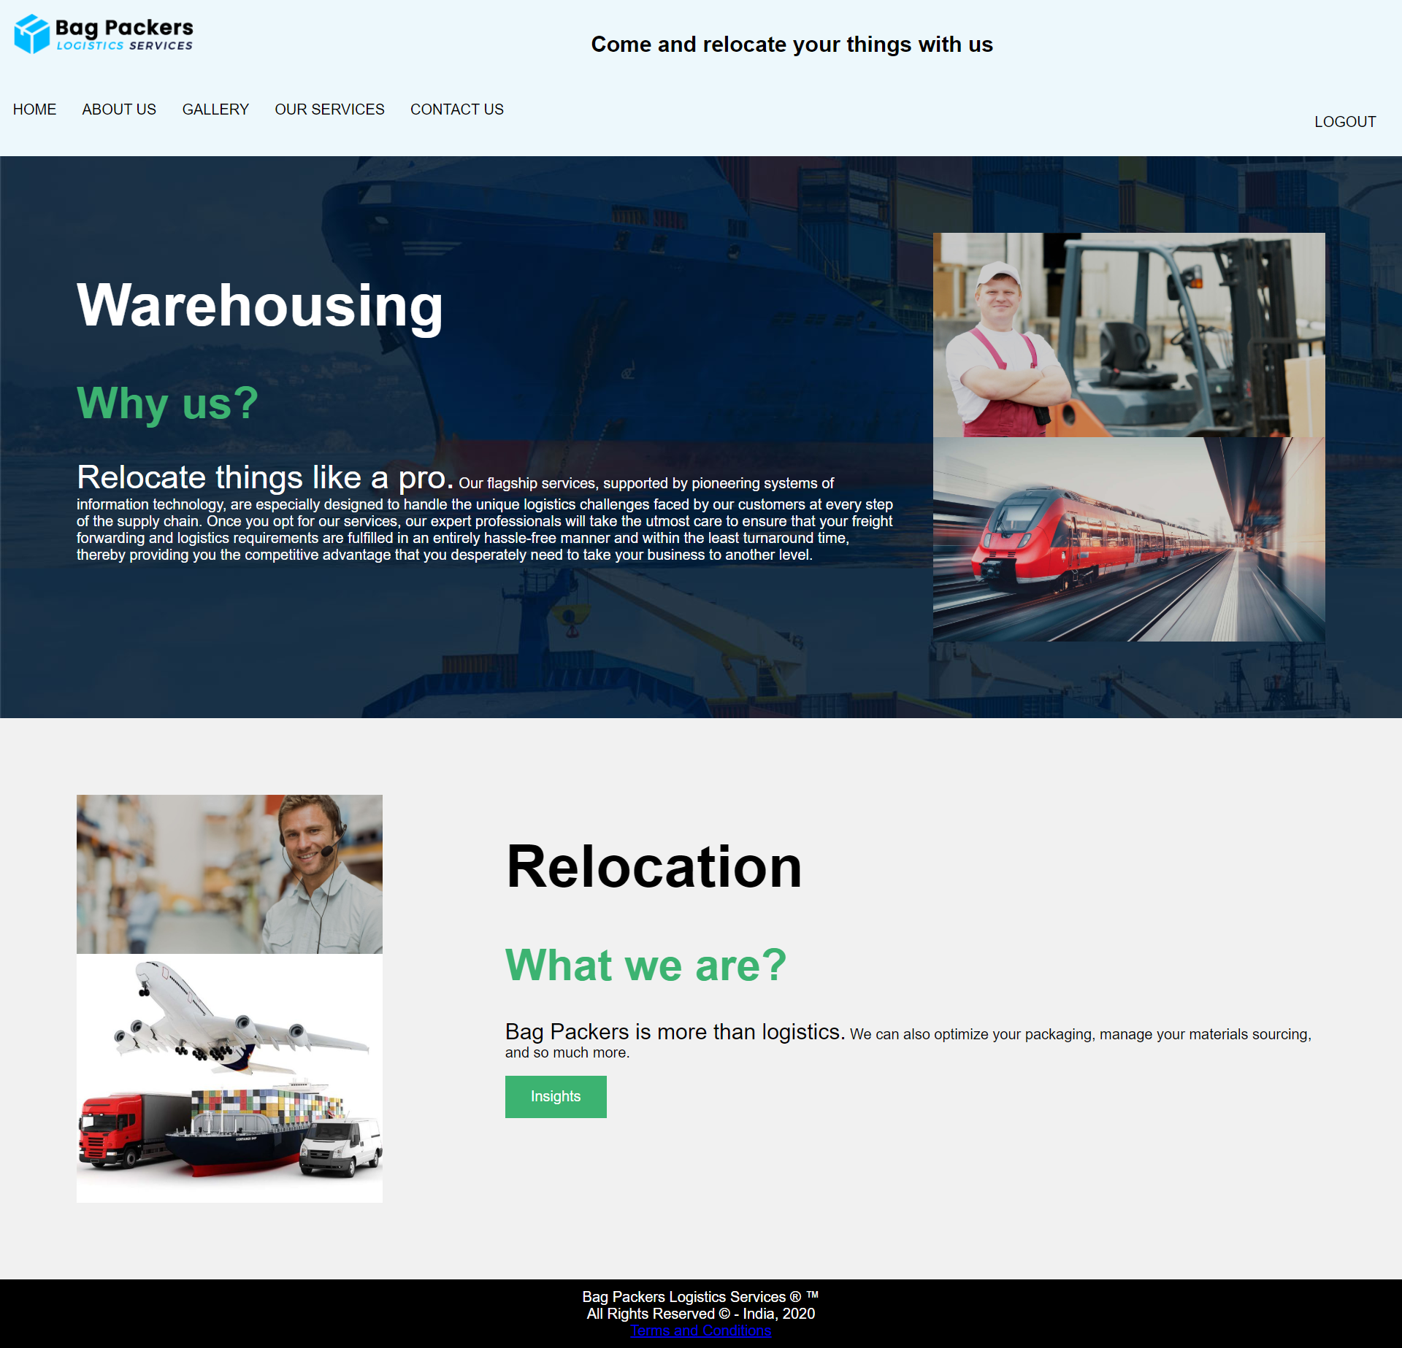

**// HTML CODE**

<!DOCTYPE html>

<html>

<head>

<meta name="viewport" content="width=device-width, initial-scale=1">

<link rel="stylesheet" type="text/css" href="home.css">

</head>

<body background="bg-box-2.jpg">

<div style="background-color:#edf8fc;padding:15px;">

<img src="navy-darkblue_dark.png" width="200" height="50" align="left"/>

<div style="text-align:center">

<h2><center>Come and relocate your things with us</center></h2>

</div></div>

<div class="navbar">

<a href="home2.html">HOME</a>

<a href="about2.html">ABOUT US</a>

<a href="gallery.html">GALLERY</a>

<div class="dropdown">

<button class="dropbtn">OUR SERVICES

<i class="fa fa-caret-down"></i>

</button>

<div class="dropdown-content">

<a href="our-services.html">SERVICES</a>

<a href="order_form.html">PRICE QUOTE</a>

<a href="parallel.html">TESTIMONIAL</a>

</div>

</div>

<a href="contact.html">CONTACT US</a>

<div class="dropdown" style="float:right">

<button class="dropbtn">

<a href="firstpage.html">LOGOUT</a></button></div>

</div>

<!-- The App Section -->

<div class="container">

<div class="row">

<div class="column-66">

<h1 class="xlarge-font"><font color="white"><b>Warehousing</b></font></h1>

<h1 class="large-font" style="color:MediumSeaGreen;"><b>Why us?</b></h1>

<p><font color="white"><span style="font-size:36px">Relocate things like a pro.</span> Our flagship services, supported by pioneering systems of information technology, are especially designed to handle the unique logistics challenges faced by our customers at every step of the supply chain. Once you opt for our services, our expert professionals will take the utmost care to ensure that your freight forwarding and logistics requirements are fulfilled in an entirely hassle-free manner and within the least turnaround time, thereby providing you the competitive advantage that you desperately need to take your business to another level.</font></p>

</div>

<div class="column-33">

<img src="slide1.jpg" width="100%" height="100%">

<img src="slide3.jpg" width="100%" height="100%">

</div>

</div>

</div>

<!-- Clarity Section -->

<div class="container" style="background-color:#f1f1f1">

<div class="row">

<div class="column-33">

<img src="slide2.jpg" alt="App" width="335" height="471">

<img src="1.jpg" alt="App" width="335" height="471">

</div>

<div class="column-66">

<h1 class="xlarge-font"><b>Relocation</b></h1>

<h1 class="large-font" style="color:MediumSeaGreen;"><b>What we are?</b></h1>

<p><span style="font-size:24px">Bag Packers is more than logistics.</span> We can also optimize your packaging, manage your materials sourcing, and so much more.</p>

<button class="button" style="background-color:MediumSeaGreen" onclick="window.location.href = 'parallel.html';">Insights</button>

</div>

</div>

</div>

<!--footer part-->

<footer>

Bag Packers Logistics Services &reg; &trade; <br>All Rights Reserved &copy; - India, 2020<br>

<a href="faq.html">Terms and Conditions</a>

</footer>

</body>

</html>

**// CSS CODE**

* {

box-sizing:border-box;

}

.navbar {

overflow: hidden;

background-color: #edf8fc;

}

.navbar a {

float: left;

font-size: 16px;

color: black;

text-align: center;

padding: 14px;

text-decoration: none;

}

.dropdown {

float: left;

overflow: hidden;

}

.dropdown .dropbtn {

font-size: 16px;

border: 0;

outline: none;

color: black;

padding: 14px;

background-color: inherit;

font-family: inherit;

margin: 0;

}

.navbar a:hover, .dropdown:hover .dropbtn {

background-color: #ddd;

}

.dropdown-content {

display: none;

position: absolute;

background-color: white;

min-width: 160px;

box-shadow: 0px 8px 16px 0px rgba(0,0,0,0.2);

z-index: 1;

}

.dropdown-content a {

float: none;

color: black;

padding: 12px 16px;

text-decoration: none;

display: block;

text-align: left;

}

.dropdown-content a:hover {

background-color: #ddd;

}

.dropdown:hover .dropdown-content {

display: block;

}

body {

margin: 0;

font-family: Arial, Helvetica, sans-serif;

}

.container {

padding: 64px;

}

.row:after {

content: "";

display: table;

clear: both

}

.column-66 {

float: left;

width: 66.66666%;

padding: 20px;

}

.column-33 {

float: left;

width: 33.33333%;

padding: 20px;

}

.large-font {

font-size: 48px;

}

.xlarge-font {

font-size: 64px

}

.button {

border: none;

color: white;

padding: 14px 28px;

font-size: 16px;

cursor: pointer;

background-color: #4CAF50;

align: center;

}

img {

display: block;

height: auto;

max-width: 100%;

}

@media screen and (max-width: 1000px) {

.column-66,

.column-33 {

width: 100%;

text-align: center;

}

img {

margin: auto;

}

}

footer{

background-color:black;

padding:10px;

color:white;

text-align:center;

}

1. **ABOUT US PAGE:**



**// HTML CODE**

<html>

<head>

<meta name="viewport" content="width=device-width, initial-scale=1">

<link rel="stylesheet" type="text/css" href="about.css">

</head>

<body background="count-bg-1.jpg">

<div style="background-color:#edf8fc;padding:15px;">

<img src="navy-darkblue_dark.png" width="200" height="50" align="left"/>

<div style="text-align:center">

<h2><center>OUR VISION</center></h2>

</div></div>

<!--menu bar-->

<div class="navbar">

<a href="home2.html">HOME</a>

<a href="about2.html">ABOUT US</a>

<a href="gallery.html">GALLERY</a>

<div class="dropdown">

<button class="dropbtn">OUR SERVICES

<i class="fa fa-caret-down"></i>

</button>

<div class="dropdown-content">

<a href="our-services.html">SERVICES</a>

<a href="order_form.html">PRICE QUOTE</a>

<a href="parallel.html">TESTIMONIAL</a>

</div>

</div>

<a href="contact.html">CONTACT US</a>

<div class="dropdown" style="float:right">

<button class="dropbtn">

<a href="firstpage.html">LOGOUT</a></button></div>

</div>

<!-- body section -->

<div class="container">

<div class="row">

<div class="column-66">

<h1 class="large-font" style="color:white;"><b>GOALS</b></h1>

<p><font color="white"><span style="font-size:20px">&quot;RISE to be an &#x20B9; 6000 crore Logistics Service Provider by 2020 (March 2021), delivering consistent customer experience in defined industry verticals through customized, Technology-driven solutions.&quot;</span><h3>Accelerating Commerce, Empowering Communities to Rise

Logistics is an invisible thread that binds everyone. People, companies, countries can specialise in what they are good at and reach the world through us. In every parcel, we move and in every trip we make, each of us strives to make a difference. This brings in prosperity for everyone. We accelerate the wheel of the economy. and we do more than this. We transform the lives we touch. Whether it's our business partners, drive, their families or communities at large, we spread smiles with every mile.</h3></font></p>

<img src="blog-8.jpg" width="100%" height="100%">

</div>

<div class="column-33">

<img src="5.jpg" width="100%" height="100%">

<img src="2.jpg" width="100%" height="100%">

</div>

</div>

</div>

<!-- purpose principles -->

<div class="container" style="background-color:#f1f1f1">

<div class="row">

<div class="column-33">

<img src="4.jpg" alt="App" width="335" height="471">

<img src="7.jpg" alt="App" width="335" height="471">

</div>

<div class="column-66">

<h1 class="large-font"><b>OUR PURPOSE PRINCIPLES</b></h1>

<p><span style="font-size:24px">Bag Packers is more than logistics.</span> </p><p>We can also optimize your packaging, manage your materials sourcing, and so much more.</p>

<br> 1. Shaping Industry

<br> 2. Transforming lives

<br> 3. Reimagining Solutions

<br> 4. Earning Trust

<br> 5. Sustaining Our Environment

<br> <h1 class="large-font" style="color:MediumSeaGreen;"><b>Get A Quote</b></h1>

<button class="button" style="background-color:MediumSeaGreen" onclick="window.location.href = 'order_form.html';">Price Quotes</button>

</div>

</div>

</div>

<!--footer part-->

<footer>

Bag Packers Logistics Services &reg; &trade; <br>All Rights Reserved &copy; - India, 2020<br>

<a href="faq.html">Terms and Conditions</a>

</footer>

</body>

</html>

**// CSS CODE**

* {

box-sizing:border-box;

}

.navbar {

overflow: hidden;

background-color: #edf8fc;

}

.navbar a {

float: left;

font-size: 16px;

color: black;

text-align: center;

padding: 14px;

text-decoration: none;

}

.dropdown {

float: left;

overflow: hidden;

}

.dropdown .dropbtn {

font-size: 16px;

border: 0;

outline: none;

color: black;

padding: 14px;

background-color: inherit;

font-family: inherit;

margin: 0;

}

.navbar a:hover, .dropdown:hover .dropbtn {

background-color: #ddd;

}

.dropdown-content {

display: none;

position: absolute;

background-color: white;

min-width: 160px;

box-shadow: 0px 8px 16px 0px rgba(0,0,0,0.2);

z-index: 1;

}

.dropdown-content a {

float: none;

color: black;

padding: 12px 16px;

text-decoration: none;

display: block;

text-align: left;

}

.dropdown-content a:hover {

background-color: #ddd;

}

.dropdown:hover .dropdown-content {

display: block;

}

body {

margin: 0;

font-family: Arial, Helvetica, sans-serif;

}

.container {

padding: 64px;

}

.row:after {

content: "";

display: table;

clear: both

}

.column-66 {

float: left;

width: 66.66666%;

padding: 20px;

}

.column-33 {

float: left;

width: 33.33333%;

padding: 20px;

}

.large-font {

font-size: 48px;

}

.xlarge-font {

font-size: 64px

}

.button {

border: none;

color: white;

padding: 14px 28px;

font-size: 16px;

cursor: pointer;

background-color: #4CAF50;

}

img {

display: block;

height: auto;

max-width: 100%;

}

@media screen and (max-width: 1000px) {

.column-66,

.column-33 {

width: 100%;

text-align: center;

}

img {

margin: auto;

}

}

footer{

background-color:black;

padding:10px;

color:white;

text-align:center;

}

1. **GALLERY PAGE:**



**// HTML CODE**

<html>

<head>

<meta name="viewport" content="width=device-width, initial-scale=1">

<link rel="stylesheet" type="text/css" href="gallery.css">

</head>

<body bgcolor="#edf8fc">

<img src="navy-darkblue_dark.png" width="200" height="50" align="left"/>

<!-- Header -->

<div class="header">

<h2>GALLERY VIEW</h2>

</div>

<div class="navbar">

<a href="home2.html">HOME</a>

<a href="about2.html">ABOUT US</a>

<a href="gallery.html">GALLERY</a>

<div class="dropdown">

<button class="dropbtn">OUR SERVICES

<i class="fa fa-caret-down"></i>

</button>

<div class="dropdown-content">

<a href="our-services.html">SERVICES</a>

<a href="order_form.html">PRICE QUOTE</a>

<a href="parallel.html">TESTIMONIAL</a>

</div>

</div>

<a href="contact.html">CONTACT US</a>

<div class="dropdown" style="float:right">

<button class="dropbtn">

<a href="firstpage.html">LOGOUT</a></button></div>

</div>

<!-- Photo Grid -->

<div class="row">

<div class="column">

<img src="1.jpg" style="width:100%">

<img src="blog-1.jpg" style="width:100%">

<img src="blog-2.jpg" style="width:100%">

<img src="blog-3.jpg" style="width:100%">

<img src="blog-4.jpg" style="width:100%">

<img src="blog-6.jpg" style="width:100%">

<img src="blog-7.jpg" style="width:100%">

</div>

<div class="column">

<img src="blog-8.jpg" style="width:100%">

<img src="bg-4.jpg" style="width:100%">

<img src="count-bg-1.jpg" style="width:100%">

<img src="slide2-3.jpg" style="width:100%">

<img src="slide1.jpg" style="width:100%">

<img src="slide2.jpg" style="width:100%">

<img src="2.jpg" style="width:100%">

</div>

<div class="column">

<img src="slide2-1.jpg" style="width:100%">

<img src="slide1-4.jpg" style="width:100%">

<img src="slide3.jpg" style="width:100%">

<img src="slide3-1.jpg" style="width:100%">

<img src="5.jpg" style="width:100%">

<img src="6.jpg" style="width:100%">

<img src="testi-2.jpg" style="width:100%">

</div>

<div class="column">

<img src="testi-3.jpg" style="width:100%">

<img src="slide3-2.jpg" style="width:100%">

<img src="slide3-4.jpg" style="width:100%">

<img src="slide3-3.jpg" style="width:100%">

<img src="slide2-2.jpg" style="width:100%">

<img src="slide2-4.jpg" style="width:100%">

<img src="4.jpg" style="width:100%">

</div>

</div>

<!--footer part-->

<footer>

Bag Packers Logistics Services &reg; &trade; <br>All Rights Reserved &copy; - India, 2020<br>

<a href="faq.html">Terms and Conditions</a>

</footer>

</body>

</html>

**// CSS CODE**

* {

box-sizing: border-box;

}

body {

margin: 0;

font-family: Arial;

}

.navbar {

overflow: hidden;

background-color: #edf8fc;

}

.navbar a {

float: left;

font-size: 16px;

color: black;

text-align: center;

padding: 14px;

text-decoration: none;

}

.dropdown {

float: left;

overflow: hidden;

}

.dropdown .dropbtn {

font-size: 16px;

border: 0;

outline: none;

color: black;

padding: 14px;

background-color: inherit;

font-family: inherit;

margin: 0;

}

.navbar a:hover, .dropdown:hover .dropbtn {

background-color: #ddd;

}

.dropdown-content {

display: none;

position: absolute;

background-color: white;

min-width: 160px;

box-shadow: 0px 8px 16px 0px rgba(0,0,0,0.2);

z-index: 1;

}

.dropdown-content a {

float: none;

color: black;

padding: 12px 16px;

text-decoration: none;

display: block;

text-align: left;

}

.dropdown-content a:hover {

background-color: #ddd;

}

.dropdown:hover .dropdown-content {

display: block;

}

.header {

text-align: center;

padding: 32px;

}

.row {

display: -ms-flexbox; /* IE10 */

display: flex;

-ms-flex-wrap: wrap; /* IE10 */

flex-wrap: wrap;

padding: 0 4px;

}

/* Create four equal columns that sits next to each other */

.column {

-ms-flex: 25%; /* IE10 */

flex: 25%;

max-width: 25%;

padding: 0 4px;

}

.column img {

margin-top: 8px;

vertical-align: middle;

width: 100%;

transition: transform .5s;

}

.column img:hover

{

transform: scale(1.1);

}

/* Responsive layout - makes a two column-layout instead of four columns */

@media screen and (max-width: 800px) {

.column {

-ms-flex: 50%;

flex: 50%;

max-width: 50%;

}

}

/* Responsive layout - makes the two columns stack on top of each other instead of next to each other */

@media screen and (max-width: 600px) {

.column {

-ms-flex: 100%;

flex: 100%;

max-width: 100%;

}

}

footer{

background-color:black;

padding:10px;

color:white;

text-align:center;

}

1. **OUR SERVICES PAGE:**
2. **SERVICES PAGE:**

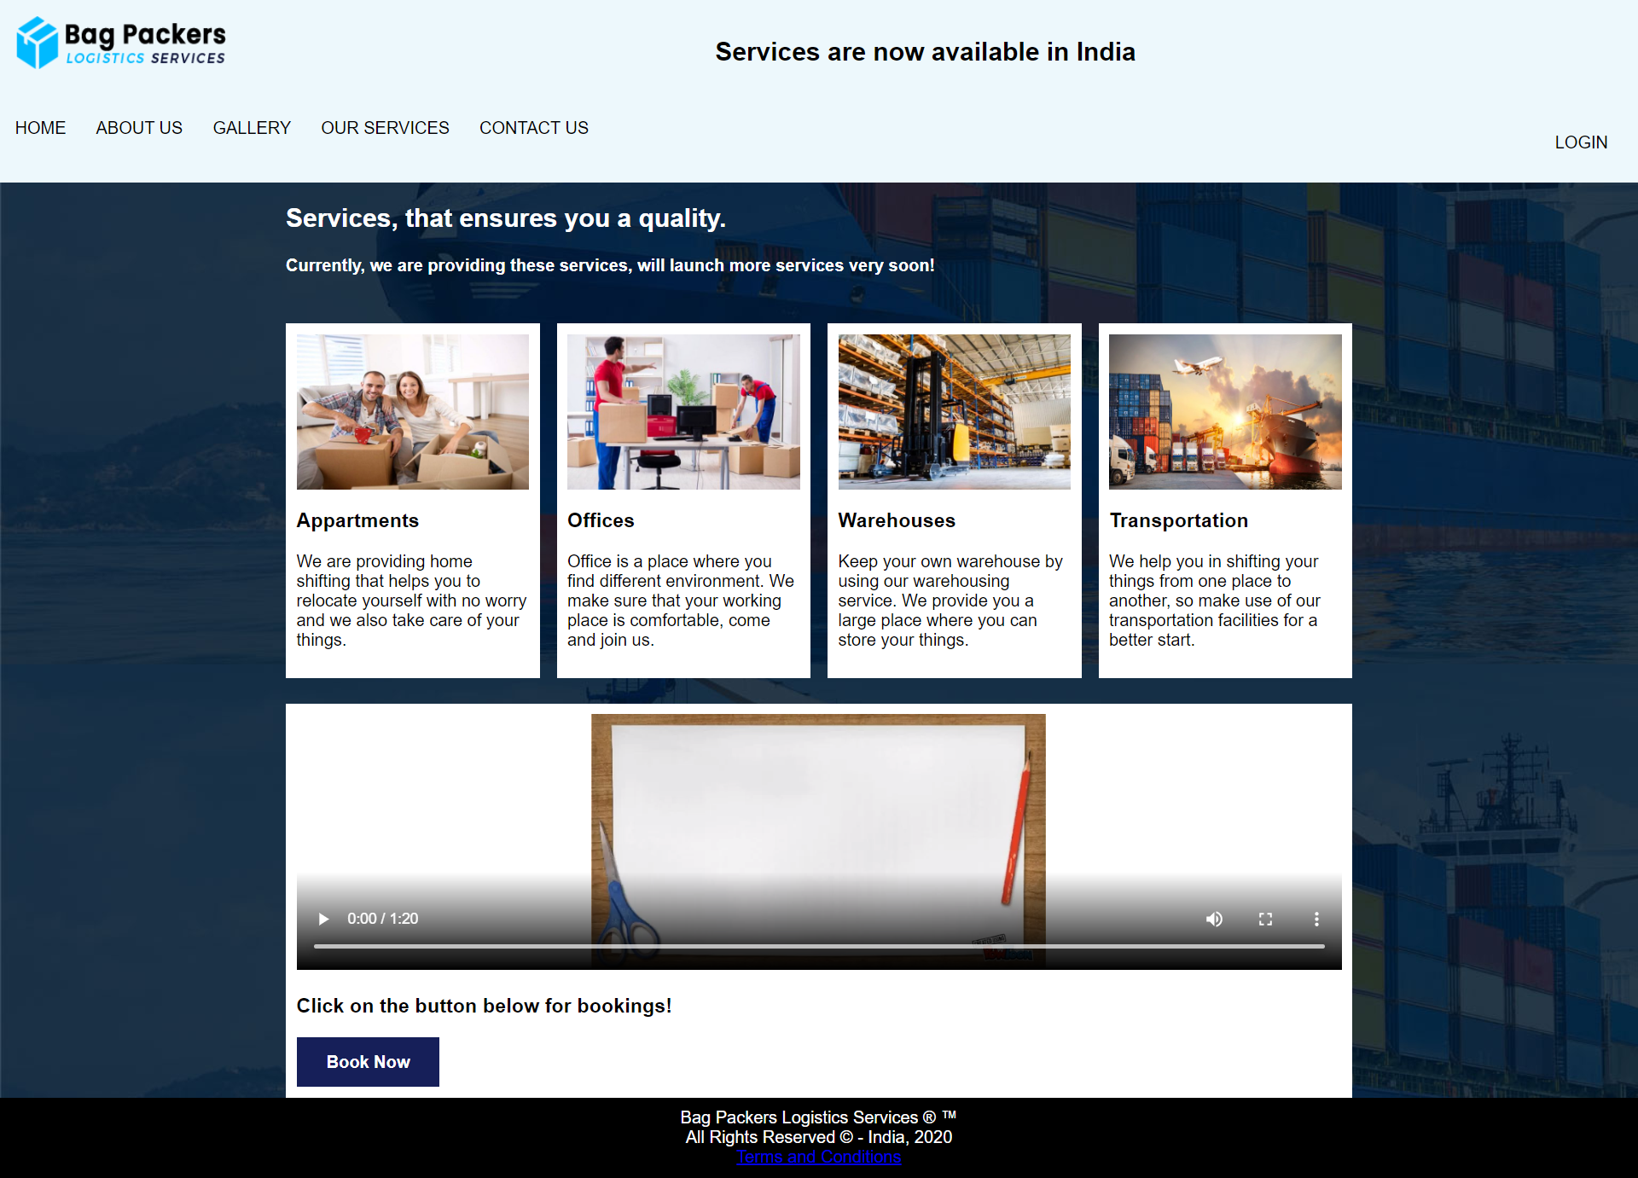

**// HTML CODE**

<!DOCTYPE html>

<html>

<head>

<meta name="viewport" content="width=device-width, initial-scale=1">

<link rel="stylesheet" type="text/css" href="services.css">

</head>

<body background="bg-box-2.jpg">

<div style="background-color:#edf8fc;padding:15px;">

<img src="navy-darkblue_dark.png" width="200" height="50" align="left"/>

<div style="text-align:center">

<h2><center>Services are now available in India</center></h2>

</div></div>

<!--menu bar-->

<div class="navbar">

<a href="home2.html">HOME</a>

<a href="about2.html">ABOUT US</a>

<a href="gallery.html">GALLERY</a>

<div class="dropdown">

<button class="dropbtn">OUR SERVICES

<i class="fa fa-caret-down"></i>

</button>

<div class="dropdown-content">

<a href="our-services.html">SERVICES</a>

<a href="order_form.html">PRICE QUOTE</a>

<a href="parallel.html">TESTIMONIAL</a>

</div>

</div>

<a href="contact.html">CONTACT US</a>

<div class="dropdown" style="float:right">

<button class="dropbtn">

<a href="login.html">LOGIN</a></button></div>

</div>

<!-- MAIN (Center website) -->

<div class="main">

<font color="white"><h2>Services, that ensures you a quality.</h2>

<h4>Currently, we are providing these services, will launch more services very soon!</h4></font>

<!-- Portfolio Gallery Grid -->

<div class="row">

<div class="column">

<div class="content">

<img src="resize-2.jpeg" alt="Appartments" style="width:100%">

<h3>Appartments</h3>

<p>We are providing home shifting that helps you to relocate yourself with no worry and we also take care of your things.</p>

</div>

</div>

<div class="column">

<div class="content">

<img src="resize-1.jpg" alt="Offices" style="width:100%">

<h3>Offices</h3>

<p>Office is a place where you find different environment. We make sure that your working place is comfortable, come and join us.</p>

</div>

</div>

<div class="column">

<div class="content">

<img src="resize-3.jpg" alt="Warehouse" style="width:100%">

<h3>Warehouses</h3>

<p>Keep your own warehouse by using our warehousing service. We provide you a large place where you can store your things.</p>

</div>

</div>

<div class="column">

<div class="content">

<img src="resize-4.jpg" alt="Transportation" style="width:100%">

<h3>Transportation</h3>

<p>We help you in shifting your things from one place to another, so make use of our transportation facilities for a better start.</p>

</div>

</div>

<!-- END GRID -->

</div>

<div class="content">

<video width="100%" height="240" controls>

<source src="video1.mp4" type="video/mp4">

</video>

<h3>Click on the button below for bookings!</h3>

<button class="button" style="background-color:#161f59" onclick="window.location.href = 'booking.html';"><b>Book Now</b></button>

</div>

<!-- END MAIN -->

</div>

<!--footer part-->

<footer>

Bag Packers Logistics Services &reg; &trade; <br>All Rights Reserved &copy; - India, 2020<br>

<a href="faq.html">Terms and Conditions</a>

</footer>

</body>

</html>

**// CSS CODE**

* {

box-sizing:border-box;

}

.navbar {

overflow: hidden;

background-color: #edf8fc;

}

.navbar a {

float: left;

font-size: 16px;

color: black;

text-align: center;

padding: 14px;

text-decoration: none;

}

.dropdown {

float: left;

overflow: hidden;

}

.dropdown .dropbtn {

font-size: 16px;

border: 0;

outline: none;

color: black;

padding: 14px;

background-color: inherit;

font-family: inherit;

margin: 0;

}

.navbar a:hover, .dropdown:hover .dropbtn {

background-color: #ddd;

}

.dropdown-content {

display: none;

position: absolute;

background-color: white;

min-width: 160px;

box-shadow: 0px 8px 16px 0px rgba(0,0,0,0.2);

z-index: 1;

}

.dropdown-content a {

float: none;

color: black;

padding: 12px 16px;

text-decoration: none;

display: block;

text-align: left;

}

.dropdown-content a:hover {

background-color: #ddd;

}

.dropdown:hover .dropdown-content {

display: block;

}

body {

margin: 0;

font-family: Arial, Helvetica, sans-serif;

}

img {

display: block;

}

.button {

border: none;

color: white;

padding: 14px 28px;

font-size: 16px;

cursor: pointer;

background-color: #4CAF50;

}

@media screen and (max-width: 1000px) {

.column-66,

.column-33 {

width: 100%;

text-align: center;

}

img {

margin: auto;

}

}

footer{

background-color:black;

padding:10px;

color:white;

text-align:center;

}

/* Center website */

.main {

max-width: 1000px;

margin: auto;

}

h1 {

font-size: 50px;

word-break: break-all;

}

.row {

margin: 8px -16px;

}

/* Add padding BETWEEN each column */

.row,

.row > .column {

padding: 8px;

}

/* Create four equal columns that floats next to each other */

.column {

float: left;

width: 25%;

margin-top: 8px;

vertical-align: middle;

transition: transform .5s;

}

/* Clear floats after rows */

.row:after {

content: "";

display: table;

clear: both;

}

.column:hover

{

transform: scale(1.1);

}

/* Content */

.content {

background-color: white;

padding: 10px;

}

/* Responsive layout - makes a two column-layout instead of four columns */

@media screen and (max-width: 900px) {

.column {

width: 50%;

}

}

/* Responsive layout - makes the two columns stack on top of each other instead of next to each other */

@media screen and (max-width: 600px) {

.column {

width: 100%;

}

}

1. **BOOKING FORM:**

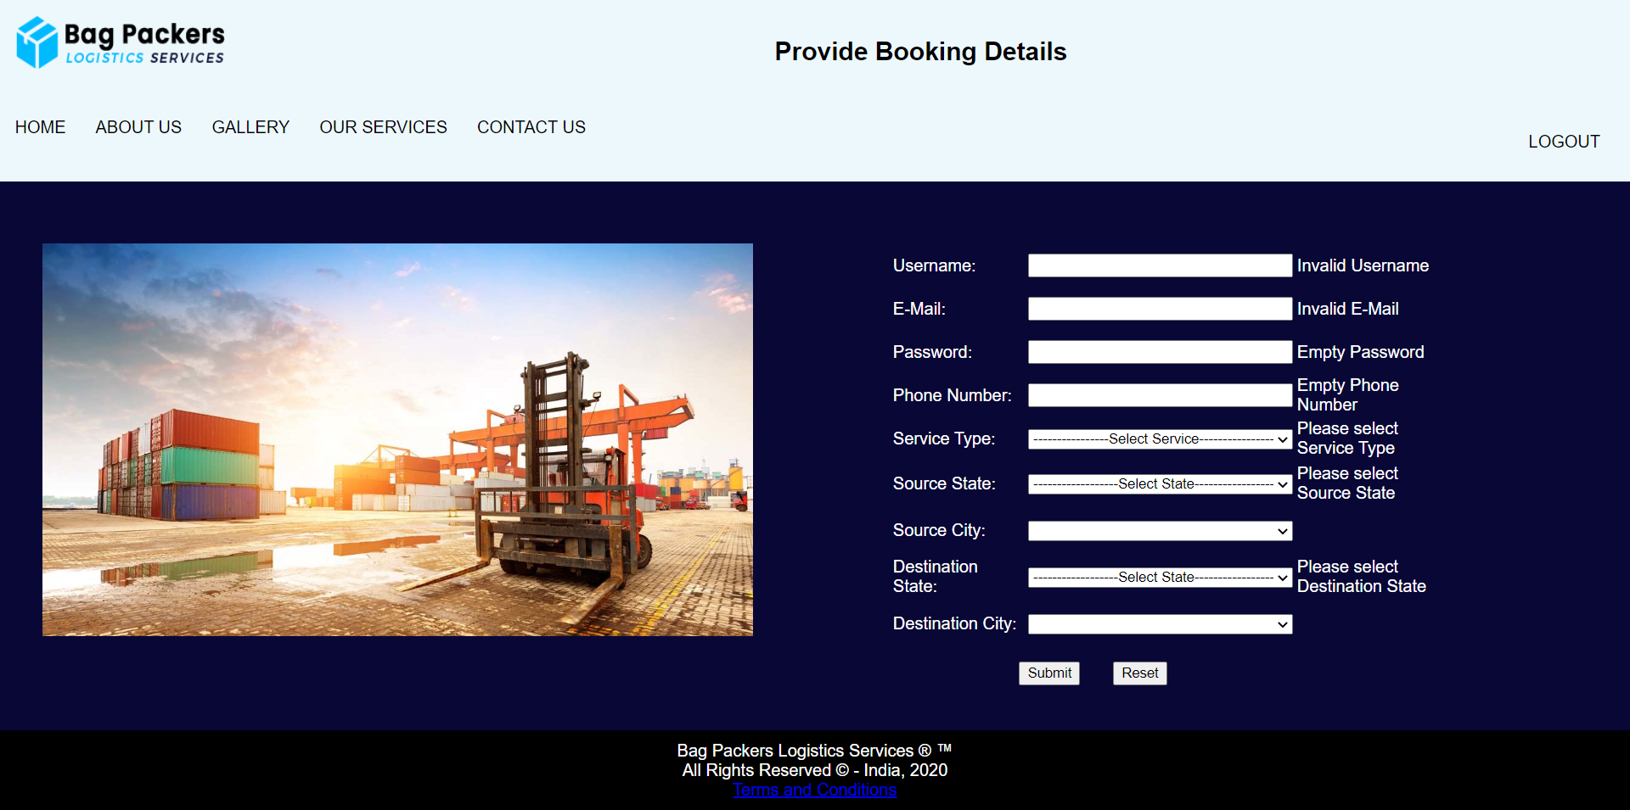

**// HTML CODE**

<!DOCTYPE html>

<html>

<head>

<meta charset="utf-8">

<link rel="stylesheet" type="text/css" href="booking.css">

<script src="booking.js"></script>

</head>

<!--header part-->

<body>

<div style="background-color:#edf8fc;padding:15px;">

<img src="navy-darkblue_dark.png" width="200" height="50" align="left"/>

<div style="text-align:center">

<h2><center>Provide Booking Details</center></h2>

</div></div>

<div class="navbar">

<a href="home2.html">HOME</a>

<a href="about2.html">ABOUT US</a>

<a href="gallery.html">GALLERY</a>

<div class="dropdown">

<button class="dropbtn">OUR SERVICES

<i class="fa fa-caret-down"></i>

</button>

<div class="dropdown-content">

<a href="our-services.html">SERVICES</a>

<a href="order_form.html">PRICE QUOTE</a>

<a href="parallel.html">TESTIMONIAL</a>

</div>

</div>

<a href="contact.html">CONTACT US</a>

<div class="dropdown" style="float:right">

<button class="dropbtn">

<a href="firstpage.html">LOGOUT</a></button>

</div>

</div>

<div class="container">

<br>

<div style="float:left; width:46%">

<img src="blog-3.jpg" height="100%" width="100%">

</div>

<table width="528" border="0" align="center">

<tbody>

<tr>

<td width="167" height="39" >Username:</td>

<td width="146"><input type="text" name="textfield" id="username" onBlur=""></td>

<td width="201"><span id="error_uname"></span></td>

</tr>

<tr>

<td height="39"> E-Mail:</td>

<td><input type="text" name="textfield3" id="email"></td>

<td width="201"><span id="error_mail"></span></td>

</tr>

<tr>

<td height="39">Password:</td>

<td><input type="password" name="password" id="password"></td>

<td width="201"><span id="error_pass"></span></td>

</tr>

<tr>

<td height="39">Phone Number:</td>

<td><input type="text" name="textfield4" id="phonenumber" maxlength="10"></td>

<td width="201"><span id="error_phone"></span></td>

</tr>

<tr>

<td height="39">Service Type:</td>

<td><select id="service" style="width:100%">

<option>----------------Select Service----------------</option>

<option>Appartments</option>

<option>Offices</option>

<option>Warehouses</option>

<option>Transportation</option>

</select></td>

<td width="201"><span id="error_service"></span></td>

</tr>

<tr>

<td height="42"> Source State:</td>

<td><select style="width:100%" onchange="print_city('state1', this.selectedIndex);" id="sts1" name ="stt" class="form-control"></select>

</td>

<td width="201"><span id="error_state1"></span></td>

</tr>

<tr>

<td height="42"> Source City:</td>

<td><select style="width:100%" onchange="print_state('city', this.selctedIndex);"id="state1" name="state" class="form-control">

</select></td>

<td width="201"><span id="error_city1"></span></td>

</tr>

<tr>

<td height="42"> Destination State:</td>

<td><select style="width:100%" onchange="print_city('state2', this.selectedIndex);" id="sts2" name ="stt" class="form-control"></select>

</td>

<td width="201"><span id="error_state2"></span></td>

</tr>

<tr>

<td height="42"> Destination City:</td>

<td><select style="width:100%" onchange="print_state('city', this.selctedIndex);"id="state2" name="state" class="form-control">

</select></td>

<td width="201"><span id="error_city2"></span></td>

</tr>

<tr>

<td height="10"></td>

<td></td>

</tr>

<tr>

<td colspan="2">

<div align="center">

<input type="submit" name="submit" id="submit" value="Submit" onClick="validateBooking();">

&nbsp;&nbsp;&nbsp;&nbsp;&nbsp;

<input type="reset" name="reset" id="reset" value="Reset" onclick="window.location.href = 'booking.html'">

</div>

</td>

<td></td>

</tr>

</tbody>

<script language="javascript"></script>

</table>

</div>

<footer>

Bag Packers Logistics Services &reg; &trade; <br>All Rights Reserved &copy; - India, 2020<br>

<a href="faq.html">Terms and Conditions</a>

</footer>

</body>

<script>

print_state("sts1");

print_state("sts2");

function isEmpty(str){

str = str.trim()

if(str==undefined || str=="" || str.length==0)

return true;

else

return false;

}

function isNumber(str){

var pattern = new RegExp("^[0-9]+$")

return pattern.test(str);

}

function validateBooking() {

validationSuccessful = true;

var uname = document.getElementById('username');

var mail = document.getElementById('email');

var pass = document.getElementById('password');

var phone = document.getElementById('phonenumber');

var service = document.getElementById('service');

/*Regex Code*/

var filter_name = /^[a-zA-Z]+$/;

var filter_mail = /^(([^<>()[\]\\.,;:\s@\"]+(\.[^<>()[\]\\.,;:\s@\"]+)*)|(\".+\"))@((\[[0-9]{1,3}\.[0-9]{1,3}\.[0-9]{1,3}\.[0-9]{1,3}\])|(([a-zA-Z\-0-9]+\.)+[a-zA-Z]{2,}))$/;

var filter_zipcode = /^[0-9]{6}$/;

/*Conditions*/

if (filter_name.test(uname.value)) {

document.getElementById('error_uname').innerHTML = '';

} else {

validationSuccessful = false;

document.getElementById('error_uname').innerHTML = '<span>Invalid Username</span>';

}

if (filter_mail.test(mail.value)) {

document.getElementById('error_mail').innerHTML = '';

} else {

validationSuccessful = false;

document.getElementById('error_mail').innerHTML = '<span>Invalid E-Mail</span>';

}

if (!isEmpty(pass.value)) {

document.getElementById('error_pass').innerHTML = '';

if(pass.value.length>=6){

document.getElementById('error_pass').innerHTML = '';

}

else{

validationSuccessful = false;

document.getElementById('error_pass').innerHTML = '<span>Should contain minimum 6 chars</span>';

}

} else {

validationSuccessful = false;

document.getElementById('error_pass').innerHTML = '<span>Empty Password</span>';

}

if (!isEmpty(phone.value)) {

document.getElementById('error_phone').innerHTML = '';

if((isNumber(phone.value)) && (phone.value.length==10)){

document.getElementById('error_phone').innerHTML = '';

}

else{

validationSuccessful = false;

document.getElementById('error_phone').innerHTML = '<span>Invalid 10-digit Mobile Number</span>';

}

} else {

validationSuccessful = false;

document.getElementById('error_phone').innerHTML = '<span>Empty Phone Number</span>';

}

if (sts1.selectedIndex == 0) {

validationSuccessful = false;

document.getElementById('error_state1').innerHTML = '<span>Please select Source State</span>';

} else {

document.getElementById('error_state1').innerHTML = '';

}

if (state1.selectedIndex == 0) {

validationSuccessful = false;

document.getElementById('error_city1').innerHTML = '<span>Please select Source City</span>';

} else {

document.getElementById('error_city1').innerHTML = '';

}

if (sts2.selectedIndex == 0) {

validationSuccessful = false;

document.getElementById('error_state2').innerHTML = '<span>Please select Destination State</span>';

} else {

document.getElementById('error_state2').innerHTML = '';

}

if (state2.selectedIndex == 0) {

validationSuccessful = false;

document.getElementById('error_city2').innerHTML = '<span>Please select Destination City</span>';

} else {

document.getElementById('error_city2').innerHTML = '';

}

if (service.selectedIndex == 0) {

validationSuccessful = false;

document.getElementById('error_service').innerHTML = '<span>Please select Service Type</span>';

} else {

document.getElementById('error_service').innerHTML = '';

}

if(validationSuccessful){

alert('Your booking is confirmed and our team will contact you soon!');

window.location.href = 'booking.html';

}

}

</script>

</html>

**// CSS CODE**

body{

margin: 0;

font-family: Arial, Helvetica, sans-serif;

}

.navbar {

overflow: hidden;

background-color: #edf8fc;

}

.navbar a {

float: left;

font-size: 16px;

color: black;

text-align: center;

padding: 14px;

text-decoration: none;

}

.dropdown {

float: left;

overflow: hidden;

}

.dropdown .dropbtn {

font-size: 16px;

border: 0;

outline: none;

color: black;

padding: 14px;

background-color: inherit;

font-family: inherit;

margin: 0;

}

.navbar a:hover, .dropdown:hover .dropbtn {

background-color: #ddd;

}

.dropdown-content {

display: none;

position: absolute;

background-color: white;

min-width: 160px;

box-shadow: 0px 8px 16px 0px rgba(0,0,0,0.2);

z-index: 1;

}

.dropdown-content a {

float: none;

color: black;

padding: 12px 16px;

text-decoration: none;

display: block;

text-align: left;

}

.dropdown-content a:hover {

background-color: #ddd;

}

.dropdown:hover .dropdown-content {

display: block;

}

*,:after,:before{box-sizing:border-box}

.clearfix:after,.clearfix:before{content:'';display:table}

.clearfix:after{clear:both;display:block}

.login-wrap{

width:100%;

margin:auto;

max-width:525px;

min-height:670px;

position:relative;

box-shadow:0 12px 15px 0 rgba(0,0,0,.24),0 17px 50px 0 rgba(0,0,0,.19);

}

.login-html{

width:100%;

height:100%;

position:absolute;

padding:90px 70px 50px 70px;

background:rgba(40,57,101,.9);

}

.login-html .sign-in-htm,

.login-html .sign-up-htm{

top:0;

left:0;

right:0;

bottom:0;

position:absolute;

transform:rotateY(180deg);

backface-visibility:hidden;

transition:all .4s linear;

}

.login-html .sign-in,

.login-html .sign-up,

.login-form .group .check{

display:none;

}

.login-html .tab,

.login-form .group .label,

.login-form .group .button{

text-transform:uppercase;

}

.login-html .tab{

font-size:22px;

margin-right:15px;

padding-bottom:5px;

margin:0 15px 10px 0;

display:inline-block;

border-bottom:2px solid transparent;

}

.login-html .sign-in:checked + .tab,

.login-html .sign-up:checked + .tab{

color:#fff;

border-color:#1161ee;

}

.login-form{

min-height:345px;

position:relative;

perspective:1000px;

transform-style:preserve-3d;

}

.login-form .group{

margin-bottom:15px;

}

.login-form .group .label,

.login-form .group .input,

.login-form .group .button{

width:100%;

color:#fff;

display:block;

}

.login-form .group .input,

.login-form .group .button{

border:none;

padding:15px 20px;

border-radius:25px;

background:rgba(255,255,255,.1);

}

.login-form .group input[data-type="password"]{

text-security:circle;

-webkit-text-security:circle;

}

.login-form .group .label{

color:#aaa;

font-size:12px;

}

.login-form .group .button{

background:#1161ee;

}

.login-form .group label .icon{

width:15px;

height:15px;

border-radius:2px;

position:relative;

display:inline-block;

background:rgba(255,255,255,.1);

}

.login-form .group label .icon:before,

.login-form .group label .icon:after{

content:'';

width:10px;

height:2px;

background:#fff;

position:absolute;

transition:all .2s ease-in-out 0s;

}

.login-form .group label .icon:before{

left:3px;

width:5px;

bottom:6px;

transform:scale(0) rotate(0);

}

.login-form .group label .icon:after{

top:6px;

right:0;

transform:scale(0) rotate(0);

}

.login-form .group .check:checked + label{

color:#fff;

}

.login-form .group .check:checked + label .icon{

background:#1161ee;

}

.login-form .group .check:checked + label .icon:before{

transform:scale(1) rotate(45deg);

}

.login-form .group .check:checked + label .icon:after{

transform:scale(1) rotate(-45deg);

}

.login-html .sign-in:checked + .tab + .sign-up + .tab + .login-form .sign-in-htm{

transform:rotate(0);

}

.login-html .sign-up:checked + .tab + .login-form .sign-up-htm{

transform:rotate(0);

}

.hr{

height:2px;

margin:60px 0 50px 0;

background:rgba(255,255,255,.2);

}

.foot-lnk{

text-align:center;

}

input[type=text]

{

width:250px;

}

input[type=password]

{

width:250px;

}

footer{

background-color:black;

padding:10px;

color:white;

text-align:center;

}

span

{

color: white;

}

* {

box-sizing: border-box;

}

.container {

border-radius: 0;

background-color: #090736;

color:white;

padding: 40px;

}

.column-33 {

float: left;

width: 33.33333%;

height: 45%;

padding: 20px;

}

**// JAVASCRIPT CODE**

var state_arr = new Array("Andaman & Nicobar", "Andhra Pradesh", "Arunachal Pradesh", "Assam", "Bihar", "Chandigarh", "Chhattisgarh", "Dadra & Nagar Haveli", "Daman & Diu", "Delhi", "Goa", "Gujarat", "Haryana", "Himachal Pradesh", "Jammu & Kashmir", "Jharkhand", "Karnataka", "Kerala", "Lakshadweep", "Madhya Pradesh", "Maharashtra", "Manipur", "Meghalaya", "Mizoram", "Nagaland", "Orissa", "Pondicherry", "Punjab", "Rajasthan", "Sikkim", "Tamil Nadu", "Tripura", "Uttar Pradesh", "Uttaranchal", "West Bengal");

var s_a = new Array();

s_a[0]="";

s_a[1]=" Alipur | Andaman Island | Anderson Island | Arainj-Laka-Punga | Austinabad | Bamboo Flat | Barren Island | Beadonabad | Betapur | Bindraban | Bonington | Brookesabad | Cadell Point | Calicut | Chetamale | Cinque Islands | Defence Island | Digilpur | Dolyganj | Flat Island | Geinyale | Great Coco Island | Haddo | Havelock Island | Henry Lawrence Island | Herbertabad | Hobdaypur | Ilichar | Ingoie | Inteview Island | Jangli Ghat | Jhon Lawrence Island | Karen | Kartara | KYD Islannd | Landfall Island | Little Andmand | Little Coco Island | Long Island | Maimyo | Malappuram | Manglutan | Manpur | Mitha Khari | Neill Island | Nicobar Island | North Brother Island | North Passage Island | North Sentinel Island | Nothen Reef Island | Outram Island | Pahlagaon | Palalankwe | Passage Island | Phaiapong | Phoenix Island | Port Blair | Preparis Island | Protheroepur | Rangachang | Rongat | Rutland Island | Sabari | Saddle Peak | Shadipur | Smith Island | Sound Island | South Sentinel Island | Spike Island | Tarmugli Island | Taylerabad | Titaije | Toibalawe | Tusonabad | West Island | Wimberleyganj | Yadita";

s_a[2]=" Achampet | Adilabad | Adoni | Alampur | Allagadda | Alur | Amalapuram | Amangallu | Anakapalle | Anantapur | Andole | Araku | Armoor | Asifabad | Aswaraopet | Atmakur | B. Kothakota | Badvel | Banaganapalle | Bandar | Bangarupalem | Banswada | Bapatla | Bellampalli | Bhadrachalam | Bhainsa | Bheemunipatnam | Bhimadole | Bhimavaram | Bhongir | Bhooragamphad | Boath | Bobbili | Bodhan | Chandoor | Chavitidibbalu | Chejerla | Chepurupalli | Cherial | Chevella | Chinnor | Chintalapudi | Chintapalle | Chirala | Chittoor | Chodavaram | Cuddapah | Cumbum | Darsi | Devarakonda | Dharmavaram | Dichpalli | Divi | Donakonda | Dronachalam | East Godavari | Eluru | Eturnagaram | Gadwal | Gajapathinagaram | Gajwel | Garladinne | Giddalur | Godavari | Gooty | Gudivada | Gudur | Guntur | Hindupur | Hunsabad | Huzurabad | Huzurnagar | Hyderabad | Ibrahimpatnam | Jaggayyapet | Jagtial | Jammalamadugu | Jangaon | Jangareddygudem | Jannaram | Kadiri | Kaikaluru | Kakinada | Kalwakurthy | Kalyandurg | Kamalapuram | Kamareddy | Kambadur | Kanaganapalle | Kandukuru | Kanigiri | Karimnagar | Kavali | Khammam | Khanapur (AP) | Kodangal | Koduru | Koilkuntla | Kollapur | Kothagudem | Kovvur | Krishna | Krosuru | Kuppam | Kurnool | Lakkireddipalli | Madakasira | Madanapalli | Madhira | Madnur | Mahabubabad | Mahabubnagar | Mahadevapur | Makthal | Mancherial | Mandapeta | Mangalagiri | Manthani | Markapur | Marturu | Medachal | Medak | Medarmetla | Metpalli | Mriyalguda | Mulug | Mylavaram | Nagarkurnool | Nalgonda | Nallacheruvu | Nampalle | Nandigama | Nandikotkur | Nandyal | Narasampet | Narasaraopet | Narayanakhed | Narayanpet | Narsapur | Narsipatnam | Nazvidu | Nelloe | Nellore | Nidamanur | Nirmal | Nizamabad | Nuguru | Ongole | Outsarangapalle | Paderu | Pakala | Palakonda | Paland | Palmaneru | Pamuru | Pargi | Parkal | Parvathipuram | Pathapatnam | Pattikonda | Peapalle | Peddapalli | Peddapuram | Penukonda | Piduguralla | Piler | Pithapuram | Podili | Polavaram | Prakasam | Proddatur | Pulivendla | Punganur | Putturu | Rajahmundri | Rajampeta | Ramachandrapuram | Ramannapet | Rampachodavaram | Rangareddy | Rapur | Rayachoti | Rayadurg | Razole | Repalle | Saluru | Sangareddy | Sathupalli | Sattenapalle | Satyavedu | Shadnagar | Siddavattam | Siddipet | Sileru | Sircilla | Sirpur Kagaznagar | Sodam | Sompeta | Srikakulam | Srikalahasthi | Srisailam | Srungavarapukota | Sudhimalla | Sullarpet | Tadepalligudem | Tadipatri | Tanduru | Tanuku | Tekkali | Tenali | Thungaturthy | Tirivuru | Tirupathi | Tuni | Udaygiri | Ulvapadu | Uravakonda | Utnor | V.R. Puram | Vaimpalli | Vayalpad | Venkatgiri | Venkatgirikota | Vijayawada | Vikrabad | Vinjamuru | Vinukonda | Visakhapatnam | Vizayanagaram | Vizianagaram | Vuyyuru | Wanaparthy | Warangal | Wardhannapet | Yelamanchili | Yelavaram | Yeleswaram | Yellandu | Yellanuru | Yellareddy | Yerragondapalem | Zahirabad ";

s_a[3]=" Along | Anini | Anjaw | Bameng | Basar | Changlang | Chowkhem | Daporizo | Dibang Valley | Dirang | Hayuliang | Huri | Itanagar | Jairampur | Kalaktung | Kameng | Khonsa | Kolaring | Kurung Kumey | Lohit | Lower Dibang Valley | Lower Subansiri | Mariyang | Mechuka | Miao | Nefra | Pakkekesang | Pangin | Papum Pare | Passighat | Roing | Sagalee | Seppa | Siang | Tali | Taliha | Tawang | Tezu | Tirap | Tuting | Upper Siang | Upper Subansiri | Yiang Kiag ";

s_a[4]=" Abhayapuri | Baithalangshu | Barama | Barpeta Road | Bihupuria | Bijni | Bilasipara | Bokajan | Bokakhat | Boko | Bongaigaon | Cachar | Cachar Hills | Darrang | Dhakuakhana | Dhemaji | Dhubri | Dibrugarh | Digboi | Diphu | Goalpara | Gohpur | Golaghat | Guwahati | Hailakandi | Hajo | Halflong | Hojai | Howraghat | Jorhat | Kamrup | Karbi Anglong | Karimganj | Kokarajhar | Kokrajhar | Lakhimpur | Maibong | Majuli | Mangaldoi | Mariani | Marigaon | Moranhat | Morigaon | Nagaon | Nalbari | Rangapara | Sadiya | Sibsagar | Silchar | Sivasagar | Sonitpur | Tarabarihat | Tezpur | Tinsukia | Udalgiri | Udalguri | UdarbondhBarpeta";

s_a[5]=" Adhaura | Amarpur | Araria | Areraj | Arrah | Arwal | Aurangabad | Bagaha | Banka | Banmankhi | Barachakia | Barauni | Barh | Barosi | Begusarai | Benipatti | Benipur | Bettiah | Bhabhua | Bhagalpur | Bhojpur | Bidupur | Biharsharif | Bikram | Bikramganj | Birpur | Buxar | Chakai | Champaran | Chapara | Dalsinghsarai | Danapur | Darbhanga | Daudnagar | Dhaka | Dhamdaha | Dumraon | Ekma | Forbesganj | Gaya | Gogri | Gopalganj | H.Kharagpur | Hajipur | Hathua | Hilsa | Imamganj | Jahanabad | Jainagar | Jamshedpur | Jamui | Jehanabad | Jhajha | Jhanjharpur | Kahalgaon | Kaimur (Bhabua) | Katihar | Katoria | Khagaria | Kishanganj | Korha | Lakhisarai | Madhepura | Madhubani | Maharajganj | Mahua | Mairwa | Mallehpur | Masrakh | Mohania | Monghyr | Motihari | Motipur | Munger | Muzaffarpur | Nabinagar | Nalanda | Narkatiaganj | Naugachia | Nawada | Pakribarwan | Pakridayal | Patna | Phulparas | Piro | Pupri | Purena | Purnia | Rafiganj | Rajauli | Ramnagar | Raniganj | Raxaul | Rohtas | Rosera | S.Bakhtiarpur | Saharsa | Samastipur | Saran | Sasaram | Seikhpura | Sheikhpura | Sheohar | Sherghati | Sidhawalia | Singhwara | Sitamarhi | Siwan | Sonepur | Supaul | Thakurganj | Triveniganj | Udakishanganj | Vaishali | Wazirganj";

s_a[6]=" Chandigarh | Mani Marja";

s_a[7]=" Ambikapur | Antagarh | Arang | Bacheli | Bagbahera | Bagicha | Baikunthpur | Balod | Balodabazar | Balrampur | Barpalli | Basana | Bastanar | Bastar | Bderajpur | Bemetara | Berla | Bhairongarh | Bhanupratappur | Bharathpur | Bhatapara | Bhilai | Bhilaigarh | Bhopalpatnam | Bijapur | Bilaspur | Bodla | Bokaband | Chandipara | Chhinagarh | Chhuriakala | Chingmut | Chuikhadan | Dabhara | Dallirajhara | Dantewada | Deobhog | Dhamda | Dhamtari | Dharamjaigarh | Dongargarh | Durg | Durgakondal | Fingeshwar | Gariaband | Garpa | Gharghoda | Gogunda | Ilamidi | Jagdalpur | Janjgir | Janjgir-Champa | Jarwa | Jashpur | Jashpurnagar | Kabirdham-Kawardha | Kanker | Kasdol | Kathdol | Kathghora | Kawardha | Keskal | Khairgarh | Kondagaon | Konta | Korba | Korea | Kota | Koyelibeda | Kuakunda | Kunkuri | Kurud | Lohadigundah | Lormi | Luckwada | Mahasamund | Makodi | Manendragarh | Manpur | Marwahi | Mohla | Mungeli | Nagri | Narainpur | Narayanpur | Neora | Netanar | Odgi | Padamkot | Pakhanjur | Pali | Pandaria | Pandishankar | Parasgaon | Pasan | Patan | Pathalgaon | Pendra | Pratappur | Premnagar | Raigarh | Raipur | Rajnandgaon | Rajpur | Ramchandrapur | Saraipali | Saranggarh | Sarona | Semaria | Shakti | Sitapur | Sukma | Surajpur | Surguja | Tapkara | Toynar | Udaipur | Uproda | Wadrainagar";

s_a[8]=" Amal | Amli | Bedpa | Chikhli | Dadra & Nagar Haveli | Dahikhed | Dolara | Galonda | Kanadi | Karchond | Khadoli | Kharadpada | Kherabari | Kherdi | Kothar | Luari | Mashat | Rakholi | Rudana | Saili | Sili | Silvassa | Sindavni | Udva | Umbarkoi | Vansda | Vasona | Velugam ";

s_a[9]=" Brancavare | Dagasi | Daman | Diu | Magarvara | Nagwa | Pariali | Passo Covo ";

s_a[10]=" Central Delhi | East Delhi | New Delhi | North Delhi | North East Delhi | North West Delhi | South Delhi | South West Delhi | West Delhi ";

s_a[11]=" Canacona | Candolim | Chinchinim | Cortalim | Goa | Jua | Madgaon | Mahem | Mapuca | Marmagao | Panji | Ponda | Sanvordem | Terekhol ";

s_a[12]=" Ahmedabad | Ahwa | Amod | Amreli | Anand | Anjar | Ankaleshwar | Babra | Balasinor | Banaskantha | Bansada | Bardoli | Bareja | Baroda | Barwala | Bayad | Bhachav | Bhanvad | Bharuch | Bhavnagar | Bhiloda | Bhuj | Billimora | Borsad | Botad | Chanasma | Chhota Udaipur | Chotila | Dabhoi | Dahod | Damnagar | Dang | Danta | Dasada | Dediapada | Deesa | Dehgam | Deodar | Devgadhbaria | Dhandhuka | Dhanera | Dharampur | Dhari | Dholka | Dhoraji | Dhrangadhra | Dhrol | Dwarka | Fortsongadh | Gadhada | Gandhi Nagar | Gariadhar | Godhra | Gogodar | Gondal | Halol | Halvad | Harij | Himatnagar | Idar | Jambusar | Jamjodhpur | Jamkalyanpur | Jamnagar | Jasdan | Jetpur | Jhagadia | Jhalod | Jodia | Junagadh | Junagarh | Kalawad | Kalol | Kapad Wanj | Keshod | Khambat | Khambhalia | Khavda | Kheda | Khedbrahma | Kheralu | Kodinar | Kotdasanghani | Kunkawav | Kutch | Kutchmandvi | Kutiyana | Lakhpat | Lakhtar | Lalpur | Limbdi | Limkheda | Lunavada | M.M.Mangrol | Mahuva | Malia-Hatina | Maliya | Malpur | Manavadar | Mandvi | Mangrol | Mehmedabad | Mehsana | Miyagam | Modasa | Morvi | Muli | Mundra | Nadiad | Nakhatrana | Nalia | Narmada | Naswadi | Navasari | Nizar | Okha | Paddhari | Padra | Palanpur | Palitana | Panchmahals | Patan | Pavijetpur | Porbandar | Prantij | Radhanpur | Rahpar | Rajaula | Rajkot | Rajpipla | Ranavav | Sabarkantha | Sanand | Sankheda | Santalpur | Santrampur | Savarkundla | Savli | Sayan | Sayla | Shehra | Sidhpur | Sihor | Sojitra | Sumrasar | Surat | Surendranagar | Talaja | Thara | Tharad | Thasra | Una-Diu | Upleta | Vadgam | Vadodara | Valia | Vallabhipur | Valod | Valsad | Vanthali | Vapi | Vav | Veraval | Vijapur | Viramgam | Visavadar | Visnagar | Vyara | Waghodia | Wankaner ";

s_a[13]=" Adampur Mandi | Ambala | Assandh | Bahadurgarh | Barara | Barwala | Bawal | Bawanikhera | Bhiwani | Charkhidadri | Cheeka | Chhachrauli | Dabwali | Ellenabad | Faridabad | Fatehabad | Ferojpur Jhirka | Gharaunda | Gohana | Gurgaon | Hansi | Hisar | Jagadhari | Jatusana | Jhajjar | Jind | Julana | Kaithal | Kalanaur | Kalanwali | Kalka | Karnal | Kosli | Kurukshetra | Loharu | Mahendragarh | Meham | Mewat | Mohindergarh | Naraingarh | Narnaul | Narwana | Nilokheri | Nuh | Palwal | Panchkula | Panipat | Pehowa | Ratia | Rewari | Rohtak | Safidon | Sirsa | Siwani | Sonipat | Tohana | Tohsam | Yamunanagar ";

s_a[14]=" Amb | Arki | Banjar | Bharmour | Bilaspur | Chamba | Churah | Dalhousie | Dehra Gopipur | Hamirpur | Jogindernagar | Kalpa | Kangra | Kinnaur | Kullu | Lahaul | Mandi | Nahan | Nalagarh | Nirmand | Nurpur | Palampur | Pangi | Paonta | Pooh | Rajgarh | Rampur Bushahar | Rohru | Shimla | Sirmaur | Solan | Spiti | Sundernagar | Theog | Udaipur | Una";

s_a[15]=" Akhnoor | Anantnag | Badgam | Bandipur | Baramulla | Basholi | Bedarwah | Budgam | Doda | Gulmarg | Jammu | Kalakot | Kargil | Karnah | Kathua | Kishtwar | Kulgam | Kupwara | Leh | Mahore | Nagrota | Nobra | Nowshera | Nyoma | Padam | Pahalgam | Patnitop | Poonch | Pulwama | Rajouri | Ramban | Ramnagar | Reasi | Samba | Srinagar | Udhampur | Vaishno Devi ";

s_a[16]=" Bagodar | Baharagora | Balumath | Barhi | Barkagaon | Barwadih | Basia | Bermo | Bhandaria | Bhawanathpur | Bishrampur | Bokaro | Bolwa | Bundu | Chaibasa | Chainpur | Chakardharpur | Chandil | Chatra | Chavparan | Daltonganj | Deoghar | Dhanbad | Dumka | Dumri | Garhwa | Garu | Ghaghra | Ghatsila | Giridih | Godda | Gomia | Govindpur | Gumla | Hazaribagh | Hunterganj | Ichak | Itki | Jagarnathpur | Jamshedpur | Jamtara | Japla | Jharmundi | Jhinkpani | Jhumaritalaiya | Kathikund | Kharsawa | Khunti | Koderma | Kolebira | Latehar | Lohardaga | Madhupur | Mahagama | Maheshpur Raj | Mandar | Mandu | Manoharpur | Muri | Nagarutatri | Nala | Noamundi | Pakur | Palamu | Palkot | Patan | Rajdhanwar | Rajmahal | Ramgarh | Ranchi | Sahibganj | Saraikela | Simaria | Simdega | Singhbhum | Tisri | Torpa ";

s_a[17]=" Afzalpur | Ainapur | Aland | Alur | Anekal | Ankola | Arsikere | Athani | Aurad | Bableshwar | Badami | Bagalkot | Bagepalli | Bailhongal | Bangalore | Bangalore Rural | Bangarpet | Bantwal | Basavakalyan | Basavanabagewadi | Basavapatna | Belgaum | Bellary | Belthangady | Belur | Bhadravati | Bhalki | Bhatkal | Bidar | Bijapur | Biligi | Chadchan | Challakere | Chamrajnagar | Channagiri | Channapatna | Channarayapatna | Chickmagalur | Chikballapur | Chikkaballapur | Chikkanayakanahalli | Chikkodi | Chikmagalur | Chincholi | Chintamani | Chitradurga | Chittapur | Cowdahalli | Davanagere | Deodurga | Devangere | Devarahippargi | Dharwad | Doddaballapur | Gadag | Gangavathi | Gokak | Gowribdanpur | Gubbi | Gulbarga | Gundlupet | H.B.Halli | H.D. Kote | Haliyal | Hampi | Hangal | Harapanahalli | Hassan | Haveri | Hebri | Hirekerur | Hiriyur | Holalkere | Holenarsipur | Honnali | Honnavar | Hosadurga | Hosakote | Hosanagara | Hospet | Hubli | Hukkeri | Humnabad | Hungund | Hunsagi | Hunsur | Huvinahadagali | Indi | Jagalur | Jamkhandi | Jewargi | Joida | K.R. Nagar | Kadur | Kalghatagi | Kamalapur | Kanakapura | Kannada | Kargal | Karkala | Karwar | Khanapur | Kodagu | Kolar | Kollegal | Koppa | Koppal | Koratageri | Krishnarajapet | Kudligi | Kumta | Kundapur | Kundgol | Kunigal | Kurugodu | Kustagi | Lingsugur | Madikeri | Madugiri | Malavalli | Malur | Mandya | Mangalore | Manipal | Manvi | Mashal | Molkalmuru | Mudalgi | Muddebihal | Mudhol | Mudigere | Mulbagal | Mundagod | Mundargi | Murugod | Mysore | Nagamangala | Nanjangud | Nargund | Narsimrajapur | Navalgund | Nelamangala | Nimburga | Pandavapura | Pavagada | Puttur | Raibag | Raichur | Ramdurg | Ranebennur | Ron | Sagar | Sakleshpur | Salkani | Sandur | Saundatti | Savanur | Sedam | Shahapur | Shankarnarayana | Shikaripura | Shimoga | Shirahatti | Shorapur | Siddapur | Sidlaghatta | Sindagi | Sindhanur | Sira | Sirsi | Siruguppa | Somwarpet | Sorab | Sringeri | Sriniwaspur | Srirangapatna | Sullia | T. Narsipur | Tallak | Tarikere | Telgi | Thirthahalli | Tiptur | Tumkur | Turuvekere | Udupi | Virajpet | Wadi | Yadgiri | Yelburga | Yellapur ";

s_a[18]=" Adimaly | Adoor | Agathy | Alappuzha | Alathur | Alleppey | Alwaye | Amini | Androth | Attingal | Badagara | Bitra | Calicut | Cannanore | Chetlet | Ernakulam | Idukki | Irinjalakuda | Kadamath | Kalpeni | Kalpetta | Kanhangad | Kanjirapally | Kannur | Karungapally | Kasargode | Kavarathy | Kiltan | Kochi | Koduvayur | Kollam | Kottayam | Kovalam | Kozhikode | Kunnamkulam | Malappuram | Mananthodi | Manjeri | Mannarghat | Mavelikkara | Minicoy | Munnar | Muvattupuzha | Nedumandad | Nedumgandam | Nilambur | Palai | Palakkad | Palghat | Pathaanamthitta | Pathanamthitta | Payyanur | Peermedu | Perinthalmanna | Perumbavoor | Punalur | Quilon | Ranni | Shertallai | Shoranur | Taliparamba | Tellicherry | Thiruvananthapuram | Thodupuzha | Thrissur | Tirur | Tiruvalla | Trichur | Trivandrum | Uppala | Vadakkanchery | Vikom | Wayanad ";

s_a[19]=" Agatti Island | Bingaram Island | Bitra Island | Chetlat Island | Kadmat Island | Kalpeni Island | Kavaratti Island | Kiltan Island | Lakshadweep Sea | Minicoy Island | North Island | South Island ";

s_a[20]=" Agar | Ajaigarh | Alirajpur | Amarpatan | Amarwada | Ambah | Anuppur | Arone | Ashoknagar | Ashta | Atner | Babaichichli | Badamalhera | Badarwsas | Badnagar | Badnawar | Badwani | Bagli | Baihar | Balaghat | Baldeogarh | Baldi | Bamori | Banda | Bandhavgarh | Bareli | Baroda | Barwaha | Barwani | Batkakhapa | Begamganj | Beohari | Berasia | Berchha | Betul | Bhainsdehi | Bhander | Bhanpura | Bhikangaon | Bhimpur | Bhind | Bhitarwar | Bhopal | Biaora | Bijadandi | Bijawar | Bijaypur | Bina | Birsa | Birsinghpur | Budhni | Burhanpur | Buxwaha | Chachaura | Chanderi | Chaurai | Chhapara | Chhatarpur | Chhindwara | Chicholi | Chitrangi | Churhat | Dabra | Damoh | Datia | Deori | Deosar | Depalpur | Dewas | Dhar | Dharampuri | Dindori | Gadarwara | Gairatganj | Ganjbasoda | Garoth | Ghansour | Ghatia | Ghatigaon | Ghorandogri | Ghughari | Gogaon | Gohad | Goharganj | Gopalganj | Gotegaon | Gourihar | Guna | Gunnore | Gwalior | Gyraspur | Hanumana | Harda | Harrai | Harsud | Hatta | Hoshangabad | Ichhawar | Indore | Isagarh | Itarsi | Jabalpur | Jabera | Jagdalpur | Jaisinghnagar | Jaithari | Jaitpur | Jaitwara | Jamai | Jaora | Jatara | Jawad | Jhabua | Jobat | Jora | Kakaiya | Kannod | Kannodi | Karanjia | Kareli | Karera | Karhal | Karpa | Kasrawad | Katangi | Katni | Keolari | Khachrod | Khajuraho | Khakner | Khalwa | Khandwa | Khaniadhana | Khargone | Khategaon | Khetia | Khilchipur | Khirkiya | Khurai | Kolaras | Kotma | Kukshi | Kundam | Kurwai | Kusmi | Laher | Lakhnadon | Lamta | Lanji | Lateri | Laundi | Maheshwar | Mahidpurcity | Maihar | Majhagwan | Majholi | Malhargarh | Manasa | Manawar | Mandla | Mandsaur | Manpur | Mauganj | Mawai | Mehgaon | Mhow | Morena | Multai | Mungaoli | Nagod | Nainpur | Narsingarh | Narsinghpur | Narwar | Nasrullaganj | Nateran | Neemuch | Niwari | Niwas | Nowgaon | Pachmarhi | Pandhana | Pandhurna | Panna | Parasia | Patan | Patera | Patharia | Pawai | Petlawad | Pichhore | Piparia | Pohari | Prabhapattan | Punasa | Pushprajgarh | Raghogarh | Raghunathpur | Rahatgarh | Raisen | Rajgarh | Rajpur | Ratlam | Rehli | Rewa | Sabalgarh | Sagar | Sailana | Sanwer | Sarangpur | Sardarpur | Satna | Saunsar | Sehore | Sendhwa | Seondha | Seoni | Seonimalwa | Shahdol | Shahnagar | Shahpur | Shajapur | Sheopur | Sheopurkalan | Shivpuri | Shujalpur | Sidhi | Sihora | Silwani | Singrauli | Sirmour | Sironj | Sitamau | Sohagpur | Sondhwa | Sonkatch | Susner | Tamia | Tarana | Tendukheda | Teonthar | Thandla | Tikamgarh | Timarani | Udaipura | Ujjain | Umaria | Umariapan | Vidisha | Vijayraghogarh | Waraseoni | Zhirnia ";

s_a[21]=" Achalpur | Aheri | Ahmednagar | Ahmedpur | Ajara | Akkalkot | Akola | Akole | Akot | Alibagh | Amagaon | Amalner | Ambad | Ambejogai | Amravati | Arjuni Merogaon | Arvi | Ashti | Atpadi | Aurangabad | Ausa | Babhulgaon | Balapur | Baramati | Barshi Takli | Barsi | Basmatnagar | Bassein | Beed | Bhadrawati | Bhamregadh | Bhandara | Bhir | Bhiwandi | Bhiwapur | Bhokar | Bhokardan | Bhoom | Bhor | Bhudargad | Bhusawal | Billoli | Brahmapuri | Buldhana | Butibori | Chalisgaon | Chamorshi | Chandgad | Chandrapur | Chandur | Chanwad | Chhikaldara | Chikhali | Chinchwad | Chiplun | Chopda | Chumur | Dahanu | Dapoli | Darwaha | Daryapur | Daund | Degloor | Delhi Tanda | Deogad | Deolgaonraja | Deori | Desaiganj | Dhadgaon | Dhanora | Dharani | Dhiwadi | Dhule | Dhulia | Digras | Dindori | Edalabad | Erandul | Etapalli | Gadhchiroli | Gadhinglaj | Gaganbavada | Gangakhed | Gangapur | Gevrai | Ghatanji | Golegaon | Gondia | Gondpipri | Goregaon | Guhagar | Hadgaon | Hatkangale | Hinganghat | Hingoli | Hingua | Igatpuri | Indapur | Islampur | Jalgaon | Jalna | Jamkhed | Jamner | Jath | Jawahar | Jintdor | Junnar | Kagal | Kaij | Kalamb | Kalamnuri | Kallam | Kalmeshwar | Kalwan | Kalyan | Kamptee | Kandhar | Kankavali | Kannad | Karad | Karjat | Karmala | Katol | Kavathemankal | Kedgaon | Khadakwasala | Khamgaon | Khed | Khopoli | Khultabad | Kinwat | Kolhapur | Kopargaon | Koregaon | Kudal | Kuhi | Kurkheda | Kusumba | Lakhandur | Langa | Latur | Lonar | Lonavala | Madangad | Madha | Mahabaleshwar | Mahad | Mahagaon | Mahasala | Mahaswad | Malegaon | Malgaon | Malgund | Malkapur | Malsuras | Malwan | Mancher | Mangalwedha | Mangaon | Mangrulpur | Manjalegaon | Manmad | Maregaon | Mehda | Mekhar | Mohadi | Mohol | Mokhada | Morshi | Mouda | Mukhed | Mul | Mumbai | Murbad | Murtizapur | Murud | Nagbhir | Nagpur | Nahavara | Nanded | Nandgaon | Nandnva | Nandurbar | Narkhed | Nashik | Navapur | Ner | Newasa | Nilanga | Niphad | Omerga | Osmanabad | Pachora | Paithan | Palghar | Pali | Pandharkawada | Pandharpur | Panhala | Paranda | Parbhani | Parner | Parola | Parseoni | Partur | Patan | Pathardi | Pathari | Patoda | Pauni | Peint | Pen | Phaltan | Pimpalner | Pirangut | Poladpur | Pune | Pusad | Pusegaon | Radhanagar | Rahuri | Raigad | Rajapur | Rajgurunagar | Rajura | Ralegaon | Ramtek | Ratnagiri | Raver | Risod | Roha | Sakarwadi | Sakoli | Sakri | Salekasa | Samudrapur | Sangamner | Sanganeshwar | Sangli | Sangola | Sanguem | Saoner | Saswad | Satana | Satara | Sawantwadi | Seloo | Shahada | Shahapur | Shahuwadi | Shevgaon | Shirala | Shirol | Shirpur | Shirur | Shirwal | Sholapur | Shri Rampur | Shrigonda | Shrivardhan | Sillod | Sinderwahi | Sindhudurg | Sindkheda | Sindkhedaraja | Sinnar | Sironcha | Soyegaon | Surgena | Talasari | Talegaon S.Ji Pant | Taloda | Tasgaon | Thane | Tirora | Tiwasa | Trimbak | Tuljapur | Tumsar | Udgir | Umarkhed | Umrane | Umrer | Urlikanchan | Vaduj | Velhe | Vengurla | Vijapur | Vita | Wada | Wai | Walchandnagar | Wani | Wardha | Warlydwarud | Warora | Washim | Wathar | Yavatmal | Yawal | Yeola | Yeotmal ";

s_a[22]=" Bishnupur | Chakpikarong | Chandel | Chattrik | Churachandpur | Imphal | Jiribam | Kakching | Kalapahar | Mao | Mulam | Parbung | Sadarhills | Saibom | Sempang | Senapati | Sochumer | Taloulong | Tamenglong | Thinghat | Thoubal | Ukhrul ";

s_a[23]=" Amlaren | Baghmara | Cherrapunjee | Dadengiri | Garo Hills | Jaintia Hills | Jowai | Khasi Hills | Khliehriat | Mariang | Mawkyrwat | Nongpoh | Nongstoin | Resubelpara | Ri Bhoi | Shillong | Tura | Williamnagar";

s_a[24]=" Aizawl | Champhai | Demagiri | Kolasib | Lawngtlai | Lunglei | Mamit | Saiha | Serchhip";

s_a[25]=" Dimapur | Jalukie | Kiphire | Kohima | Mokokchung | Mon | Phek | Tuensang | Wokha | Zunheboto ";

s_a[26]=" Anandapur | Angul | Anugul | Aska | Athgarh | Athmallik | Attabira | Bagdihi | Balangir | Balasore | Baleswar | Baliguda | Balugaon | Banaigarh | Bangiriposi | Barbil | Bargarh | Baripada | Barkot | Basta | Berhampur | Betanati | Bhadrak | Bhanjanagar | Bhawanipatna | Bhubaneswar | Birmaharajpur | Bisam Cuttack | Boriguma | Boudh | Buguda | Chandbali | Chhatrapur | Chhendipada | Cuttack | Daringbadi | Daspalla | Deodgarh | Deogarh | Dhanmandal | Dharamgarh | Dhenkanal | Digapahandi | Dunguripali | G. Udayagiri | Gajapati | Ganjam | Ghatgaon | Gudari | Gunupur | Hemgiri | Hindol | Jagatsinghapur | Jajpur | Jamankira | Jashipur | Jayapatna | Jeypur | Jharigan | Jharsuguda | Jujumura | Kalahandi | Kalimela | Kamakhyanagar | Kandhamal | Kantabhanji | Kantamal | Karanjia | Kashipur | Kendrapara | Kendujhar | Keonjhar | Khalikote | Khordha | Khurda | Komana | Koraput | Kotagarh | Kuchinda | Lahunipara | Laxmipur | M. Rampur | Malkangiri | Mathili | Mayurbhanj | Mohana | Motu | Nabarangapur | Naktideul | Nandapur | Narlaroad | Narsinghpur | Nayagarh | Nimapara | Nowparatan | Nowrangapur | Nuapada | Padampur | Paikamal | Palla Hara | Papadhandi | Parajang | Pardip | Parlakhemundi | Patnagarh | Pattamundai | Phiringia | Phulbani | Puri | Puruna Katak | R. Udayigiri | Rairakhol | Rairangpur | Rajgangpur | Rajkhariar | Rayagada | Rourkela | Sambalpur | Sohela | Sonapur | Soro | Subarnapur | Sunabeda | Sundergarh | Surada | T. Rampur | Talcher | Telkoi | Titlagarh | Tumudibandha | Udala | Umerkote ";

s_a[27]=" Bahur | Karaikal | Mahe | Pondicherry | Purnankuppam | Valudavur | Villianur | Yanam ";

s_a[28]=" Abohar | Ajnala | Amritsar | Balachaur | Barnala | Batala | Bathinda | Chandigarh | Dasua | Dinanagar | Faridkot | Fatehgarh Sahib | Fazilka | Ferozepur | Garhashanker | Goindwal | Gurdaspur | Guruharsahai | Hoshiarpur | Jagraon | Jalandhar | Jugial | Kapurthala | Kharar | Kotkapura | Ludhiana | Malaut | Malerkotla | Mansa | Moga | Muktasar | Nabha | Nakodar | Nangal | Nawanshahar | Nawanshahr | Pathankot | Patiala | Patti | Phagwara | Phillaur | Phulmandi | Quadian | Rajpura | Raman | Rayya | Ropar | Rupnagar | Samana | Samrala | Sangrur | Sardulgarh | Sarhind | SAS Nagar | Sultanpur Lodhi | Sunam | Tanda Urmar | Tarn Taran | Zira ";

s_a[29]=" Abu Road | Ahore | Ajmer | Aklera | Alwar | Amber | Amet | Anupgarh | Asind | Aspur | Atru | Bagidora | Bali | Bamanwas | Banera | Bansur | Banswara | Baran | Bari | Barisadri | Barmer | Baseri | Bassi | Baswa | Bayana | Beawar | Begun | Behror | Bhadra | Bharatpur | Bhilwara | Bhim | Bhinmal | Bikaner | Bilara | Bundi | Chhabra | Chhipaborad | Chirawa | Chittorgarh | Chohtan | Churu | Dantaramgarh | Dausa | Deedwana | Deeg | Degana | Deogarh | Deoli | Desuri | Dhariawad | Dholpur | Digod | Dudu | Dungarpur | Dungla | Fatehpur | Gangapur | Gangdhar | Gerhi | Ghatol | Girwa | Gogunda | Hanumangarh | Hindaun | Hindoli | Hurda | Jahazpur | Jaipur | Jaisalmer | Jalore | Jhalawar | Jhunjhunu | Jodhpur | Kaman | Kapasan | Karauli | Kekri | Keshoraipatan | Khandar | Kherwara | Khetri | Kishanganj | Kishangarh | Kishangarhbas | Kolayat | Kota | Kotputli | Kotra | Kotri | Kumbalgarh | Kushalgarh | Ladnun | Ladpura | Lalsot | Laxmangarh | Lunkaransar | Mahuwa | Malpura | Malvi | Mandal | Mandalgarh | Mandawar | Mangrol | Marwar-Jn | Merta | Nadbai | Nagaur | Nainwa | Nasirabad | Nathdwara | Nawa | Neem Ka Thana | Newai | Nimbahera | Nohar | Nokha | Onli | Osian | Pachpadara | Pachpahar | Padampur | Pali | Parbatsar | Phagi | Phalodi | Pilani | Pindwara | Pipalda | Pirawa | Pokaran | Pratapgarh | Raipur | Raisinghnagar | Rajgarh | Rajsamand | Ramganj Mandi | Ramgarh | Rashmi | Ratangarh | Reodar | Rupbas | Sadulshahar | Sagwara | Sahabad | Salumber | Sanchore | Sangaria | Sangod | Sapotra | Sarada | Sardarshahar | Sarwar | Sawai Madhopur | Shahapura | Sheo | Sheoganj | Shergarh | Sikar | Sirohi | Siwana | Sojat | Sri Dungargarh | Sri Ganganagar | Sri Karanpur | Sri Madhopur | Sujangarh | Taranagar | Thanaghazi | Tibbi | Tijara | Todaraisingh | Tonk | Udaipur | Udaipurwati | Uniayara | Vallabhnagar | Viratnagar ";

s_a[30]=" Barmiak | Be | Bhurtuk | Chhubakha | Chidam | Chubha | Chumikteng | Dentam | Dikchu | Dzongri | Gangtok | Gauzing | Gyalshing | Hema | Kerung | Lachen | Lachung | Lema | Lingtam | Lungthu | Mangan | Namchi | Namthang | Nanga | Nantang | Naya Bazar | Padamachen | Pakhyong | Pemayangtse | Phensang | Rangli | Rinchingpong | Sakyong | Samdong | Singtam | Siniolchu | Sombari | Soreng | Sosing | Tekhug | Temi | Tsetang | Tsomgo | Tumlong | Yangang | Yumtang ";

s_a[31]=" Ambasamudram | Anamali | Arakandanallur | Arantangi | Aravakurichi | Ariyalur | Arkonam | Arni | Aruppukottai | Attur | Avanashi | Batlagundu | Bhavani | Chengalpattu | Chengam | Chennai | Chidambaram | Chingleput | Coimbatore | Courtallam | Cuddalore | Cumbum | Denkanikoitah | Devakottai | Dharampuram | Dharmapuri | Dindigul | Erode | Gingee | Gobichettipalayam | Gudalur | Gudiyatham | Harur | Hosur | Jayamkondan | Kallkurichi | Kanchipuram | Kangayam | Kanyakumari | Karaikal | Karaikudi | Karur | Keeranur | Kodaikanal | Kodumudi | Kotagiri | Kovilpatti | Krishnagiri | Kulithalai | Kumbakonam | Kuzhithurai | Madurai | Madurantgam | Manamadurai | Manaparai | Mannargudi | Mayiladuthurai | Mayiladutjurai | Mettupalayam | Metturdam | Mudukulathur | Mulanur | Musiri | Nagapattinam | Nagarcoil | Namakkal | Nanguneri | Natham | Neyveli | Nilgiris | Oddanchatram | Omalpur | Ootacamund | Ooty | Orathanad | Palacode | Palani | Palladum | Papanasam | Paramakudi | Pattukottai | Perambalur | Perundurai | Pollachi | Polur | Pondicherry | Ponnamaravathi | Ponneri | Pudukkottai | Rajapalayam | Ramanathapuram | Rameshwaram | Ranipet | Rasipuram | Salem | Sankagiri | Sankaran | Sathiyamangalam | Sivaganga | Sivakasi | Sriperumpudur | Srivaikundam | Tenkasi | Thanjavur | Theni | Thirumanglam | Thiruraipoondi | Thoothukudi | Thuraiyure | Tindivanam | Tiruchendur | Tiruchengode | Tiruchirappalli | Tirunelvelli | Tirupathur | Tirupur | Tiruttani | Tiruvallur | Tiruvannamalai | Tiruvarur | Tiruvellore | Tiruvettipuram | Trichy | Tuticorin | Udumalpet | Ulundurpet | Usiliampatti | Uthangarai | Valapady | Valliyoor | Vaniyambadi | Vedasandur | Vellore | Velur | Vilathikulam | Villupuram | Virudhachalam | Virudhunagar | Wandiwash | Yercaud ";

s_a[32]=" Agartala | Ambasa | Bampurbari | Belonia | Dhalai | Dharam Nagar | Kailashahar | Kamal Krishnabari | Khopaiyapara | Khowai | Phuldungsei | Radha Kishore Pur | Tripura ";

s_a[33]=" Achhnera | Agra | Akbarpur | Aliganj | Aligarh | Allahabad | Ambedkar Nagar | Amethi | Amiliya | Amroha | Anola | Atrauli | Auraiya | Azamgarh | Baberu | Badaun | Baghpat | Bagpat | Baheri | Bahraich | Ballia | Balrampur | Banda | Bansdeeh | Bansgaon | Bansi | Barabanki | Bareilly | Basti | Bhadohi | Bharthana | Bharwari | Bhogaon | Bhognipur | Bidhuna | Bijnore | Bikapur | Bilari | Bilgram | Bilhaur | Bindki | Bisalpur | Bisauli | Biswan | Budaun | Budhana | Bulandshahar | Bulandshahr | Capianganj | Chakia | Chandauli | Charkhari | Chhata | Chhibramau | Chirgaon | Chitrakoot | Chunur | Dadri | Dalmau | Dataganj | Debai | Deoband | Deoria | Derapur | Dhampur | Domariyaganj | Dudhi | Etah | Etawah | Faizabad | Farrukhabad | Fatehpur | Firozabad | Garauth | Garhmukteshwar | Gautam Buddha Nagar | Ghatampur | Ghaziabad | Ghazipur | Ghosi | Gonda | Gorakhpur | Gunnaur | Haidergarh | Hamirpur | Hapur | Hardoi | Harraiya | Hasanganj | Hasanpur | Hathras | Jalalabad | Jalaun | Jalesar | Jansath | Jarar | Jasrana | Jaunpur | Jhansi | Jyotiba Phule Nagar | Kadipur | Kaimganj | Kairana | Kaisarganj | Kalpi | Kannauj | Kanpur | Karchhana | Karhal | Karvi | Kasganj | Kaushambi | Kerakat | Khaga | Khair | Khalilabad | Kheri | Konch | Kumaon | Kunda | Kushinagar | Lalganj | Lalitpur | Lucknow | Machlishahar | Maharajganj | Mahoba | Mainpuri | Malihabad | Mariyahu | Math | Mathura | Mau | Maudaha | Maunathbhanjan | Mauranipur | Mawana | Meerut | Mehraun | Meja | Mirzapur | Misrikh | Modinagar | Mohamdabad | Mohamdi | Moradabad | Musafirkhana | Muzaffarnagar | Nagina | Najibabad | Nakur | Nanpara | Naraini | Naugarh | Nawabganj | Nighasan | Noida | Orai | Padrauna | Pahasu | Patti | Pharenda | Phoolpur | Phulpur | Pilibhit | Pitamberpur | Powayan | Pratapgarh | Puranpur | Purwa | Raibareli | Rampur | Ramsanehi Ghat | Rasara | Rath | Robertsganj | Sadabad | Safipur | Sagri | Saharanpur | Sahaswan | Sahjahanpur | Saidpur | Salempur | Salon | Sambhal | Sandila | Sant Kabir Nagar | Sant Ravidas Nagar | Sardhana | Shahabad | Shahganj | Shahjahanpur | Shikohabad | Shravasti | Siddharthnagar | Sidhauli | Sikandra Rao | Sikandrabad | Sitapur | Siyana | Sonbhadra | Soraon | Sultanpur | Tanda | Tarabganj | Tilhar | Unnao | Utraula | Varanasi | Zamania ";

s_a[34]=" Almora | Bageshwar | Bhatwari | Chakrata | Chamoli | Champawat | Dehradun | Deoprayag | Dharchula | Dunda | Haldwani | Haridwar | Joshimath | Karan Prayag | Kashipur | Khatima | Kichha | Lansdown | Munsiari | Mussoorie | Nainital | Pantnagar | Partapnagar | Pauri Garhwal | Pithoragarh | Purola | Rajgarh | Ranikhet | Roorkee | Rudraprayag | Tehri Garhwal | Udham Singh Nagar | Ukhimath | Uttarkashi ";

s_a[35]=" Adra | Alipurduar | Amlagora | Arambagh | Asansol | Balurghat | Bankura | Bardhaman | Basirhat | Berhampur | Bethuadahari | Birbhum | Birpara | Bishanpur | Bolpur | Bongoan | Bulbulchandi | Burdwan | Calcutta | Canning | Champadanga | Contai | Cooch Behar | Daimond Harbour | Dalkhola | Dantan | Darjeeling | Dhaniakhali | Dhuliyan | Dinajpur | Dinhata | Durgapur | Gangajalghati | Gangarampur | Ghatal | Guskara | Habra | Haldia | Harirampur | Harishchandrapur | Hooghly | Howrah | Islampur | Jagatballavpur | Jalpaiguri | Jhalda | Jhargram | Kakdwip | Kalchini | Kalimpong | Kalna | Kandi | Karimpur | Katwa | Kharagpur | Khatra | Krishnanagar | Mal Bazar | Malda | Manbazar | Mathabhanga | Medinipur | Mekhliganj | Mirzapur | Murshidabad | Nadia | Nagarakata | Nalhati | Nayagarh | Parganas | Purulia | Raiganj | Rampur Hat | Ranaghat | Seharabazar | Siliguri | Suri | Takipur | Tamluk";

function print_state(state_id){

// given the id of the <select> tag as function argument, it inserts <option> tags

var option_str = document.getElementById(state_id);

option_str.length=0;

option_str.options[0] = new Option('------------------Select State------------------','');

option_str.selectedIndex = 0;

for (var i=0; i<state_arr.length; i++) {

option_str.options[option_str.length] = new Option(state_arr[i],state_arr[i]);

}

}

function print_city(city_id, city_index){

var option_str = document.getElementById(city_id);

option_str.length=0;

option_str.options[0] = new Option('-------------------Select City-------------------','');

option_str.selectedIndex = 0;

var city_arr = s_a[city_index].split("|");

for (var i=0; i<city_arr.length; i++) {

option_str.options[option_str.length] = new Option(city_arr[i],city_arr[i]);

}

}

1. **PRICE QUOTATION FORM:**

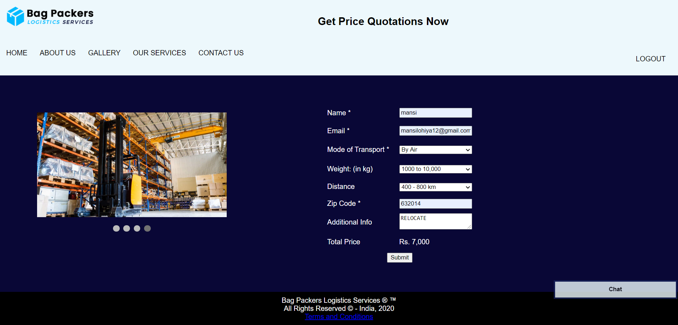

**// HTML CODE**

<!DOCTYPE html>

<html>

<head>

<meta charset="utf-8">

<title>Order Form</title>

<link rel="stylesheet" href="orderform_css.css">

<link rel="stylesheet" href="slider.css">

<script type="text/javascript" src="from_validation.js"></script>

</head>

<body>

<div style="background-color:#edf8fc;padding:15px;">

<img src="navy-darkblue_dark.png" width="200" height="50" align="left"/>

<div style="text-align:center">

<h2>

<center>Get Price Quotations Now</center>

</h2>

</div>

</div>

<div class="navbar">

<a href="home2.html">HOME</a>

<a href="about2.html">ABOUT US</a>

<a href="gallery.html">GALLERY</a>

<div class="dropdown">

<button class="dropbtn">OUR SERVICES

<i class="fa fa-caret-down"></i>

</button>

<div class="dropdown-content">

<a href="our-services.html">SERVICES</a>

<a href="order_form.html">PRICE QUOTE</a>

<a href="parallel.html">TESTIMONIAL</a>

</div>

</div>

<a href="contact.html">CONTACT US</a>

<div class="dropdown" style="float:right">

<button class="dropbtn">

<a href="firstpage.html">LOGOUT</a></button>

</div>

</div>

<div class="container">

<div class="column-33">

<div class="slideshow-container1">

<div class="mySlides fade">

<div class="numbertext">1 / 4</div>

<img src="slide3-2.jpg" style="width:100%">

</div>

<div class="mySlides fade">

<div class="numbertext">2 / 4</div>

<img src="slide3-1.jpg" style="width:100%">

</div>

<div class="mySlides fade">

<div class="numbertext">3 / 4</div>

<img src="blog-5.jpg" style="width:100%">

</div>

<div class="mySlides fade">

<div class="numbertext">4 / 4</div>

<img src="blog-8.jpg" style="width:100%">

</div>

</div>

<br>

<div style="text-align:center">

<span class="dot"></span>

<span class="dot"></span>

<span class="dot"></span>

<span class="dot"></span>

</div>

</div>

<table width="528" border="0" align="center">

<tbody>

<tr>

<td width="167" height="39">Name <span font-color="white">*</span></td>

<td width="146"><input type="text" name="textfield" id="name"></td>

<td width="201"><span id="error_name"></span></td>

</tr>

<tr>

<td height="39">Email <span font-color="red">*</span></td>

<td><input type="text" name="textfield2" id="mail"></td>

<td><span id="error_mail"></span></td>

</tr>

<tr>

<td height="42">Mode of Transport <span font-color="red">*</span></td>

<td>

<select id="sel" style="width:100%">

<option>-------------Select-------------</option>

<option>By Air</option>

<option>By Road</option>

</select>

</td>

<td><span id="error_select"></span></td>

</tr>

<tr>

<td height="42">Weight: (in kg)</td>

<td>

<select name="select3" id="weight" style="width:100%">

<option>-------Select Weight-------</option>

<option>500 to 1000</option>

<option>1000 to 10,000</option>

<option>10,000 to 15,000</option>

<option>Above 15,000</option>

</select>

</td>

<td><span id="error_weight"></span></td>

</tr>

<tr>

<td height="35">Distance</td>

<td>

<select name="select" id="distance" style="width:100%">

<option>------Select Distance------</option>

<option>Upto 400 km</option>

<option>400 - 800 km</option>

<option>800 - 1300 km</option>

<option>1300 - 1900 km</option>

</select>

</td>

</tr>

<tr>

<td height="38">Zip Code <span font-color="white">*</span></td>

<td><input type="text" id="zipcode" maxlength="6"></td>

<td><span id="error_zipcode"></span></td>

</tr>

<tr>

<td height="43">Additional Info</td>

<td><textarea name="textarea" style="width:100%"></textarea></td>

<td>&nbsp;</td>

</tr>

<tr>

<td height="43">Total Price</td>

<td>

<div id="price">Rs. 0</div>

</td>

<td></td>

</tr>

<tr>

<td colspan="2"><div align="center"><button onClick="validate()">Submit</button></div></td>

<td></td>

</tr>

</tbody>

</table>

</div>

<!--Chat section-->

<button class="open-button" onclick="openForm()"><b>Chat</b></button>

<div class="chat-popup" id="myForm">

<form action="/action_page.php" class="form-container">

<h1>Chat</h1>

<textarea placeholder="Type your message.." name="msg" required></textarea>

<button type="submit" class="btn"><b>Send</b></button>

<button type="button" class="btn cancel" onclick="closeForm()"><b>Close</b></button>

</form>

</div>

<!--footer part-->

<footer>

Bag Packers Logistics Services &reg; &trade; <br>All Rights Reserved &copy; - India, 2020<br>

<a href="faq.html">Terms and Conditions</a>

</footer>

</body>

<script type="text/javascript">

function openForm() {

document.getElementById("myForm").style.display = "block";

}

function closeForm() {

document.getElementById("myForm").style.display = "none";

}

</script>

<script type="text/javascript" src="slider.js"></script>

</html>

**// CSS CODE**

span

{

color: white;

}

* {

box-sizing: border-box;

}

.container {

border-radius: 0;

background-color: #090736;

color:white;

padding: 20px;

}

/* Responsive layout - when the screen is less than 600px wide, make the two columns stack on top of each other instead of next to each other */

@media screen and (max-width: 600px) {

.col-25, .col-75, input[type=submit] {

width: 100%;

margin-top: 0;

}

}

* {

box-sizing:border-box;

}

.navbar {

overflow: hidden;

background-color: #edf8fc;

}

.navbar a {

float: left;

font-size: 16px;

color: black;

text-align: center;

padding: 14px;

text-decoration: none;

}

.dropdown {

float: left;

overflow: hidden;

}

.dropdown .dropbtn {

font-size: 16px;

border: 0;

outline: none;

color: black;

padding: 14px;

background-color: inherit;

font-family: inherit;

margin: 0;

}

.navbar a:hover, .dropdown:hover .dropbtn {

background-color: #ddd;

}

.dropdown-content {

display: none;

position: absolute;

background-color: white;

min-width: 160px;

box-shadow: 0px 8px 16px 0px rgba(0,0,0,0.2);

z-index: 1;

}

.dropdown-content a {

float: none;

color: black;

padding: 12px 16px;

text-decoration: none;

display: block;

text-align: left;

}

.dropdown-content a:hover {

background-color: #ddd;

}

.dropdown:hover .dropdown-content {

display: block;

}

body {

margin: 0;

font-family: Arial, Helvetica, sans-serif;

}

.container {

padding: 64px;

}

.row:after {

content: "";

display: table;

clear: both

}

.column-66 {

float: left;

width: 66.66666%;

padding: 20px;

}

.column-33 {

float: left;

width: 33.33333%;

padding: 20px;

}

.large-font {

font-size: 48px;

}

.xlarge-font {

font-size: 64px

}

.button {

border: none;

color: white;

padding: 14px 28px;

font-size: 16px;

cursor: pointer;

background-color: #4CAF50;

align: center;

}

img {

display: block;

height: auto;

max-width: 100%;

}

@media screen and (max-width: 1000px) {

.column-66,

.column-33 {

width: 100%;

text-align: center;

}

img {

margin: auto;

}

}

footer{

background-color:black;

padding:10px;

color:white;

text-align:center;

}

/* Button used to open the chat form - fixed at the bottom of the page */

.open-button {

background-color: #edf8fc;

color: black;

padding: 10px 10px;

border: 3px solid #161f59;

cursor: pointer;

opacity: 0.8;

position: fixed;

bottom: 60px;

right: 2px;

width: 280px;

}

/* The popup chat - hidden by default */

.chat-popup {

display: none;

position: fixed;

bottom: 0;

right: 15px;

border: 3px solid #edf8fc;

z-index: 9;

}

/* Add styles to the form container */

.form-container {

max-width: 300px;

padding: 10px;

background-color: white;

}

/* Full-width textarea */

.form-container textarea {

width: 100%;

padding: 15px;

margin: 5px 0 22px 0;

border: 3px solid #edf8fc;

background: #edf8fc;

resize: none;

min-height: 200px;

}

/* When the textarea gets focus, do something */

.form-container textarea:focus {

background-color: #edf8fc;

outline: #edf8fc;

}

/* Set a style for the submit/send button */

.form-container .btn {

background-color: #161f59;

color: white;

padding: 10px 10px;

border:3px solid #161f59;

cursor: pointer;

width: 100%;

margin-bottom:10px;

opacity: 0.8;

}

/* Add a red background color to the cancel button */

.form-container .cancel {

background-color: #161f59;

border:3px solid #161f59;

}

/* Add some hover effects to buttons */

.form-container .btn:hover, .open-button:hover {

opacity: 1;

}

**// JAVASCRIPT CODE**

function validate() {

var name = document.getElementById('name');

var mail = document.getElementById('mail');

var zip_code = document.getElementById('zipcode');

/*Regex Code*/

var filter_name = /^[a-zA-Z]+$/;

var filter_mail = /^(([^<>()[\]\\.,;:\s@\"]+(\.[^<>()[\]\\.,;:\s@\"]+)*)|(\".+\"))@((\[[0-9]{1,3}\.[0-9]{1,3}\.[0-9]{1,3}\.[0-9]{1,3}\])|(([a-zA-Z\-0-9]+\.)+[a-zA-Z]{2,}))$/;

var filter_zipcode = /^[0-9]{6}$/;

/*Conditions*/

if (filter_zipcode.test(zip_code.value)) {

document.getElementById('error_zipcode').innerHTML = '';

} else {

document.getElementById('error_zipcode').innerHTML = '<span>Invalid zipcode</span>';

}

if (filter_name.test(name.value)) {

document.getElementById('error_name').innerHTML = '';

} else {

document.getElementById('error_name').innerHTML = '<span>Invalid name</span>';

}

if (filter_mail.test(mail.value)) {

document.getElementById('error_mail').innerHTML = '';

} else {

document.getElementById('error_mail').innerHTML = '<span>Invalid mail</span>';

}

if (sel.selectedIndex == 0) {

document.getElementById('error_select').innerHTML = '<span>Please select mode of transport</span>';

return false;

} else {

document.getElementById('error_select').innerHTML = '';

}

/*Select Conditions*/

var weight = document.getElementById('weight').selectedIndex;

var distance = document.getElementById('distance').selectedIndex;

var transport = document.getElementById('sel').selectedIndex;

/*Air Combo*/

if (weight == 1 && distance == 1 && transport == 1)

{

document.getElementById('price').innerHTML = 'Rs. 5,000';

}

else if (weight == 2 && distance == 2 && transport == 1)

{

document.getElementById('price').innerHTML = 'Rs. 7,000';

}

else if (weight == 3 && distance == 3 && transport == 1)

{

document.getElementById('price').innerHTML = 'Rs. 10,000';

}

else if (weight == 4 && distance == 4 && transport == 1)

{

document.getElementById('price').innerHTML = 'Rs. 13,000';

}

/*Road Combo*/

else if (weight == 1 && distance == 1 && transport == 2)

{

document.getElementById('price').innerHTML = 'Rs. 3,500';

}

else if (weight == 2 && distance == 2 && transport == 2)

{

document.getElementById('price').innerHTML = 'Rs. 5,000';

}

else if (weight == 3 && distance == 3 && transport == 2)

{

document.getElementById('price').innerHTML = 'Rs. 10,000';

}

else if (weight == 4 && distance == 4 && transport == 2)

{

document.getElementById('price').innerHTML = 'Rs. 11,500';

}

else

{

document.getElementById('price').innerHTML = 'Rs. 3,000';

}

}

1. **TESTIMONIAL PAGE:**



**// HTML CODE**

<!DOCTYPE html>

<html>

<head>

<meta name="viewport" content="width=device-width, initial-scale=1">

<link rel="stylesheet" type="text/css" href="parallel.css">

</head>

<body>

<div style="background-color:#edf8fc;padding:15px;">

<img src="navy-darkblue_dark.png" width="200" height="50" align="left"/>

<div style="text-align:center">

<h2><center>Happy Customers</center></h2>

</div></div>

<div class="navbar">

<a href="home2.html">HOME</a>

<a href="about2.html">ABOUT US</a>

<a href="gallery.html">GALLERY</a>

<div class="dropdown">

<button class="dropbtn">OUR SERVICES

<i class="fa fa-caret-down"></i>

</button>

<div class="dropdown-content">

<a href="our-services.html">SERVICES</a>

<a href="order_form.html">PRICE QUOTE</a>

<a href="parallel.html">TESTIMONIAL</a>

</div>

</div>

<a href="contact.html">CONTACT US</a>

<div class="dropdown" style="float:right">

<button class="dropbtn">

<a href="firstpage.html">LOGOUT</a></button></div>

</div>

<div class="bgimg-1">

<div class="caption">

<span class="border"><b>"Our mission is to provide world class facilites to our customers."</b></span>

</div>

</div>

<div style="color: #777;background-color:white;text-align:center;padding:50px 80px;text-align: justify;">

<h3 style="text-align:center;">DOMESTIC RELOCATIONS</h3>

<p>"Thank you very much for your teams excellent assistance during the move.They were fantastic and it is by far and beyond the best move we have ever experienced. Thank you to your team from going the extra mile and working on Friday to deliver to site as soon as possible. Appreciate that it is difficult to affect the flight times but very grateful to both you and your team to doing everything in your power to speed things up on arrival and deliver on a Friday. This helped us avoid further delays in the programme."</p>

<b>Operations Manager - GBM (IBM)</b>

</div>

<div class="bgimg-2">

<div class="caption">

<span class="border"><b>"Your things, our responibility."</b></span>

</div>

</div>

<div style="color: #777;background-color:white;text-align:center;padding:50px 80px;text-align: justify;">

<h3 style="text-align:center;">AIR FREIGHT</h3>

<p>"It gives me a great pleasure to say that great team has extended hands to our Brands in supporting Logistics. AFL Air Freight Team without saying has done a tremendous job in collecting all shipments and have brought into AFL Dubai Cargo Village. Must also say that the activity went on beyond working hours and that huge initiative from AFL Air Freight team was put in place. The whole team had shown great teamwork to ensure in supporting Business. Given short notice to complete all documents/clearance and transfers, I must say that this was achieved without any error. WELL DONE TEAM AFL AIR FREIGHT DCV !!!"</p>

<b>Assistant Logistics Manager - Al Futtaim Premium Fashion & Department Stores</b>

</div>

<div class="bgimg-3">

<div class="caption">

<span class="border"><b>"Trust is the only key that binds us with our customers."</b></span>

</div>

</div>

<div style="color: #777;background-color:white;text-align:center;padding:50px 80px;text-align: justify;">

<h3 style="text-align:center;">WAREHOUSING & CONTRACTS LOGISTICS</h3>

<p>Congratulations again on the new cold store re facility up and running. Thank you for considering our request and creating a cooled chamber for our goods. Great piece of work done by AFL on anniversary orders scheduling and deliveries. I would like to acknowledge your excellent service towards our deliveries for our Eid and Bikes promotion, and for the launch of our autumn winter apparel. Many thanks for your help and support."</p>

<b>Logistics Executive, Inventory - ACE Hardware</b>

</div>

<div class="bgimg-1">

<div class="caption">

<span class="border"><b>"We promise to deliver quality services to our customers."</b></span>

</div>

</div>

<div style="color: #777;background-color:white;text-align:center;padding:50px 80px;text-align: justify;">

<h3 style="text-align:center;">LAST MILE HOME DELIVERY</h3>

<p>"This is to inform you that my husband and I had an online order with ACE Dubai and booked delivery and assembly as well. Manosh and Gajandra come on time and also gave us a confirmation call well in advance. They were very professional, kind and efficient. Anyhow, I believe every good service should be praised and that’s the reason I am writing this email to you."</p>

<b>Anonymus</b>

</div>

<div class="bgimg-2">

<div class="caption">

<span class="border"><b>Give your Feedback!!</b></span>

<button class="button" style="background-color:#161f59" onClick="openForm()"><b>FEEDBACK</b></button>

</div>

</div>

<div class="form-popup" id="myForm" style="width:20%">

<form action="/action_page.php" class="form-container">

<label for="feedback"></label>

<!--<input type="textarea" placeholder="Write your opinion" name="feedback" required>-->

<textarea placeholder="Write your opinion" name="feedback" rows="6" required="" style="display: block;width:100%;"></textarea>

<br>

<button type="submit" class="btn"><b>Submit</b></button>

<button type="button" class="btn cancel" onclick="closeForm()"><b>Close</b></button>

</form>

</div>

<script>

function openForm() {

document.getElementById("myForm").style.display = "block";

}

function closeForm() {

document.getElementById("myForm").style.display = "none";

}

</script>

<!--footer part-->

<footer>

Bag Packers Logistics Services &reg; &trade; <br>All Rights Reserved &copy; - India, 2020<br>

<a href="faq.html">Terms and Conditions</a>

</footer>

</body>

</html>

**// CSS CODE**

body, html {

height: 100%;

margin: 0;

}

.bgimg-1, .bgimg-2, .bgimg-3 {

position: relative;

background-attachment: fixed;

background-position: center;

background-repeat: no-repeat;

background-size: cover;

}

.bgimg-1 {

background-image: url("6.jpg");

min-height: 100%;

}

.bgimg-2 {

background-image: url("3.jpg");

min-height: 400px;

}

.bgimg-3 {

background-image: url("slide2-2.jpg");

min-height: 400px;

}

.caption {

position: absolute;

left: 0;

top: 40%;

width: 100%;

text-align: center;

color: #000;

}

.caption span.border {

background-color: #161f59;

color: white;

padding: 18px;

font-size: 25px;

letter-spacing: 10px;

}

h3 {

letter-spacing: 5px;

text-transform: uppercase;

font: 20px "Lato", sans-serif;

color: #111;

}

/* Turn off parallax scrolling for tablets and phones */

@media only screen and (max-device-width: 1024px) {

.bgimg-1, .bgimg-2, .bgimg-3 {

background-attachment: scroll;

}

}

* {

box-sizing:border-box;

}

.navbar {

overflow: hidden;

background-color: #edf8fc;

}

.navbar a {

float: left;

font-size: 16px;

color: black;

text-align: center;

padding: 14px;

text-decoration: none;

}

.dropdown {

float: left;

overflow: hidden;

}

.dropdown .dropbtn {

font-size: 16px;

border: 0;

outline: none;

color: black;

padding: 14px;

background-color: inherit;

font-family: inherit;

margin: 0;

}

.navbar a:hover, .dropdown:hover .dropbtn {

background-color: #ddd;

}

.dropdown-content {

display: none;

position: absolute;

background-color: white;

min-width: 160px;

box-shadow: 0px 8px 16px 0px rgba(0,0,0,0.2);

z-index: 1;

}

.dropdown-content a {

float: none;

color: black;

padding: 12px 16px;

text-decoration: none;

display: block;

text-align: left;

}

.dropdown-content a:hover {

background-color: #ddd;

}

.dropdown:hover .dropdown-content {

display: block;

}

body {

margin: 0;

font-family: Arial, Helvetica, sans-serif;

}

.container {

padding: 64px;

}

.row:after {

content: "";

display: table;

clear: both

}

.column-66 {

float: left;

width: 66.66666%;

padding: 20px;

}

.column-33 {

float: left;

width: 33.33333%;

padding: 20px;

}

.large-font {

font-size: 48px;

}

.xlarge-font {

font-size: 64px

}

.button {

border: none;

color: white;

padding: 14px 28px;

font-size: 16px;

cursor: pointer;

background-color: #4CAF50;

}

img {

display: block;

height: auto;

max-width: 100%;

}

@media screen and (max-width: 1000px) {

.column-66,

.column-33 {

width: 100%;

text-align: center;

}

img {

margin: auto;

}

}

.button {

border: none;

color: white;

padding: 14px 28px;

font-size: 16px;

cursor: pointer;

background-color: #161f59;

margin: 0;

position: absolute;

top: 50%;

left: 33%;

-ms-transform: translate(150%, 150%);

transform: translate(150%, 150%);

}

/* The popup form - hidden by default */

.form-popup {

display: none;

position: fixed;

bottom: 0;

right: 15px;

border: 3px solid #f1f1f1;

z-index: 9;

}

/* Add styles to the form container */

.form-container {

max-width: 300px;

padding: 10px;

background-color: white;

}

/* Full-width input fields */

.form-container input[type=text], .form-container input[type=password] {

width: 100%;

padding: 15px;

margin: 5px 0 22px 0;

border: 2;

background: #edf8fc;

}

/* When the inputs get focus, do something */

.form-container input[type=text]:focus, .form-container input[type=password]:focus {

background-color: #edf8fc;

outline: none;

}

/* Set a style for the submit/login button */

.form-container .btn {

background-color: #161f59;

color: white;

padding: 10px 15px;

border: none;

cursor: pointer;

width: 100%;

margin-bottom:10px;

opacity: 0.8;

}

/* Add a red background color to the cancel button */

.form-container .cancel {

background-color: #161f59;

}

/* Add some hover effects to buttons */

.form-container .btn:hover, .open-button:hover {

opacity: 1;

}

footer{

background-color:black;

padding:10px;

color:white;

text-align:center;

}

1. **CONTACT US PAGE:**

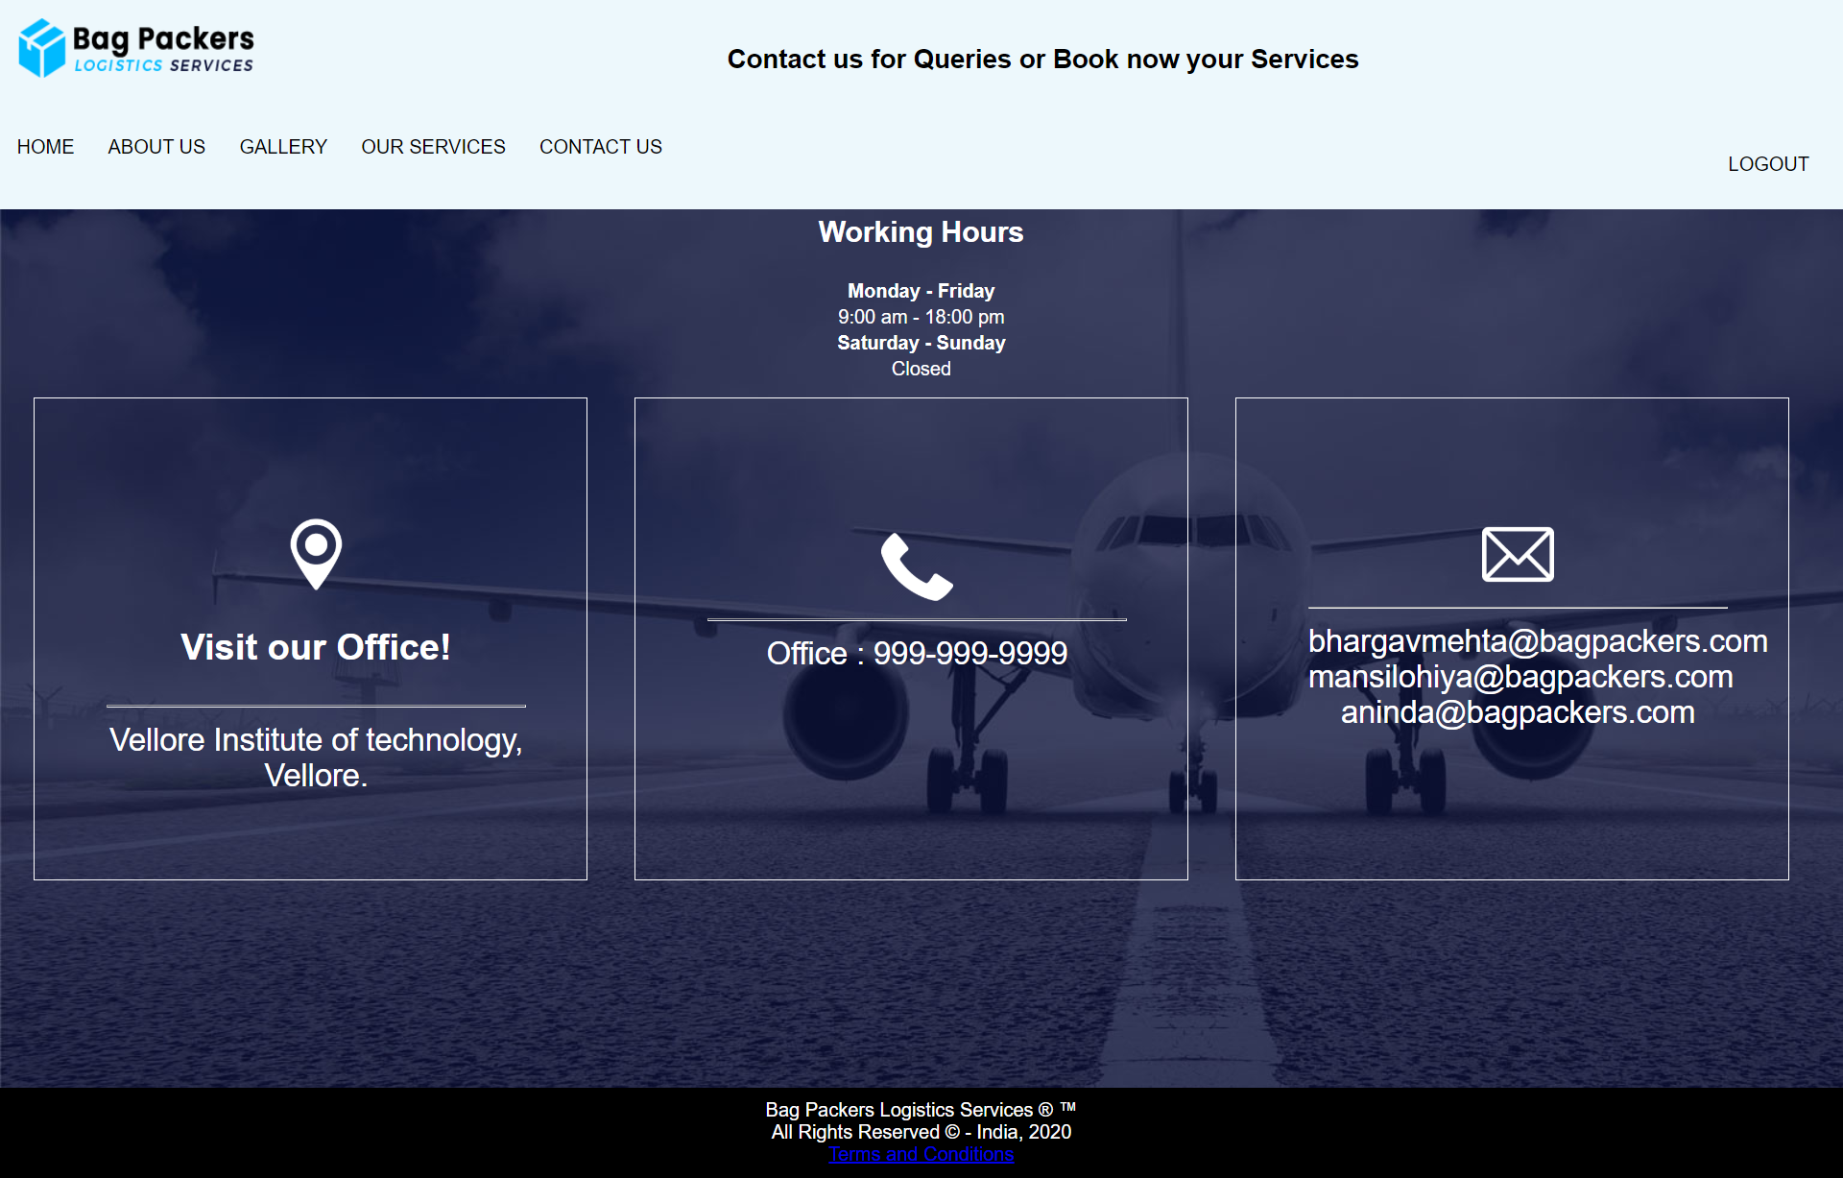

**// HTML CODE**

<html>

<head>

<meta name="viewport" content="width=device-width, initial-scale=1">

<link rel="stylesheet" type="text/css" href="contact.css">

</head>

<body background="count-bg-1.jpg">

<div style="background-color:#edf8fc;padding:15px;">

<img src="navy-darkblue_dark.png" width="200" height="50" align="left"/>

<div style="text-align:center">

<p align="center" style="color:black; font-size:22px;"><b>Contact us for Queries or Book now your Services</b></p>

</div></div>

<!--menu bar-->

<div class="navbar">

<a href="home2.html">HOME</a>

<a href="about2.html">ABOUT US</a>

<a href="gallery.html">GALLERY</a>

<div class="dropdown">

<button class="dropbtn">OUR SERVICES

<i class="fa fa-caret-down"></i>

</button>

<div class="dropdown-content">

<a href="our-services.html">SERVICES</a>

<a href="order_form.html">PRICE QUOTE</a>

<a href="parallel.html">TESTIMONIAL</a>

</div>

</div>

<a href="contact.html">CONTACT US</a>

<div class="dropdown" style="float:right">

<button class="dropbtn">

<a href="firstpage.html">LOGOUT</a></button></div>

</div>

<!--body section-->

<table>

<tr></tr>

</table>

<table align="center">

<tr>

<th><h2>Working Hours</h2></th>

</tr>

<tr align="center">

<td><p></p></td>

</tr>

<tr align="center">

<td><strong>Monday - Friday</strong> </td>

</tr>

<tr align="center">

<td>9:00 am - 18:00 pm</td>

</tr>

<tr align="center">

<td><strong>Saturday - Sunday</strong> </td>

</tr>

<tr align="center">

<td>Closed</td>

</tr>

</table>

<table>

<td>

<div class="floating-box"><img class="image-size" src="location.png" width="20%">

<h3>Visit our Office!</h3><hr>

Vellore Institute of technology, Vellore.</div>

</td>

<td>

<div class="floating-box"><img class="image-size padding-top" src="phone.png" width="45%">

<br>

<hr>

Office : 999-999-9999

</div>

<td>

<div class="floating-box"><img class="image-size" src="mail.png" width="40%">

<hr>

bhargavmehta@bagpackers.com

<br>

mansilohiya@bagpackers.com

<br>

aninda@bagpackers.com

</div>

</td>

</table>

<!--footer part-->

<footer>

Bag Packers Logistics Services &reg; &trade; <br>All Rights Reserved &copy; - India, 2020<br>

<a href="faq.html">Terms and Conditions</a>

</footer>

</body>

</html>

**// CSS CODE**

body{

margin: 0;

font-family: Arial, Helvetica, sans-serif;

color:white;

}

.navbar {

overflow: hidden;

background-color: #edf8fc;

}

.navbar a {

float: left;

font-size: 16px;

color: black;

text-align: center;

padding: 14px;

text-decoration: none;

}

.dropdown {

float: left;

overflow: hidden;

}

.dropdown .dropbtn {

font-size: 16px;

border: 0;

outline: none;

color: black;

padding: 14px;

background-color: inherit;

font-family: inherit;

margin: 0;

}

.navbar a:hover, .dropdown:hover .dropbtn {

background-color: #ddd;

}

.dropdown-content {

display: none;

position: absolute;

background-color: white;

min-width: 160px;

box-shadow: 0px 8px 16px 0px rgba(0,0,0,0.2);

z-index: 1;

}

.dropdown-content a {

float: none;

color: black;

padding: 12px 16px;

text-decoration: none;

display: block;

text-align: left;

}

.dropdown-content a:hover {

background-color: #ddd;

}

.dropdown:hover .dropdown-content {

display: block;

}

.floating-box

{

width: 350px;

text-align:center;

border: 1px solid white;

padding: 50px;

color:white;

font-size:26px;

padding-left:60px;

padding-top:100px;

margin: 10px;

margin-left:25px;

height: 250px;

}

.image-size

{

width: 60px;

height: 60px;

}

.padding-top

{

padding-top: 10px;

}

/* Responsive layout - makes a two column-layout instead of four columns */

@media screen and (max-width: 800px) {

.image-size .padding-top .floating-box {

-ms-flex: 50%;

flex: 50%;

max-width: 50%;

}

}

/* Responsive layout - makes the two columns stack on top of each other instead of next to each other */

@media screen and (max-width: 600px) {

.image-size .padding-top .floating-box {

-ms-flex: 100%;

flex: 100%;

max-width: 100%;

}

}

footer{

background-color:black;

padding:10px;

color:white;

text-align:center;

margin-top:160px;

}

1. **FAQ PAGE:**

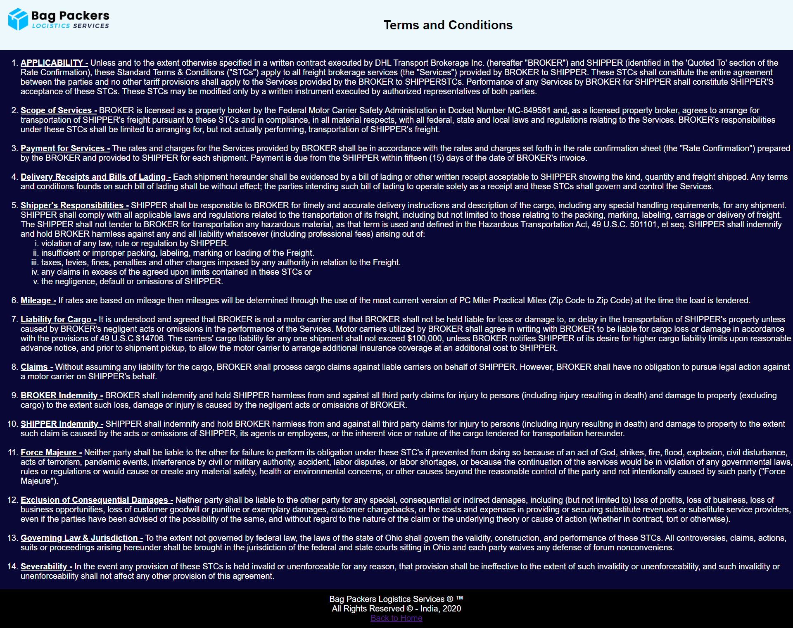

**// HTML CODE**

<!DOCTYPE html>

<html>

<head>

<meta name="viewport" content="width=device-width, initial-scale=1">

<link rel="stylesheet" type="text/css" href="faq.css">

</head>

<body>

<div style="background-color:#edf8fc;padding:15px;">

<img src="navy-darkblue_dark.png" width="200" height="50" align="left"/>

<div style="text-align:center">

<h2><center><font color="black">Terms and Conditions</font></center></h2>

</div></div>

<!-- body section-->

<body>

<ol>

<li><u><b>APPLICABILITY -</b></u> Unless and to the extent otherwise specified in a written contract executed by DHL Transport Brokerage Inc. (hereafter "BROKER") and SHIPPER (identified in the 'Quoted To' section of the Rate Confirmation), these Standard Terms & Conditions ("STCs") apply to all freight brokerage services (the "Services") provided by BROKER to SHIPPER. These STCs shall constitute the entire agreement between the parties and no other tariff provisions shall apply to the Services provided by the BROKER to SHIPPERSTCs. Performance of any Services by BROKER for SHIPPER shall constitute SHIPPER'S acceptance of these STCs. These STCs may be modified only by a written instrument executed by authorized representatives of both parties.</li>

<br><li><u><b>Scope of Services -</b></u> BROKER is licensed as a property broker by the Federal Motor Carrier Safety Administration in Docket Number MC-849561 and, as a licensed property broker, agrees to arrange for transportation of SHIPPER's freight pursuant to these STCs and in compliance, in all material respects, with all federal, state and local laws and regulations relating to the Services. BROKER's responsibilities under these STCs shall be limited to arranging for, but not actually performing, transportation of SHIPPER's freight.</li>

<br><li><u><b>Payment for Services -</b></u> The rates and charges for the Services provided by BROKER shall be in accordance with the rates and charges set forth in the rate confirmation sheet (the "Rate Confirmation") prepared by the BROKER and provided to SHIPPER for each shipment. Payment is due from the SHIPPER within fifteen (15) days of the date of BROKER's invoice.</li>

<br><li><u><b>Delivery Receipts and Bills of Lading -</b></u> Each shipment hereunder shall be evidenced by a bill of lading or other written receipt acceptable to SHIPPER showing the kind, quantity and freight shipped. Any terms and conditions founds on such bill of lading shall be without effect; the parties intending such bill of lading to operate solely as a receipt and these STCs shall govern and control the Services.</li>

<br><li><u><b>Shipper's Responsibilities -</b></u> SHIPPER shall be responsible to BROKER for timely and accurate delivery instructions and description of the cargo, including any special handling requirements, for any shipment. SHIPPER shall comply with all applicable laws and regulations related to the transportation of its freight, including but not limited to those relating to the packing, marking, labeling, carriage or delivery of freight. The SHIPPER shall not tender to BROKER for transportation any hazardous material, as that term is used and defined in the Hazardous Transportation Act, 49 U.S.C. 501101, et seq. SHIPPER shall indemnify and hold BROKER harmless against any and all liability whatsoever (including professional fees) arising out of:

<ol type="i"><li> violation of any law, rule or regulation by SHIPPER.</li>

<li> insufficient or improper packing, labeling, marking or loading of the Freight.</li>

<li> taxes, levies, fines, penalties and other charges imposed by any authority in relation to the Freight.</li>

<li>any claims in excess of the agreed upon limits contained in these STCs or</li>

<li> the negligence, default or omissions of SHIPPER.</li></ol></li>

<br><li><u><b>Mileage -</b></u> If rates are based on mileage then mileages will be determined through the use of the most current version of PC Miler Practical Miles (Zip Code to Zip Code) at the time the load is tendered.</li>

<br><li><u><b>Liability for Cargo -</b></u> It is understood and agreed that BROKER is not a motor carrier and that BROKER shall not be held liable for loss or damage to, or delay in the transportation of SHIPPER's property unless caused by BROKER's negligent acts or omissions in the performance of the Services. Motor carriers utilized by BROKER shall agree in writing with BROKER to be liable for cargo loss or damage in accordance with the provisions of 49 U.S.C $14706. The carriers' cargo liability for any one shipment shall not exceed $100,000, unless BROKER notifies SHIPPER of its desire for higher cargo liability limits upon reasonable advance notice, and prior to shipment pickup, to allow the motor carrier to arrange additional insurance coverage at an additional cost to SHIPPER.</li>

<br><li><u><b>Claims -</b></u> Without assuming any liability for the cargo, BROKER shall process cargo claims against liable carriers on behalf of SHIPPER. However, BROKER shall have no obligation to pursue legal action against a motor carrier on SHIPPER's behalf.</li>

<br><li><u><b>BROKER Indemnity -</u></b> BROKER shall indemnify and hold SHIPPER harmless from and against all third party claims for injury to persons (including injury resulting in death) and damage to property (excluding cargo) to the extent such loss, damage or injury is caused by the negligent acts or omissions of BROKER.</li>

<br><li><u><b>SHIPPER Indemnity -</u></b> SHIPPER shall indemnify and hold BROKER harmless from and against all third party claims for injury to persons (including injury resulting in death) and damage to property to the extent such claim is caused by the acts or omissions of SHIPPER, its agents or employees, or the inherent vice or nature of the cargo tendered for transportation hereunder.</li>

<br><li><u><b>Force Majeure -</b></u> Neither party shall be liable to the other for failure to perform its obligation under these STC's if prevented from doing so because of an act of God, strikes, fire, flood, explosion, civil disturbance, acts of terrorism, pandemic events, interference by civil or military authority, accident, labor disputes, or labor shortages, or because the continuation of the services would be in violation of any governmental laws, rules or regulations or would cause or create any material safety, health or environmental concerns, or other causes beyond the reasonable control of the party and not intentionally caused by such party ("Force Majeure").</li>

<br><li><u><b>Exclusion of Consequential Damages -</b></u> Neither party shall be liable to the other party for any special, consequential or indirect damages, including (but not limited to) loss of profits, loss of business, loss of business opportunities, loss of customer goodwill or punitive or exemplary damages, customer chargebacks, or the costs and expenses in providing or securing substitute revenues or substitute service providers, even if the parties have been advised of the possibility of the same, and without regard to the nature of the claim or the underlying theory or cause of action (whether in contract, tort or otherwise).</li>

<br><li><u><b>Governing Law & Jurisdiction -</b></u> To the extent not governed by federal law, the laws of the state of Ohio shall govern the validity, construction, and performance of these STCs. All controversies, claims, actions, suits or proceedings arising hereunder shall be brought in the jurisdiction of the federal and state courts sitting in Ohio and each party waives any defense of forum nonconveniens.</li>

<br><li><u><b>Severability -</b></u> In the event any provision of these STCs is held invalid or unenforceable for any reason, that provision shall be ineffective to the extent of such invalidity or unenforceability, and such invalidity or unenforceability shall not affect any other provision of this agreement.</li>

</ol>

<!--footer part-->

<footer>

Bag Packers Logistics Services &reg; &trade; <br>All Rights Reserved &copy; - India, 2020<br>

<a href="home2.html">Back to Home</a>

</footer>

</body>

</html>

**// CSS CODE**

* {

box-sizing:border-box;

}

.navbar {

overflow: hidden;

background-color: #edf8fc;

}

.navbar a {

float: left;

font-size: 16px;

color: black;

text-align: center;

padding: 14px;

text-decoration: none;

}

.dropdown {

float: left;

overflow: hidden;

}

.dropdown .dropbtn {

font-size: 16px;

border: 0;

outline: none;

color: black;

padding: 14px;

background-color: inherit;

font-family: inherit;

margin: 0;

}

.navbar a:hover, .dropdown:hover .dropbtn {

background-color: #ddd;

}

.dropdown-content {

display: none;

position: absolute;

background-color: white;

min-width: 160px;

box-shadow: 0px 8px 16px 0px rgba(0,0,0,0.2);

z-index: 1;

}

.dropdown-content a {

float: none;

color: black;

padding: 12px 16px;

text-decoration: none;

display: block;

text-align: left;

}

.dropdown-content a:hover {

background-color: #ddd;

}

.dropdown:hover .dropdown-content {

display: block;

}

body {

margin: 0;

font-family: Arial, Helvetica, sans-serif;

background-color: #090736;

color:white;

}

.container {

padding: 64px;

}

.row:after {

content: "";

display: table;

clear: both

}

.column-66 {

float: left;

width: 66.66666%;

padding: 20px;

}

.column-33 {

float: left;

width: 33.33333%;

padding: 20px;

}

.large-font {

font-size: 48px;

}

.xlarge-font {

font-size: 64px

}

.button {

border: none;

color: white;

padding: 14px 28px;

font-size: 16px;

cursor: pointer;

background-color: #4CAF50;

align: center;

}

img {

display: block;

height: auto;

max-width: 100%;

}

@media screen and (max-width: 1000px) {

.column-66,

.column-33 {

width: 100%;

text-align: center;

}

img {

margin: auto;

}

}

footer{

background-color:black;

padding:10px;

color:white;

text-align:center;

}

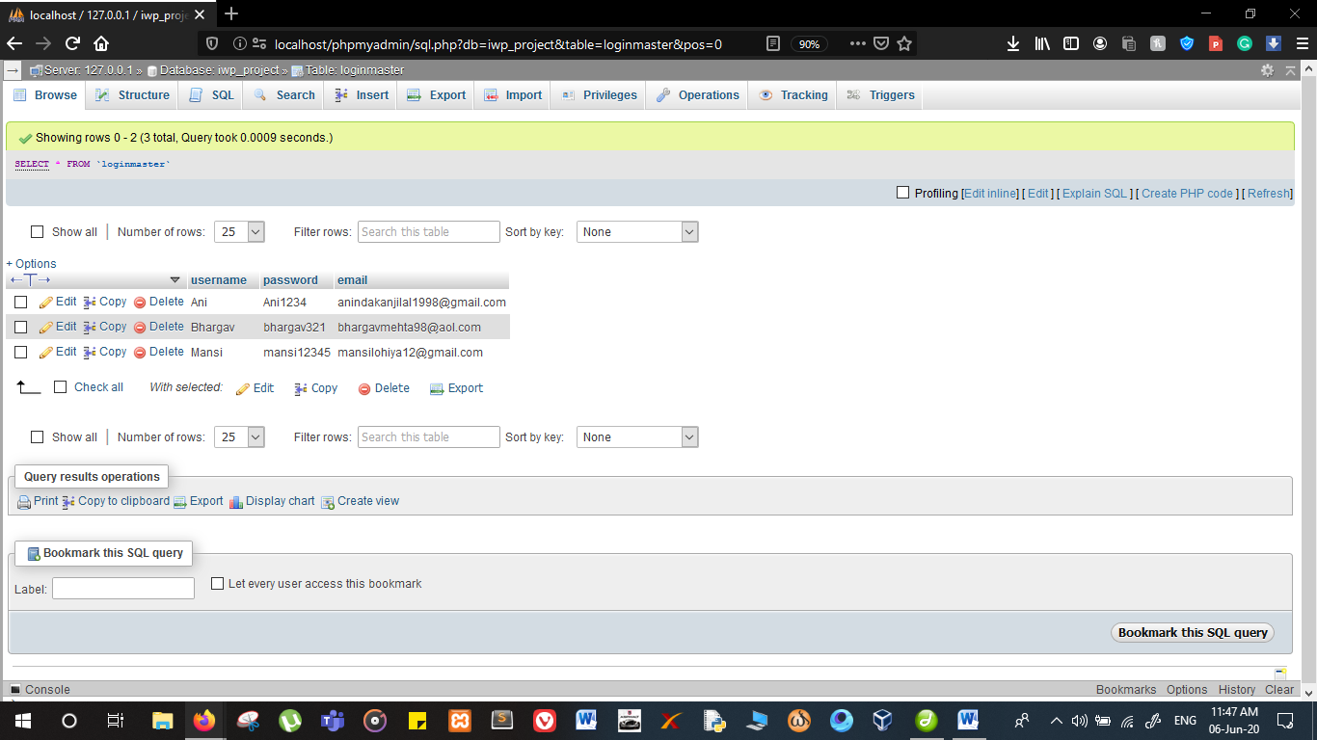

<?php

$servername="127.0.0.1";

$username='root';

$password='';

$dbname = "iwp_project";

try {

$usern = $_POST['usr'];

$passw= $_POST['passwrd'];

$mail = $_POST['mailid'];

$conn = new PDO("mysql:host=$servername;dbname=$dbname", $username, $password);

/* set the PDO error mode to exception */

$conn->setAttribute(PDO::ATTR_ERRMODE, PDO::ERRMODE_EXCEPTION);

$sql = "INSERT INTO loginmaster (username,password,email) VALUES ('$usern', '$passw','$mail')";

$conn->exec($sql);

header("Location: profile.html");

}

catch(PDOException $e)

{

echo "<br>" . $e->getMessage();

}

$conn = null;

?>

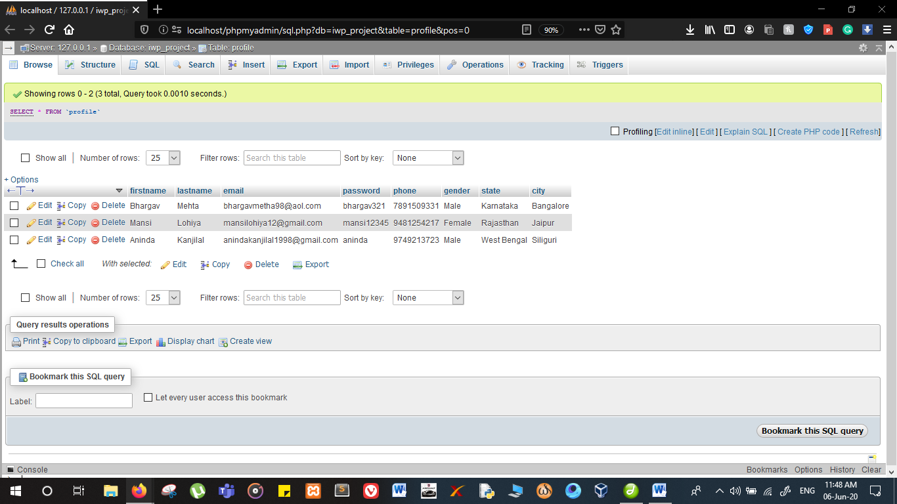

<?php

$servername="127.0.0.1";

$username='root';

$password='';

$dbname = "iwp_project";

try {

$first= $_POST['firstname'];

$last = $_POST['lastname'];

$email = $_POST['email'];

$pass= $_POST['password'];

$phone = $_POST['phone'];

$gender = $_POST['gender'];

$state = $_POST['stt'];

$city = $_POST['state'];

$conn = new PDO("mysql:host=$servername;dbname=$dbname", $username, $password);

/* set the PDO error mode to exception */

$conn->setAttribute(PDO::ATTR_ERRMODE, PDO::ERRMODE_EXCEPTION);

$sql = "INSERT INTO profile (firstname,lastname,email,password,phone,gender,state,city)

VALUES ('$first','$last','$email','$pass','$phone','$gender','$state','$city')";

$conn->exec($sql);

header("Location: home2.html");

}

catch(PDOException $e)

{

echo "<br>" . $e->getMessage();

}

$conn = null;

?>

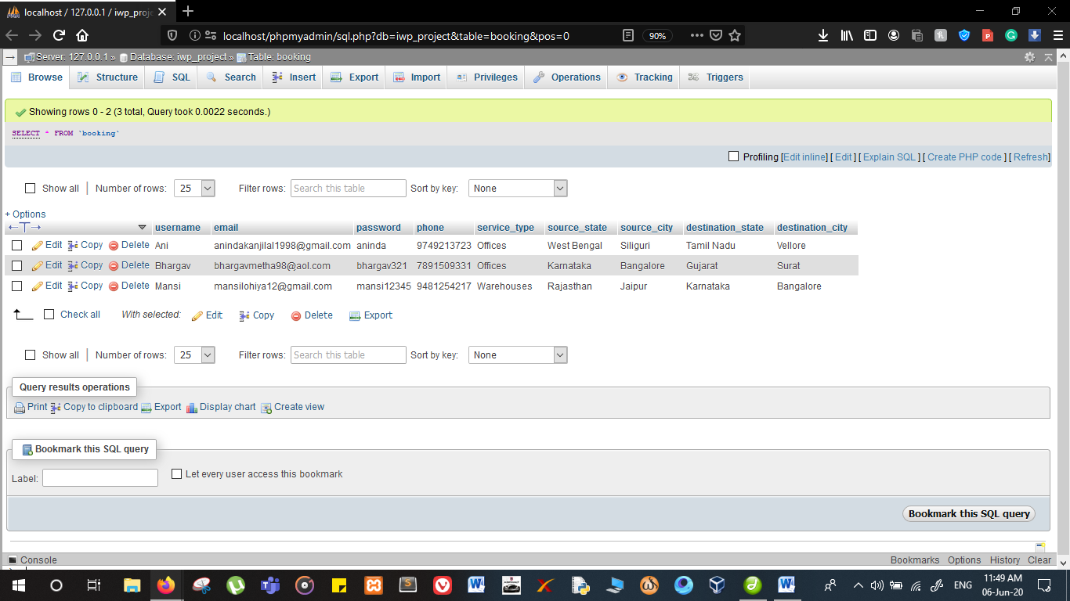

<?php

$servername="127.0.0.1";

$username='root';

$password='';

$dbname = "iwp_project";

try {

$user= $_POST['username'];

$email = $_POST['email'];

$pass= $_POST['password'];

$phone = $_POST['phone'];

$service_type = $_POST['service_type'];

$source_state = $_POST['source_state'];

$source_city = $_POST['source_city'];

$destination_state = $_POST['destination_state'];

$destination_city = $_POST['destination_city'];

$conn = new PDO("mysql:host=$servername;dbname=$dbname", $username, $password);

/* set the PDO error mode to exception */

$conn->setAttribute(PDO::ATTR_ERRMODE, PDO::ERRMODE_EXCEPTION);

$sql = "INSERT INTO booking (username, email, password, phone, service_type, source_state, source_city, destination_state, destination_city)

VALUES ('$user','$email','$pass','$phone','$service_type','$source_state','$source_city','$destination_state','$destination_city')";

$conn->exec($sql);

header("Location: home2.html");

}

catch(PDOException $e)

{

echo "<br>" . $e->getMessage();

}

$conn = null;

?>

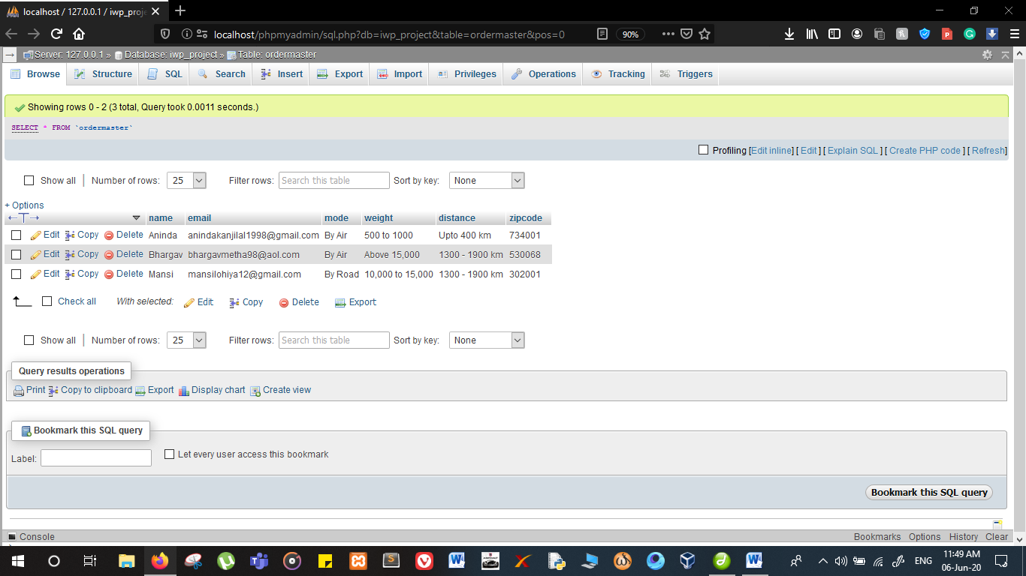

<?php

$servername="127.0.0.1";

$username='root';

$password='';

$dbname = "iwp_project";

try {

$name= $_POST['name'];

$email = $_POST['email'];

$mode= $_POST['mode'];

$weight = $_POST['wt'];

$distance = $_POST['dist'];

$zipcode = $_POST['zipcode'];

$conn = new PDO("mysql:host=$servername;dbname=$dbname", $username, $password);

/* set the PDO error mode to exception */

$conn->setAttribute(PDO::ATTR_ERRMODE, PDO::ERRMODE_EXCEPTION);

$sql = "INSERT INTO ordermaster (name,email,mode,weight,distance,zipcode)

VALUES ('$name','$email','$mode','$weight','$distance','$zipcode')";

$conn->exec($sql);

header("Location: home2.html");

}

catch(PDOException $e)

{

echo "<br>" . $e->getMessage();

}

$conn = null;

?>